*Florida International University*

*School of Computing and Information Sciences*

Software Engineering Focus

Final Deliverable

Project Title: FLACADA

**Team Members: Mabel Amaya, Nickolas Morales**

**Product Owner(s)**: Helen Gonzalez

**Mentor(s)**:

**Instructor**: Masoud Sadjadi

The MIT License (MIT)

Copyright (c) *2016 Florida International University*

Permission is hereby granted, free of charge, to any person obtaining a copy of this software and associated documentation files (the "Software"), to deal in the Software without restriction, including without limitation the rights to use, copy, modify, merge, publish, distribute, sublicense, and/or sell copies of the Software, and to permit persons to whom the Software is furnished to do so, subject to the following conditions:

The above copyright notice and this permission notice shall be included in all copies or substantial portions of the Software.

THE SOFTWARE IS PROVIDED "AS IS", WITHOUT WARRANTY OF ANY KIND, EXPRESS OR IMPLIED, INCLUDING BUT NOT LIMITED TO THE WARRANTIES OF MERCHANTABILITY, FITNESS FOR A PARTICULAR PURPOSE AND NONINFRINGEMENT. IN NO EVENT SHALL THE AUTHORS OR COPYRIGHT HOLDERS BE LIABLE FOR ANY CLAIM, DAMAGES OR OTHER LIABILITY, WHETHER IN AN ACTION OF CONTRACT, TORT OR OTHERWISE, ARISING FROM, OUT OF OR IN CONNECTION WITH THE SOFTWARE OR THE USE OR OTHER DEALINGS IN THE SOFTWARE.

***Abstract***

*This document presents the information necessary to gain a good understanding of the process used to develop a web application for a conference event for the Florida Academic Advising Association (FLACADA). This document includes all the user stories developed during five sprints of two weeks each as well as their acceptance criteria and their related tasks. In this document, we also talk about the software requirements for the application and we talk about our usage of the MEAN stack architecture to develop it. Finally, we included our deployment and package diagrams to show our system design as well as all use case diagrams, sequence diagrams, and class diagrams for all our developed user stories.*

**Table of Contents**

**Introduction** ………………………………………………………………………………………………………………………………. 5

Current System ……….…………………………………………………………………………………………………………... 5

Purpose of New System …………………………………………………..………………………………………………….. 5

**User Stories**

Implemented User Stories ………………………………………….………………………………………………………. 6

Pending User Stories …………………………………………………………………...………………………………..……. 9

**Project Plan**

Hardware and Software Resources ……………………………………………………...……………………….… 10

Sprints Plan ……………………………………………………………..………………………………………………………. 12

*Sprint 1*  …………………………………………………………………………………………………………………………... 12

*Sprint 2*  …………………………………………………………………………………………………………………………... 12

*Sprint 3*  …………………………………………………………………………………………………………………………... 13

*Sprint 4*  …………………………………………………………………………………………………………………………... 16

*Sprint 5*  …………………………………………………………………………………………………………………………... 20

**System Design**

Architectural Patterns ………………………………………………………………………………………………….. 23

System and Subsystem Decomposition …………………………………………………………………………….… 24

Deployment Diagram …………………………………………………………………………………………………….…... 25

Design Patterns ………………………………………………………………………………………………………….…..... 25

**System Validation**  …………………………………………………………………………………………………………………….26

**Glossary**  ………………………………………………………………………………………………………………………………….38

**Appendix**  ………………………………………………………………………………………………………………………………….39

Appendix A - UML Diagrams ………………………………………………………………………………………………. 39

Appendix B - User Interface Design …………………………………………………………………………….……. 78

Appendix C - Sprint Review Reports …………………………………………………………………………...….. 103

Appendix D - User Manuals, Installation/Maintenance Document, Shortcomings/Wishlist Document and other documents …………………………………………………………………….……………….. 106

**References** ……………………………………………………………………………………………………………………...………..110

# 

# Introduction

The Florida Academic Advising Association (FLACADA) web application allows users to see all exhibitors, sponsors, sessions and speakers from the conference. It also allows users to create an account so they can add sessions to their schedule and have their own personalized schedule for the conference. Admins will also have the privilege to add and delete sessions, speakers, sponsors and exhibitors from the app.

## Current System

**FLACADA**

FLACADA 1.0 is the first iteration of this app, we started from scratch using the MEAN stack framework for full stack web development. Making it easy for anyone with basic javascript knowledge to be able to develop from the front end to the back end of the whole application. We focused more on a solid foundation with an easy to follow architecture for smooth alterations in the future. UI design was not our main focus, we will leave that for future iterations of the application. Also, future iterations may include: live feeds, messaging between users, location services, and drag and drop functionality for things like images.

## Purpose of New System

The purpose of our new system was to set up an architecture that’s scalable and easy to change based on desired changes in functionality. All of our functions are fully integrated and hosted in our cloud service platform: ‘Heroku’ using ‘Mlab with Amazon Web Services’. As more complex functionality is implemented like drag and drop images, live feeds, videos. It will be needed to scale Heroku to use more dynos and to increase the amount of storage in the Amazon live database.

# User Stories

The following section provides the detailed user stories that were implemented in this iteration of the …. project. These user stories served as the basis for the implementation of the project’s features. This section also shows the user stories that are to be considered for future development.

## Implemented User Stories

**User story #685 - Implement the homepage**

As a user, I would like to have a homepage so that I can see the navigation bar and the welcome and social media panels

**User story #689 - Create exhibitors and sponsors views**

As a user, I would like to have a sponsors page and an exhibitors page so that I can see information about the sponsors and exhibitors at the conference

**User story #692 - Create a resources button**

As a guest, I would like to have a resources button so that I can be linked to FLACADA’s resources page

**User story #704 - Create view for sessions**

As a user, I would like to have a schedule page so that I can see all the details of the sessions offered at the conference

**User story #712 - Create view for speakers**

As a user, I would like to have a speakers page so that I can see the details of the speakers the conference

**User story #713 - Create contact us button**

As a guest, I would like to have a contact us button so that I can be linked to FLACADA’s contact us page

**User story #714 - Create get involved button**

As a guest, I would like to have a get involved button so that I can be linked to FLACADA’s get involved page

**User story #715 - Create jobs button**

As a guest, I would like to have a jobs button so that I can be linked to FLACADA’s jobs page

**User story #693 - Implement my schedule**

As a user, I would like to have a page for my schedule so that I can see the sessions I’ve added to my schedule

**User story #724** - **Implement create sessions**

As an admin, I would like to create sessions so that I can add new sessions to the schedule page

**User story #725** - **Implement register**

As a guest, I would like to create an account so that I can sign in and create my own schedule

**User story #749 - Implement delete sessions**

As an admin, I would like to delete sessions so that I can control the content in the sessions page

**User story #750 - Implement delete speakers**

As an admin, I would like to delete speakers so that I can control the content in the speakers page

**User story #757 - Implement login**

As a guest, I would like to sign in to my account so that I can create my own schedule

**User story #758 - Implement logout**

As a user, I would like to have a logout button so that I can logout of my account

**User story #753 - Create button to add sessions to my schedule**

As a user, I would like to add sessions to my schedule so that I can create my own schedule for the conference

**User story #754 - Create button to delete sessions from my schedule**

As a user I would like to delete sessions from my schedule so that I can remove unwanted sessions or sessions added by accident.

**User story #756 - Implement create speakers**

As an admin I would like to create speakers so that I can add new speakers to the speakers page

**User story #734 - Create local page**

As a user, I would like to have a local page so that I can see a list of local events, dining options and weather

**User story #735 - Create wifi page**

As a user, I would like to have a wifi page so that I can see wifi login information

**User story #694 - Implement create exhibitors**

As an admin, I would like to add and delete sponsors and exhibitors so that I can control the content in the exhibitors and sponsors’ pages

**User story #759 - Create maps page**

As a user I would like to have a maps page so that I can see a list of facility maps for the conference

**User story #760 - Create FAQ page**

As a user I would like to have a FAQ page so that I can see frequently asked questions and their answers

**User story #755 - Implement create sponsors**

As an admin I would like to create sponsors so that I can add new sponsors to the sponsors page

**User story #752 - Implement delete exhibitors**

As an admin I would like to delete exhibitors so that I can control the content in the exhibitors page

**User story #751 - Implement delete sponsors**

As an admin I would like to delete sponsors so that I can control the content in the sponsors page

## Pending User Stories

**User story #705 - Implement notifications**

As a user, I would like to get notifications about the sessions on my schedule so that I can be reminded about their start time

**User story #742 - Get social**

As a user, I would like to have a live feed of a specified social media hashtag

**User story #812 - Implement create maps**

As an admin, I would like to create maps so that I can add new maps to the maps page

**User story #813 - Implement create FAQ**

As an admin, I would like to create FAQ so that I can add new FAQ to FAQ maps page

**User story #816 - Implement create local**

As an admin, I would like to create local events so that I can add new local events to the local page

**User story #817 - Implement create wifi**

As an admin, I would like to create wifi information so that I can add new wifi information to the wifi page

**User story #814 - Implement delete maps**

As an admin, I would like to delete maps so that I can control the content in the maps page

**User story #815 - Implement delete FAQ**

As an admin, I would like to delete FAQ so that I can control the content in the FAQ page

**User story #818 - Implement delete local**

As an admin, I would like to delete local events so that I can control the content in the local page

**User story #819 - Implement delete wifi**

As an admin, I would like to delete wifi information so that I can control the content in the wifi page

# Project Plan

This section describes the planning that went into the realization of this project. This project incorporated the agile development techniques and as such required the sprints to be planned. These sprint plannings are detailed in the section. This section also describes the components, both software and hardware, chosen for this project.

## 

## Hardware and Software Resources

The following is a list of all hardware and software resources that were used in this project:

**Hardware:**

Any computer with at least the following specs:

**Processor:** 500-Mhz Pentium-class or Intel

**Min RAM:** 256 MB

**Min Disk Space:** 100MB

**Windows OS:** Windows XP

**OS X:** OS X 10.5.8

**Linux:** Unbuntu 10.04

**Software**

**Internet Browser:** such as Chrome, Safari

**Text Editor:** such as Atom, VS Code

**CMD Line:** such as Terminal

**MongoDB**

**MLab**

**Express**

**Angular**

**NodeJS**

**Dependencies:**(At time of development)

"body-parser": "^1.17.2",

"cookie-parser": "^1.4.3",

"debug": "^2.6.8",

"dotenv": "^4.0.0",

"express": "^4.15.3",

"express-jwt": "^5.3.0",

"foreman": "^2.0.0",

"heroku": "^0.2.0",

"jade": "^1.11.0",

"jsonwebtoken": "^7.4.1",

"mongoose": "^4.11.1",

"morgan": "^1.8.2",

"passport": "^0.3.2",

"passport-local": "^1.0.0",

"serve-favicon": "^2.4.3"

## Sprints Plan

### Sprint 1

**User story #685 - Implement the homepage**

As a user, I would like to have a homepage so that I can see the navigation bar and the welcome and social media panels

**Acceptance Criteria:**

1. All the links working with an acceptable UI Structure
2. The FLACADA logo has to be at the top
3. The welcome pane has the about us, bylaws and membership link
4. Social media panel has links for FLACADA’s facebook, instagram, and twitter
5. The navigation button has 4 tabs: conference, newsletter, shop, and more
6. The newsletter and shop tab link to FLACADA’s newsletter and shop page, respectively.
7. The conference tab links to the conference page
8. The more tab is a dropdown with 4 buttons that link to FLACADA’s resources, jobs, get involved, and contact us pages
9. Navigation bar has to be at the bottom

**Related Tasks:**

Task #669 - FLACADA Homepage Menu tabs

Task #668 - FLACADA Homepage content

### Sprint 2

**User story #689 - Create exhibitors and sponsors views**

As a user, I would like to have a sponsors page and an exhibitors page so that I can see information about the sponsors and exhibitors at the conference

**Acceptance Criteria:**

1. Both links are on the conference page
2. The sponsors page displays their picture and their name
3. If you click on the name of the sponsor, you’re taken to a page that shows the rest of the details for the sponsor which are their description and their website
4. The exhibitors page displays their picture and their name
5. If you click on the name of the exhibitor, you’re taken to a page that shows the rest of the details for the exhibitor

**Related Tasks:**

Task #710 - Exhibitors and sponsors angular

Task #701 - Controllers for exhibitors and sponsors

Task #683 - Updating CSS and creating sponsor and exhibitor models

Task #674 - Exhibitors and Sponsors (models)

### Sprint 3

**User story #692 - Create a resources button**

As a guest, I would like to have a resources button so that I can be linked to FLACADA’s resources page

**Acceptance Criteria:**

1. The button is on the more tab
2. The button’s name is resources
3. The button has the URL for FLACADA’s resources page
4. When you click on the button, FLACADA’s resources page is opened in a new tab

**Related Tasks:**

Task #698 - Create resource links

**User story #704 - Create view for sessions**

As a user, I would like to have a schedule page so that I can see all the details of the sessions offered at the conference

**Acceptance Criteria:**

1. The link for the schedule page is on the conference page
2. The sessions page shows the name of the sessions, their start and end time and their location
3. Clicking on the name of the session takes you to that individual session’s page which shows the speakers and the description of the session.
4. When the user goes to the individual session’s page and they click on the speakers, they’re taken to that speaker’s page

**Related Tasks:**

Task #709 - Angular for sessions

Task #706 - Sessions view

Task #703 - Models for sessions

Task #702 - Routing for sessions

Task #700 - Controller for sessions

**User story #712 - Create view for speakers**

As a user, I would like to have a speakers page so that I can see the details of the speakers the conference

**Acceptance Criteria:**

1. The link for the speakers page is on the conference page
2. The speakers page shows the name of the speakers, their title and their institution
3. Clicking on the name of the speaker takes you to that individual speaker’s page which shows the sessions they’re in and their email
4. When the user goes to the individual speaker’s page and they click on the sessions, they’re taken to that session’s page

**Related Tasks:**

Task #723 - Model for speakers

Task #722 - Angular for speakers

Task #721 - View for speakers

Task #720 - Controller for speakers

Task #719 - Routing for speakers

Task #708 - UI Speaker Form

**User story #713 - Create contact us button**

As a guest, I would like to have a contact us button so that I can be linked to FLACADA’s contact us page

**Acceptance Criteria:**

1. The button is on the more tab
2. The button’s name is contact us
3. The button has the URL for FLACADA’s contact us page
4. When you click on the button, FLACADA’s contact us page is opened in a new tab

**Related Tasks:**

Task #716 - Create contact us link

**User story #714 - Create get involved button**

As a guest, I would like to have a get involved button so that I can be linked to FLACADA’s get involved page

**Acceptance Criteria:**

1. The button is on the more tab
2. The button’s name is get involved!
3. The button has the URL for FLACADA’s get involved page
4. When you click on the button, FLACADA’s get involved page is opened in a new tab

**Related Tasks:**

Task #717 - Create get involved! link

**User story #715 - Create jobs button**

As a guest, I would like to have a jobs button so that I can be linked to FLACADA’s jobs page

**Acceptance Criteria:**

1. The button is on the more tab
2. The button’s name is jobs
3. The button has the URL for FLACADA’s jobs page
4. When you click on the button, FLACADA’s jobs page is opened in a new tab

**Related Tasks**:

Task #718 - Create jobs link

### Sprint 4

**User story #693 - Implement my schedule page**

As a user, I would like to have a page for my schedule so that I can see the sessions I’ve added to my schedule

**Acceptance Criteria:**

1. The link for my schedule is on the conference page
2. The my schedule page shows all the sessions the user added from the schedule page

**Related Tasks:**

Task #820 - Service to get my schedule

Task #699 - Routing for my schedule

Task #670 - Create a view and controller for my schedule

**User story #724** - **Implement create sessions**

As an admin, I would like to create sessions so that I can add new sessions to the schedule page

**Acceptance Criteria:**

1. There is an add session button on the sessions page
2. There is an add session button next to every speaker so that a session can be added to a speaker
3. Admin is given a popup to fill out all the information needed to add a session
4. If the admin doesn’t fill out all fields, they will not be able to submit the form

**Related Tasks:**

Task #783 - Service to create sessions

Task #772 - Controller and view for creating sessions

Task #771 - Popup form to create sessions

Task #729 - API routing to create sessions

**User story #725** - **Implement register**

As a guest, I would like to create an account so that I can sign in and create my own schedule

**Acceptance Criteria:​**

1. The register form asks for name, email and password
2. Guest will not be allowed to submit the registration form if all the fields are not filled out

**Related Tasks:**

Task #795 - Controller and view to register

Task #794 - API routing to register

Task #793 - Service to register

**User story #749 - Implement delete sessions**

As an admin, I would like to delete sessions so that I can control the content in the sessions page

**Acceptance Criteria:**

1. There is a delete all button on the sessions page
2. There is a delete button next to every session

**Related Tasks:**

Task #784 - Service to delete sessions

Task #776 - Controller and view to delete sessions

Task #775 - API routing to delete sessions

**User story #750 - Implement delete speakers**

As an admin, I would like to delete speakers so that I can control the content in the speakers page

**Acceptance Criteria:**

1. There is a delete all button on the speakers page
2. There is a delete button next to every speaker

**Related Tasks:**

Task #786 - Service to delete speakers

Task #778 - Controller and view to delete speakers

Task #777 - API routing to delete speakers

**User story #757 - Implement login**

As a guest, I would like to sign in to my account so that I can create my own schedule

**Acceptance Criteria:**

1. Only users have the ability to create their own schedule
2. The login button is on the navigation bar
3. Email and password will be used to sign in
4. If a user tries to log in with the wrong password, they’ll get a message saying so
5. If a user tries to log in with the wrong email, they’ll get a message saying so

**Related Tasks:**

Task #789 - Service for login

Task #788 - API routing for login

Task #787 - Controller and view for login

**User story #758 - Implement logout**

As a user, I would like to have a logout button so that I can logout of my account

**Acceptance Criteria:**

1. The logout button is on the navigation bar

Related Tasks:

Task #792 - Controller and view for logout

Task #791 - API routing to logout

Task #790 - Service to logout

**User story #753 - Create button to add sessions to my schedule**

As a user, I would like to add sessions to my schedule so that I can create my own schedule for the conference

**Acceptance Criteria:**

1. Every session on the schedule page has an add to my schedule button
2. If a session is successfully added to my schedule, a message is shown

**Related Tasks:**

Task #781 - Service to add sessions to my schedule

Task #780 - Controller and view to add sessions to my schedule

Task #779 - API routing to add sessions to my schedule

**User story #754 - Create button to delete sessions from my schedule**

As a user I would like to delete sessions from my schedule so that I can remove unwanted sessions or sessions added by accident.

**Acceptance Criteria:**

1. There’s a delete button next to every session on the my schedule page
2. There is start over button on the schedule page to allow the user to delete all the sessions on their schedule and start over

**Related Tasks:**

Task #782 - Service to delete sessions from my schedule

Task #765 - Create API routing for delete button from my schedule

Task #764 - Create view and controller to delete sessions from my schedule

**User story #756 - Implement create speakers**

As an admin I would like to create speakers so that I can add new speakers to the speakers page

**Acceptance Criteria:**

1. There is an add speaker button on the speakers page
2. There is an add speaker button next to every session so that a speaker can be added to a session
3. Admin is given a popup to fill out all the information needed to add a speaker
4. If the admin doesn’t fill out all fields, they will not be able to submit the form

**Related Tasks:**

Task #785 - Service to create speakers

Task #774 - Controller and view to create speakers

Task #773 - API routing for creating speakers

Task #728 - Popup form for speakers

### Sprint 5

**User story #734 - Create local page**

As a user, I would like to have a local page so that I can see a list of local events, dining options and weather

**Acceptance Criteria:**

1. The link to the local page is on the conference page
2. The local page shows a list of local events, dining options and weather

**Related Tasks:**

Task #737 - Controller and view for local

**User story #735 - Create wifi page**

As a user, I would like to have a wifi page so that I can see wifi login information

**Acceptance Criteria:**

1. The link to the wifi page is on the conference page
2. The wifi page shows the login information for the wifi at the conference

**Related Tasks:**

Task #798 - Controller and view for wifi

**User story #694 - Implement create exhibitors**

As an admin, I would like to add and delete sponsors and exhibitors so that I can control the content in the exhibitors and sponsors’ pages

**Acceptance Criteria:**

1. There is an add exhibitor button on the exhibitor page
2. Admin is given a popup to fill out all the information needed to add an exhibitor
3. If the admin doesn’t fill out all fields, they will not be able to submit the form

**Related Tasks:**

Task #802 - Controller and view to create exhibitors

Task #801 - API routing to create exhibitors

Task #800 - Service to create exhibitors

Task #799 - Popup form to create exhibitors

**User story #759 - Create maps page**

As a user I would like to have a maps page so that I can see a list of facility maps for the conference

**Acceptance Criteria:**

1. The link to the maps page is on the conference page
2. The maps page shows a list of maps of the facilities at the conference

**Related Tasks:**

Task #797 - Controller and view for maps

**User story #760 - Create FAQ page**

As a user I would like to have a FAQ page so that I can see frequently asked questions and their answers

**Acceptance Criteria:**

1. The link to the FAQ page is on the conference page
2. The FAQ page shows frequently asked questions and their answers

**Related Tasks:**

Task #796 - Controller and view for FAQ

**User story #755 - Implement create sponsors**

As an admin I would like to create sponsors so that I can add new sponsors to the sponsors page

**Acceptance Criteria:**

1. There is an add sponsor button on the sponsors page
2. Admin is given a popup to fill out all the information needed to add a sponsor
3. If the admin doesn’t fill out all fields, they will not be able to submit the for

**Related Tasks:**

Task #805 - API routing to create sponsors

Task #804 - Service to create sponsors

Task #803 - Controller and view to create sponsors

Task #711 -Popup form for sponsors

**User story #752 - Implement delete exhibitors**

As an admin I would like to delete exhibitors so that I can control the content in the exhibitors page

**Acceptance Criteria:**

1. There is a delete all button on the exhibitors page
2. There is a delete button next to every exhibitor

**Related Tasks:**

Task #808 - Controller and view to delete exhibitors

Task #807 - Service to delete exhibitors

Task #806 - API routing to delete exhibitors

**User story #751 - Implement delete sponsors**

As an admin I would like to delete sponsors so that I can control the content in the sponsors page

**Acceptance Criteria:**

1. There is a delete all button on the sponsors page
2. There is a delete button next to every sponsor

**Related Tasks:**

Task #811 - Controller and view to delete sponsors

Task #810 - Service to delete sponsors

Task #809 - API routing to delete sponsors

# System Design

This section contains information on the design decisions that went into this project. The architecture patterns are outlined and explained. The entire system is shown in a package diagram and the subsystems are explained. Finally, the design patterns used in the project are discussed.

## Architectural Patterns

Our architecture is MVC. MVC stands for model-view-controller, and its an architecture that aims to separate out the data (model), the display (view), and application logic (controller). This separation aims to remove any tight coupling between the components, theoretically making code more maintainable and reusable.

MEAN Stack is comprised of four main technologies, with a cast of supporting technologies:

* **M**ongoDB - the database
* **E**xpress - the web framework
* **A**ngular - the front-end framework
* **N**ode.Js - the web server

MEAN Stack pulls together some of the “best-of-breed” modern web technologies into a powerful and flexible stack. The thing that makes MEAN Stack stand out is the fact that you only need to know one language and its the same language you browser runs on: Javascript.

## 

## 

## System and Subsystem Decomposition

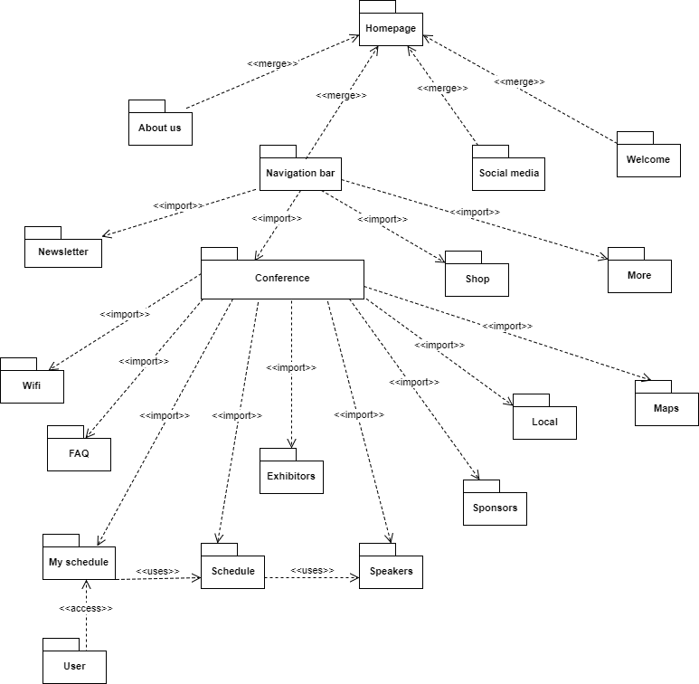

Since we used the MVC architecture, every package contains a model, a view and a controller. The homepage merges about us, welcome, navigation bar and social media since this is all the content to be displayed on the homepage. The navigation bar depends on its four tabs: newsletter, conference, shop and more. Conference depends on eight packages: wifi, FAQ, exhibitors, sponsors, schedule, speakers and my schedule. Since schedule contains speaker, the schedule package uses the speakers package to display speakers’ information on the schedule page. Also, since my schedule is made up of sessions from the schedule, the my schedule package uses the schedule package. Finally, since a user who creates an account is able to create their own schedule, each user has access to their own schedule so the user package has access to the my schedule package.

## Deployment Diagram

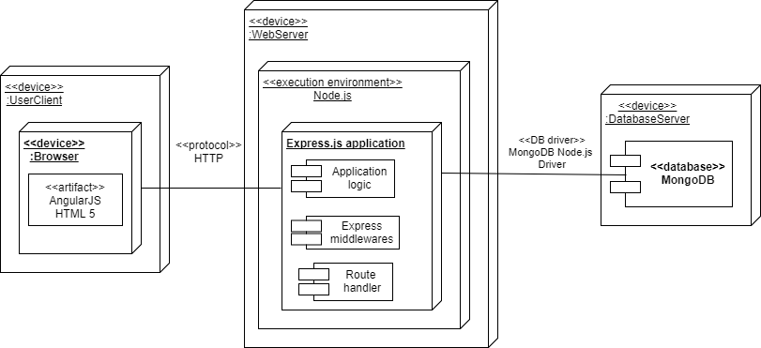

## Design Patterns

We used the Command Design Pattern which its intent is to encapsulate request objects and promote “invocation of a method on an object” to full object status and an object oriented call back. Command decouple that object that invokes the certain operation from the logic. To do this we design OO base classes that maps a receiver with some action that the object can “do”. This separation provides flexibility in the timing and sequencing of commands. Materializing commands this way means they can be manipulated like ony other object.

# System Validation

This section shows the unit tests and integration tests that were done throughout the course of developing the FLACADA app.

**Unit testing**

Test case ID: #1

Description/Summary of Test: Membership has the right styling and links to memberships page

Pre-condition: Internet access with and is in our homepage

Expected Results: The link is aware there’s a mouse hover and changes style and when clicked it redirects to membership page

Actual Result: changed style and redirected to memberships page

Status (Fail/Pass): PASS

Test case ID: #2

Description/Summary of Test: Bylaws has the right styling and links to memberships page

Pre-condition: Internet access with and is in our homepage

Expected Results: The link is aware there’s a mouse hover and changes style and when clicked it redirects to Bylaws page

Actual Result: changed style and redirected to Bylaws page

Status (Fail/Pass): PASS

Test case ID: #3

Description/Summary of Test: About Us shows formatted in side-bar

Pre-condition: Internet access with and is in our homepage

Expected Results: home page loads with About Us in side-bar formatted to the right in desktop and to the bottom in mobile

Actual Result: Home page loads with About Us in side-bar formatted to the right in desktop and to the bottom in mobile

Status (Fail/Pass): PASS

Test case ID: #4

Description/Summary of Test: facebook has the right styling and links to facebook page

Pre-condition: Internet access with and is in our homepage

Expected Results: The link is aware there’s a mouse hover and changes style and when clicked it redirects to facebook page

Actual Result: changed style and redirected to facebook page

Status (Fail/Pass): PASS

Test case ID: #5

Description/Summary of Test: instagram has the right styling and links to instagram page

Pre-condition: Internet access with and is in our homepage

Expected Results: The link is aware there’s a mouse hover and changes style and when clicked it redirects to instagram page

Actual Result: changed style and redirected to instagram page

Status (Fail/Pass): PASS

Test case ID: #6

Description/Summary of Test: twitter has the right styling and links to twitter page

Pre-condition: Internet access with and is in our homepage

Expected Results: The link is aware there’s a mouse hover and changes style and when clicked it redirects to twitter page

Actual Result: changed style and redirected to twitter page

Status (Fail/Pass): PASS

Test case ID: #7

Description/Summary of Test: When a User clicks on the conference navbar option it redirects them to the ‘/conference’ page with its according URL

Pre-condition: Internet access with and is in our homepage

Expected Results: The link is aware there’s a mouse hover and changes style and when clicked it redirects to conference page

Actual Result: The link is aware there’s a mouse hover and changes style and when clicked it redirects to conference page

Status (Fail/Pass): PASS

Test case ID: #8

Description/Summary of Test: When a User clicks on the Newsletter navbar option it redirects them to Newsletter page

Pre-condition: Internet access with and is in our homepage

Expected Results: The link is aware there’s a mouse hover and changes style and when clicked it redirects to Newsletter page

Actual Result: The link is aware there’s a mouse hover and changes style and when clicked it redirects to Newsletter page

Status (Fail/Pass): PASS

Test case ID: #9

Description/Summary of Test: When a User clicks on the Shop navbar option it redirects them to the Shop page

Pre-condition: Internet access with and is in our homepage

Expected Results: The link is aware there’s a mouse hover and changes style and when clicked it redirects to shop page

Actual Result: The link is aware there’s a mouse hover and changes style and when clicked it redirects to shop page

Status (Fail/Pass): PASS

Test case ID: #10

Description/Summary of Test: When a User clicks on the more navbar option it redirects them to the 404 ‘/more’ page

Pre-condition: Internet access with and is in our homepage

Expected Results: The link is aware there’s a mouse hover and changes style and when clicked it redirects to the 404 ‘/more’ page

Actual Result: The link is aware there’s a mouse hover and changes style and when clicked it redirects to the 404 ‘/more’ page

Status (Fail/Pass): PASS

Test case ID: #11

Description/Summary of Test: When the page is viewed on a tablet, desktop view, or mobile phone view the navigation bar resizes appropriately

Pre-condition: The website has to be currently loaded in a tablet, mobile phone, and a desktop

Expected Results: When seen in desktop view, the navbar should expand the length of the screen and when it gets to a tablet or mobile phone sized view it collapses into a triggering button.

Actual Result: When seen in desktop view, the navbar should expand the length of the screen and when it gets to a tablet or mobile phone sized view it collapses into a triggering button.

Status (Fail/Pass): PASS

Test case ID: #12

Description/Summary of Test: exhibitors has the right styling and links to exhibitor’s list page with correct layout

Pre-condition: User must be in the in the ‘/conference’ page

Expected Results: exhibitors link has the right styling and links to exhibitor’s list page with correct layout

Actual Result: exhibitors has the right styling and links to exhibitor’s list page with correct layout

Status (Fail/Pass): PASS

Test case ID: #13

Description/Summary of Test: exhibitors details page has banner logo of the company at the top with a company description and link a to their website

Pre-condition: User must have clicked on an exhibitor in the exhibitor’s list page

Expected Results: exhibitors details page has banner logo of the company at the top with a company description and link a to their website

Actual Result: empty form

Status (Fail/Pass): FAILED

Test case ID: #14

Description/Summary of Test: sponsors has the right styling and links to sponsor’s list page with correct layout

Pre-condition: User must be in the in the ‘/conference’ page

Expected Results: sponsors link has the right styling and links to sponsors’s list page with correct layout

Actual Result: sponsors has the right styling and links to sponsors’s list page with correct layout

Status (Fail/Pass): PASS

Test case ID: #15

Description/Summary of Test: sponsors details page has banner logo of the company at the top with a company description and link a to their website

Pre-condition: User must have clicked on a sponsor in the sponsor’s list page

Expected Results: sponsors details page has banner logo of the company at the top with a company description and link a to their website

Actual Result: empty form

Status (Fail/Pass): FAILED

Test case ID: #16

Description/Summary of Test: Collapsed Navbar and ‘More’ navbar option drops down and ‘Resources’ link work

Pre-condition: User must be in a ‘mobile sized’ screen (9.7 inches or less)

Expected Results: When user clicks on the collapse button, the navbar menu options drop down and when the ‘More’ tab is clicked, ‘Resource’ link drops down and works.

Actual Result: User clicks on the collapse button, the navbar menu options drop down and when the ‘More’ tab is clicked, ‘Resource’ link drops down and works.

Status (Fail/Pass): PASS

Test case ID: #17

Description/Summary of Test: sessions has the right styling and links to session’s list page with correct layout

Pre-condition: User must be in the in the ‘/conference’ page

Expected Results: sessions link has the right styling and links to session’s list page with correct layout

Actual Result: sessions has the right styling and links to session’s list page with correct layout

Status (Fail/Pass): PASS

Test case ID: #18

Description/Summary of Test: session details page has the name of the session, start and end time, speaker name, place, description.

Pre-condition: User must have clicked on a session in the session’s list page

Expected Results: session details page has the name of the session, start and end time, speaker name, place, description.

Actual Result: session details page has the name of the session, start and end time, speaker name, place, description.

Status (Fail/Pass): PASS

Test case ID: #19

Description/Summary of Test: speakers has the right styling and links to speaker’s list page with correct layout

Pre-condition: User must be in the in the ‘/conference’ page

Expected Results: speakers link has the right styling and links to speaker’s list page with correct layout

Actual Result: speakers has the right styling and links to speaker’s list page with correct layout

Status (Fail/Pass): PASS

Test case ID: #20

Description/Summary of Test: speakers details page has a picture of the speaker with name, position, email, phone, sessions.

Pre-condition: User must have clicked on an speaker in the speaker’s list page

Expected Results: speakers details page has a picture of the speaker with name, position, email, phone, sessions.

Actual Result: speakers details page has a picture of the speaker with name, position, email, phone, sessions.

Status (Fail/Pass): PASS

Test case ID: #21

Description/Summary of Test: Collapsed Navbar and ‘More’ navbar option drops down and ‘Contact Us’ link work

Pre-condition: User must be in a ‘mobile sized’ screen (9.7 inches or less)

Expected Results: When user clicks on the collapse button, the navbar menu options drop down and when the ‘More’ tab is clicked, ‘Contact Us’ link drops down and works.

Actual Result: User clicks on the collapse button, the navbar menu options drop down and when the ‘More’ tab is clicked, ‘Contact Us’ link drops down and works.

Status (Fail/Pass): PASS

Test case ID: #22

Description/Summary of Test: Collapsed Navbar and ‘More’ navbar option drops down and ‘Get Involved’ link work

Pre-condition: User must be in a ‘mobile sized’ screen (9.7 inches or less)

Expected Results: When user clicks on the collapse button, the navbar menu options drop down and when the ‘More’ tab is clicked, ‘Get Involved’ link drops down and works.

Actual Result: User clicks on the collapse button, the navbar menu options drop down and when the ‘More’ tab is clicked, ‘Get Involved’ link drops down and works.

Status (Fail/Pass): PASS

Test case ID: #23

Description/Summary of Test: Collapsed Navbar and ‘More’ navbar option drops down and ‘Jobs’ link work

Pre-condition: User must be in a ‘mobile sized’ screen (9.7 inches or less)

Expected Results: When user clicks on the collapse button, the navbar menu options drop down and when the ‘More’ tab is clicked, ‘Jobs’ link drops down and works.

Actual Result: User clicks on the collapse button, the navbar menu options drop down and when the ‘More’ tab is clicked, ‘Jobs’ link drops down and works.

Status (Fail/Pass): PASS

Test case ID: #24

Description/Summary of Test: User navigated to the Schedule Page and adds to their schedule certain sessions.

Pre-condition: Must be logged in as a User and the Sessions list must be populated.

Expected Results: Session was added to mySchedule.

Actual Result: Session was added to mySchedule.

Status (Fail/Pass): PASS

Test case ID: #25

Description/Summary of Test: User navigated to the Schedule Page and adds to their schedule certain sessions.

Pre-condition: Must be logged in as a User and the Sessions list must be populated.

Expected Results: Session was added to mySchedule.

Actual Result: Session was added to mySchedule.

Status (Fail/Pass): PASS

Test case ID: #26

Description/Summary of Test: Advisor will navigate to their schedule page and delete a certain session by clicking the delete session button.

Pre-condition: Must be logged in as a user and must be enrolled in at least one session.

Expected Results: Session has been deleted from their schedule.

Actual Result: Session has been deleted from their schedule.

Status (Fail/Pass): PASS

Test case ID: #27

Description/Summary of Test: Advisor will navigate to their mySchedule page and click the Start Over button and all their sessions will be deleted from their schedule.

Pre-condition: Must be logged in as a user and there has to be at least one session in their schedule.

Expected Results: All the sessions were deleted from their schedule.

Actual Result: All the sessions were deleted from their schedule.

Status (Fail/Pass): PASS

Test case ID: #28

Description/Summary of Test: Admin will navigate to the Exhibitors page and click the Add Exhibitor button and create a new exhibitor.

Pre-condition: Must be logged in as admin.

Expected Results: Exhibitor was posted.

Actual Result: Exhibitor was posted.

Status (Fail/Pass): PASS

Test case ID: #29

Description/Summary of Test: Admin will navigate to Exhibitor page and select an exhibitor and delete it.

Pre-condition: Must be logged in as admin and exhibitors list must be populated.

Expected Results: Deleted Exhibitor.

Actual Result: Deleted Exhibitor.

Status (Fail/Pass): PASS

Test case ID: #30

Description/Summary of Test: Admin will navigate to the exhibitors page and click on the Delete All Exhibitors button and all the exhibitors will be deleted.

Pre-condition: Must be logged in as an admin and the exhibitors list must be populated.

Expected Results: All exhibitors were deleted.

Actual Result: All exhibitors were deleted.

Status (Fail/Pass): PASS

Test case ID: #31

Description/Summary of Test: Admin will navigate to the Sponsors page and click the add sponsors button and create a new sponsor.

Pre-condition: Must be logged in as an admin.

Expected Results: Sponsor was posted.

Actual Result: Sponsor was posted.

Status (Fail/Pass): PASS

Test case ID: #32

Description/Summary of Test: Admin will navigate to the Sponsors page and Click the delete button next to a specific Sponsor and it will be deleted.

Pre-condition: Must be logged in as admin and Sponsors list must be populated.

Expected Results: Sponsor was deleted.

Actual Result: Sponsor was deleted.

Status (Fail/Pass): PASS

Test case ID: #33

Description/Summary of Test: Admin will navigate to the Sponsors page and click on the Delete All Sponsors button and all the sponsors will be deleted.

Pre-condition: Must be logged in as an admin and the Sponsors list must be populated.

Expected Results: All the Sponsors were deleted.

Actual Result: All the Sponsors were deleted.

Status (Fail/Pass): PASS

Test case ID: #34

Description/Summary of Test: Admin selects a speaker and clicks on the button to add a session, a modal appears, the admin fills the form out and submits the session to that speaker and then it appears in the ‘Schedule’ page.

Pre-condition: Currently be logged in as an Admin

Expected Results: A new Session was posted for the specific speaker

Actual Result: A new Session was posted for the specific speaker

Status (Fail/Pass): PASS

Test case ID: #35

Description/Summary of Test: Admin will select a session to delete by selecting the delete button next to the corresponding session

Pre-condition: Currently logged on as admin

Expected Results: The session was deleted

Actual Result: The session was deleted

Status (Fail/Pass): PASS

Test case ID: #36

Description/Summary of Test: Admin will navigate to the Schedule Page and click the delete all sessions button and all the sessions will be deleted

Pre-condition: Must be logged in as admin and the list of sessions has to be populated

Expected Results: All sessions were deleted

Actual Result: All sessions were deleted

Status (Fail/Pass): PASS

Test case ID: #37

Description/Summary of Test: Admin will navigate to the schedule page and select a certain session and add a speaker to by filling out the form.

Pre-condition: must be logged in as an admin and at least one session must be present on the page.

Expected Results: A speaker was added to a certain session.

Actual Result: A speaker was added to a certain session.

Status (Fail/Pass): PASS

Test case ID: #38

Description/Summary of Test: Admin will navigate to the speakers page and delete a certain speaker.

Pre-condition: Must be logged in as admin and the speaker list must be populated.

Expected Results: Speaker was deleted.

Actual Result: Speaker was deleted.

Status (Fail/Pass): PASS

Test case ID: #39

Description/Summary of Test: Admin will navigate to Speakers page and click on the Delete All Speakers button and all the speakers will be deleted.

Pre-condition: Must be logged in as admin and Speakers list must be populated.

Expected Results: All Speakers are deleted.

Actual Result: All Speakers are deleted.

Status (Fail/Pass): PASS

Test case ID: #40

Description/Summary of Test: Will fill out the registration form and check in the mongoDB if the user has posted in the users collection of the flacada DB.

Pre-condition: Guest has to have clicked on the register link and currently in the registration page.

Expected Results: The entries were validated correctly and the user was posted to the DB.

Actual Result: The entries were validated correctly and the user was posted to the DB.

Status (Fail/Pass): PASS

Test case ID: #41

Description/Summary of Test: After Successful registration, the user will log out and go to the login form and log in with the credential specified previously in the registration process.

Pre-condition: Successful User Registration and currently logged out

Expected Results: User will fill in credentials and will login successfully

Actual Result: login was successful

Status (Fail/Pass): PASS

Test case ID: #42

Description/Summary of Test: User will click the logout link and the token will be deleted A.K.A user has logged out

Pre-condition: User or Admin has to be logged in currently

Expected Results: Token was deleted as shown by the name of the user not being displayed on the navbar

Actual Result: Token was deleted as shown by the name of the user not being displayed on the navbar

Status (Fail/Pass): PASS

Test case ID: #43

Description/Summary of Test: Navigate to the Map page and view the current location

Pre-condition: application must be running

Expected Results: view map with current location

Actual Result: view map with current location

Status (Fail/Pass): PASSED

Test case ID: #44

Description/Summary of Test: Navigate to the Loca page and view all the local information

Pre-condition: Application must be running

Expected Results: view local information

Actual Result: view local information

Status (Fail/Pass): PASSED

Test case ID: 45

Description/Summary of Test: Navigate to Wifi page and view the wifi information

Pre-condition: application must be running

Expected Results: View WIFI

Actual Result: View WIFI

Status (Fail/Pass): PASSED

Test case ID: 46

Description/Summary of Test: Navigate to the FAQ page and view the FAQ listings

Pre-condition: Application must be running

Expected Results: view the FAQ

Actual Result: view the FAQ

Status (Fail/Pass): PASSED

**Integration Tests**

The application was tested manually by allowing multiple users to use the application and follow certain tasks such as registering for an account or adding sessions to their schedule.

As most of the work done was split into individualized groups, there was little room for integration, or integration tests.

At the request of our product owner, the concept of integration was to be reserved for future iterations of the project.

# 

# 

# 

# 

# 

# 

# 

# Glossary

* **Angular:** HTML is great for declaring static documents, but it falters when we try to use it for declaring dynamic views in web-applications. AngularJS lets you extend HTML vocabulary for your application. The resulting environment is extraordinarily expressive, readable, and quick to develop.
* **ExpressJS:** is a minimal and flexible Node.js web application framework that provides a robust set of features for web and mobile applications.
* **Heroku:** is a cloud platform as a service supporting several programming languages that is used as a web application deployment model.
* **mLab:** is a fully managed cloud database service that hosts MongoDB databases. mLab runs on cloud providers Amazon, Google, and Microsoft Azure, and has partnered with platform-as-a-service providers.
* **MongoDB:** is a free and open-source cross-platform document-oriented database program. Classified as a NoSQL database program, MongoDB uses JSON-like documents with schemas.
* **Mongoose:** provides a straight-forward, schema-based solution to model your application data. It includes built-in type casting, validation, query building, business logic hooks and more, out of the box.
* **NodeJS:** As an asynchronous event driven JavaScript runtime, Node is designed to build scalable network applications. In the following "hello world" example, many connections can be handled concurrently. Upon each connection the callback is fired, but if there is no work to be done, Node will sleep.

# 

# 

# Appendix

## Appendix A - UML Diagrams

**Use** **Case diagram**

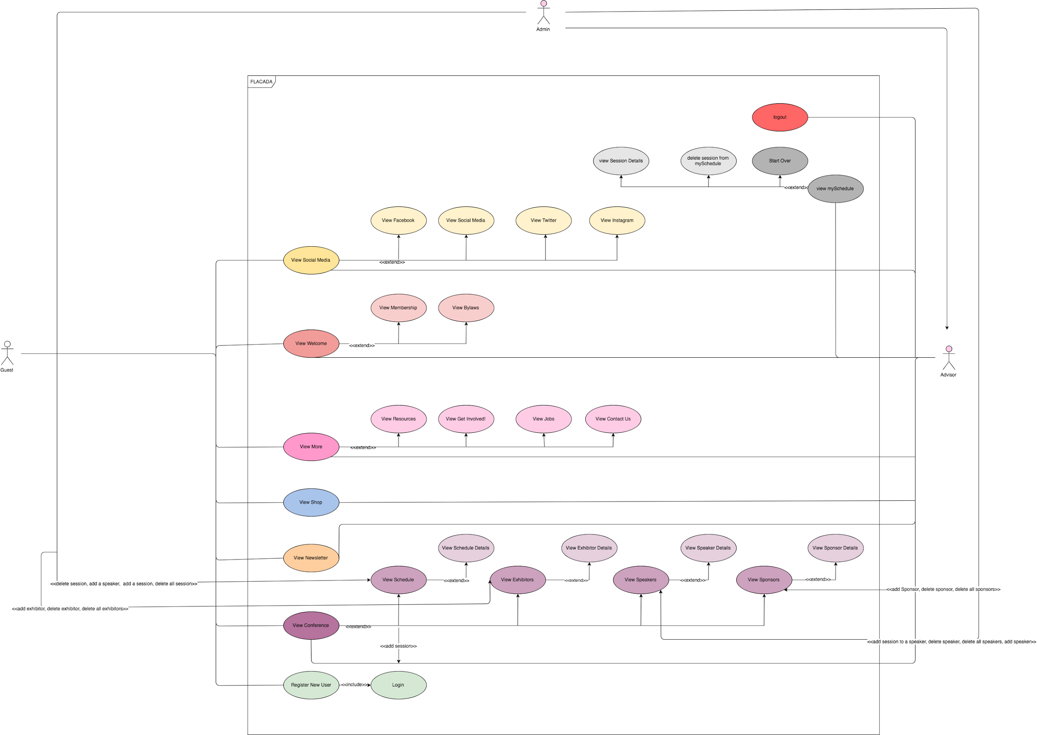

**Case diagram**

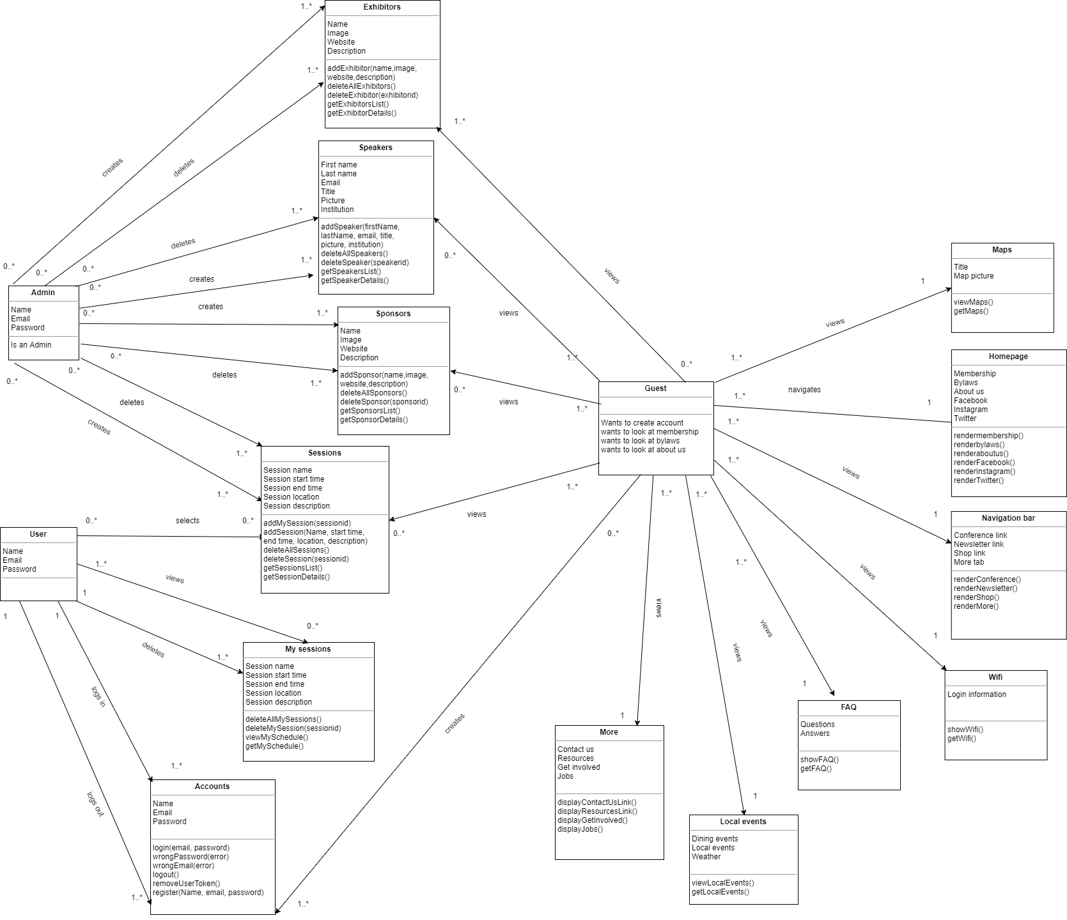

## 

## User story #685

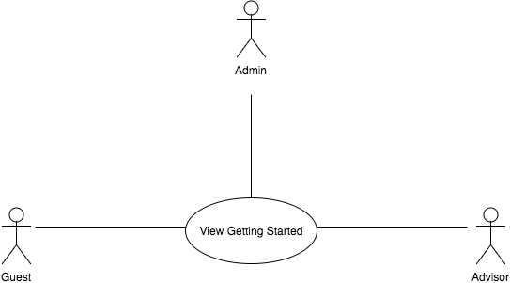

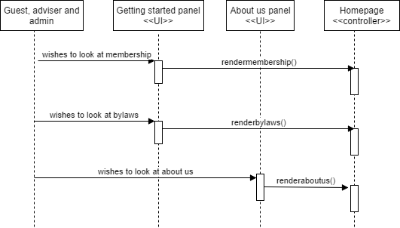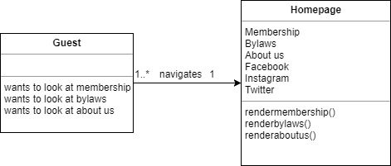

## 

## socialmediaseqdiag.png

## viewsocialmedia.png

## 

## navigationoptionsseqdiag.png

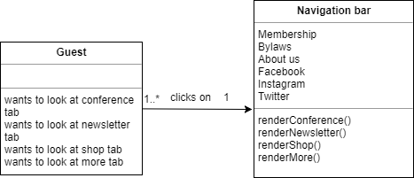

## User story #689

## 

## viewexhibitorsseqdiag.png

## viewexhibitors.png

## 

## 

## viewsponsorsseqdiag.png

## 

## viewsponsors.png

## 

## User story #692

## 

## 

## viewresourcesseqdiag.png

## viewresourcesclass.png

**User story #704**

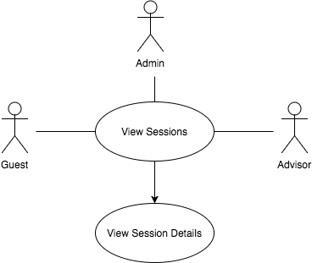

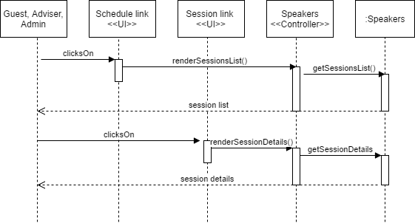

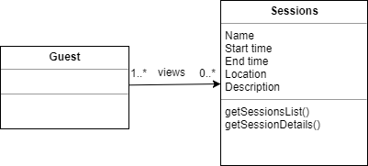

**User story #712**

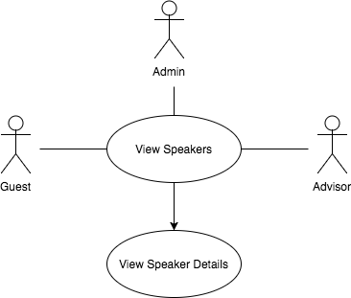

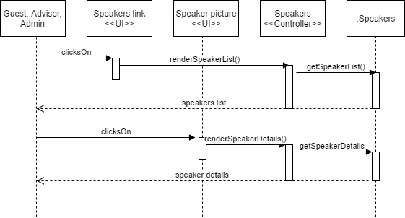

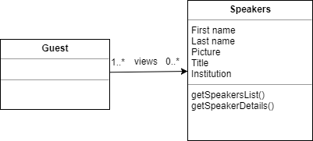

**User story #713**

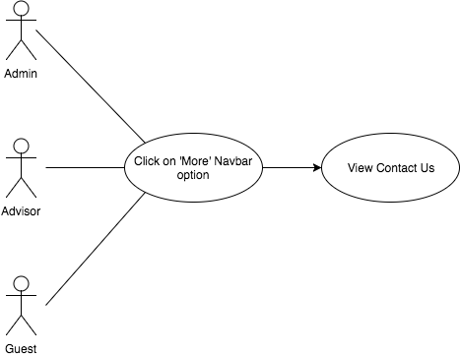

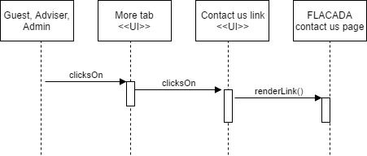

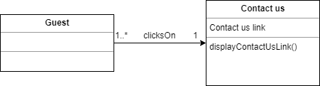

**User story #714**

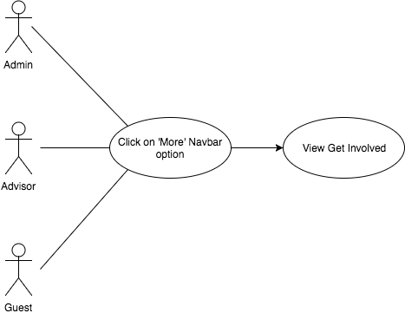

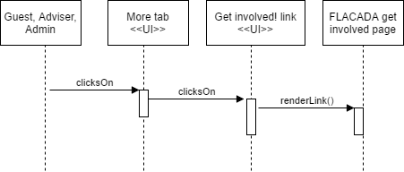

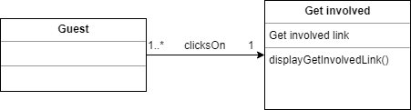

**User story #715**

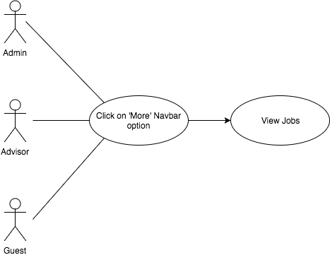

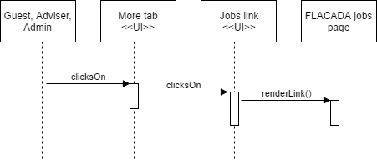

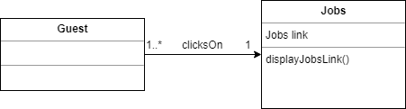

**User story #693**

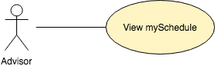

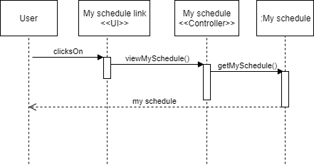

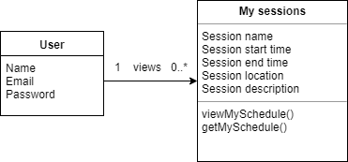

**User story #753**

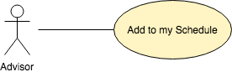

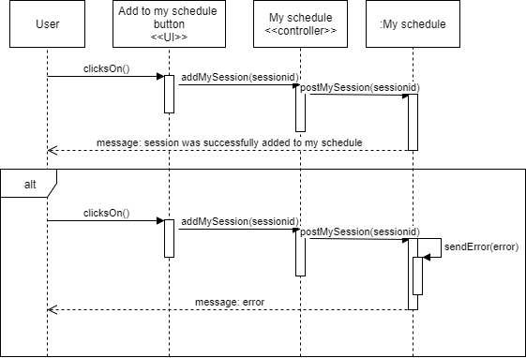

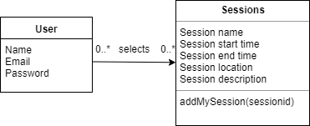

**User story #754**

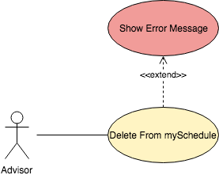

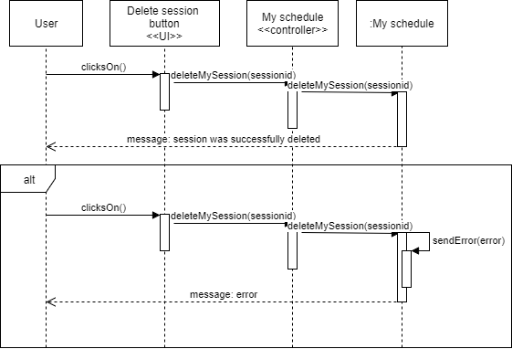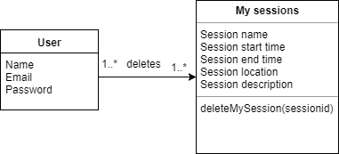

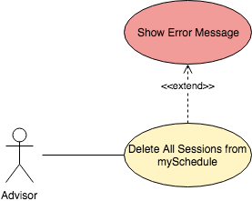

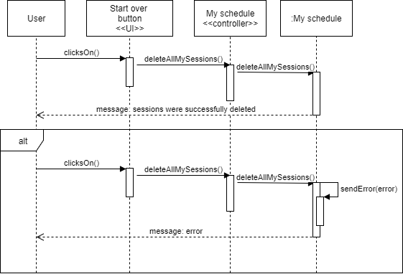

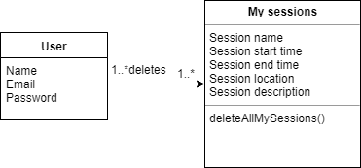

**User story #724**

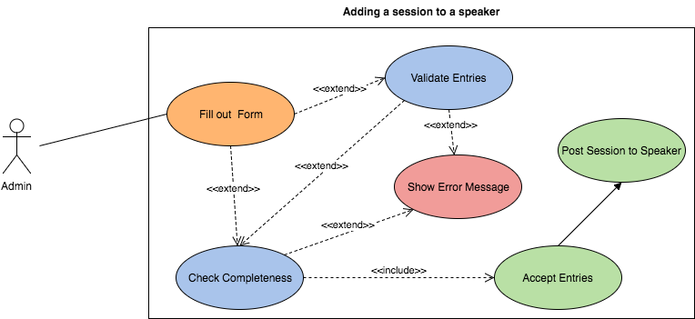

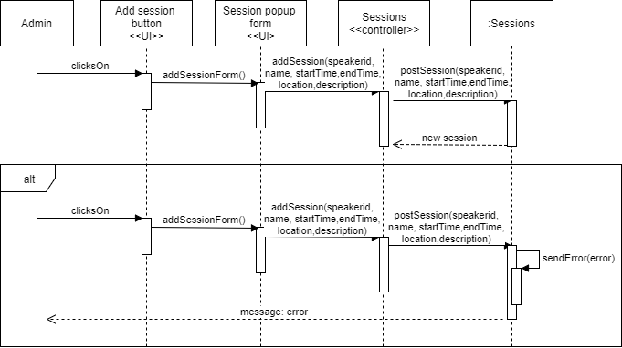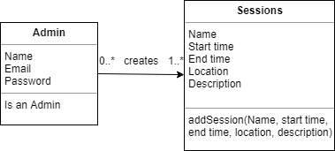

**User story #749**

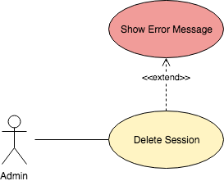

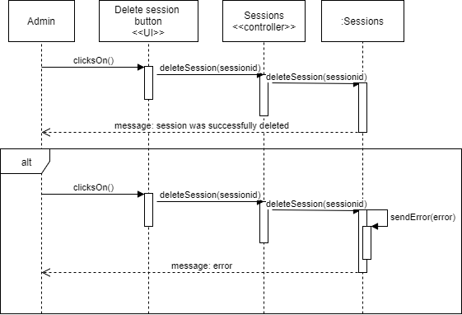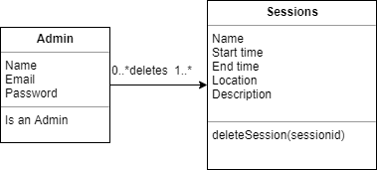

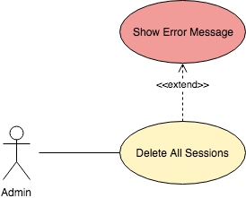

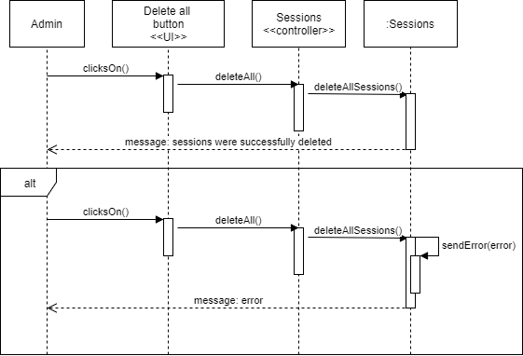

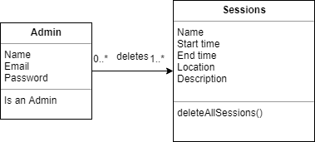

**User story #756**

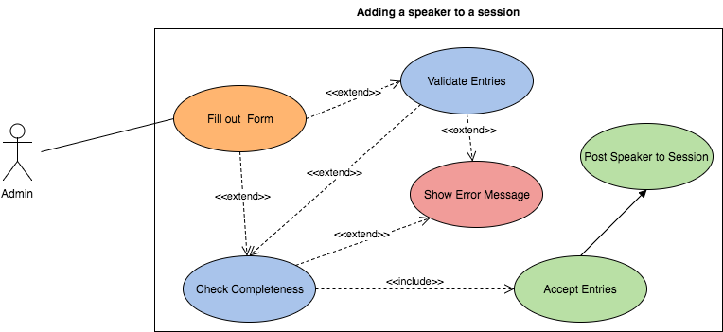

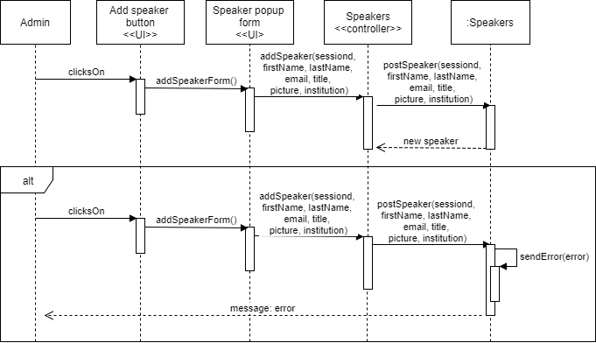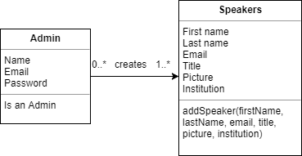

**User story #750**

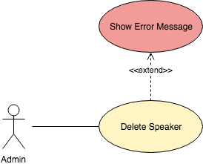

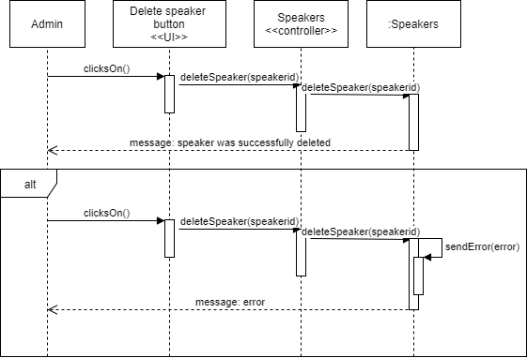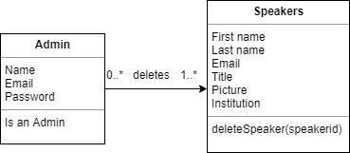

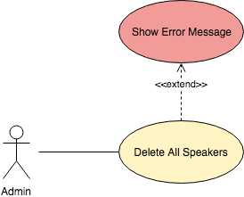

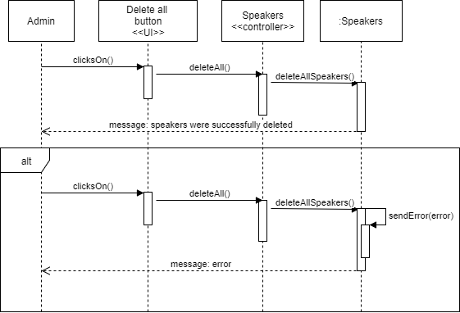

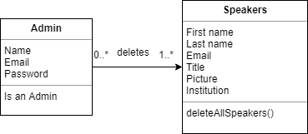

**User Story #725**

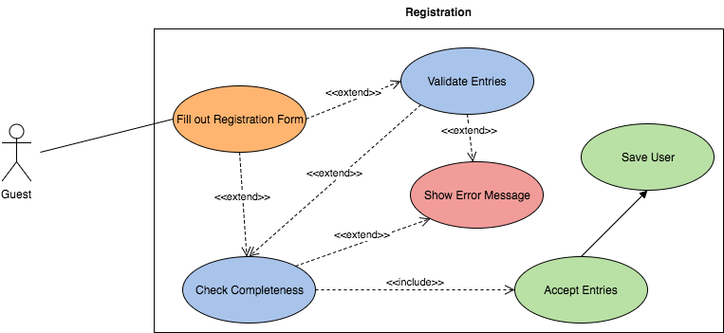

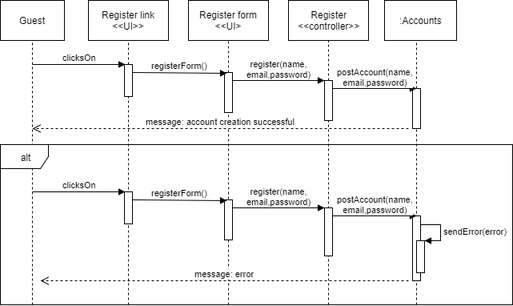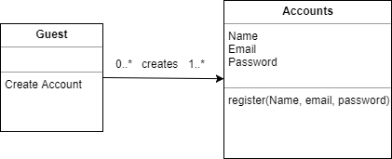

**User story #757**

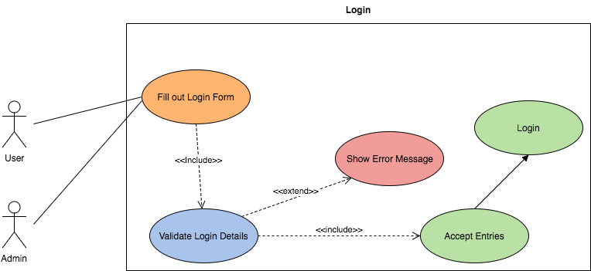

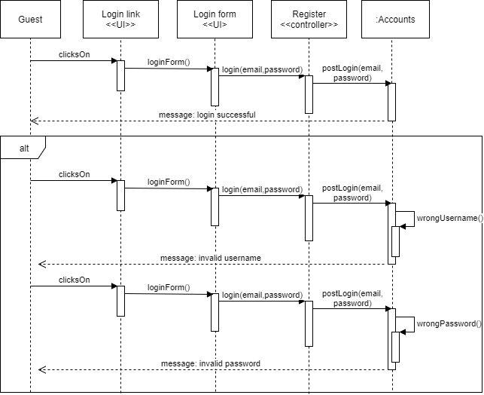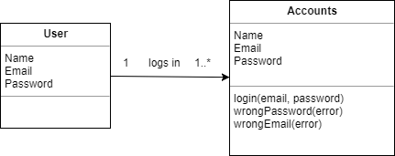

**User story #758**

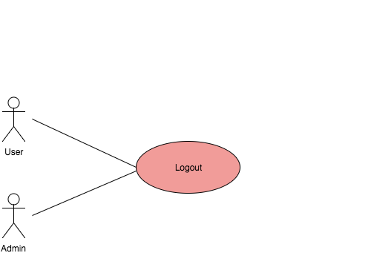

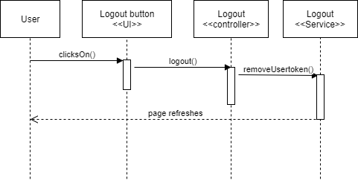

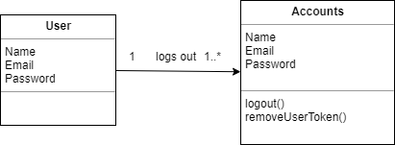

**User story #694**

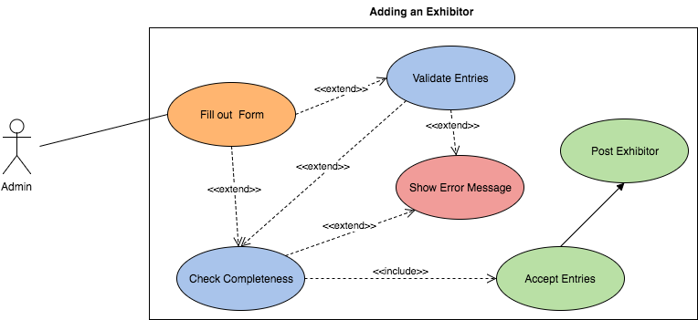

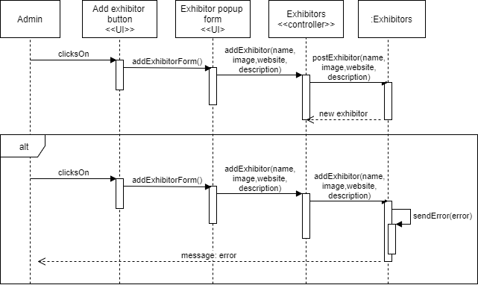

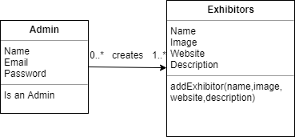

**User story #752**

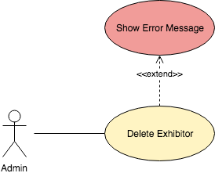

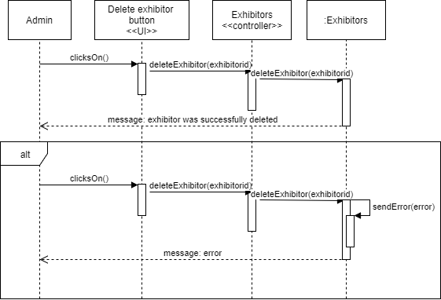

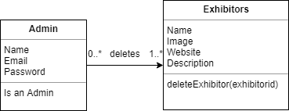

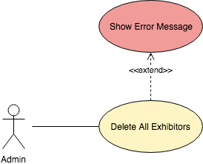

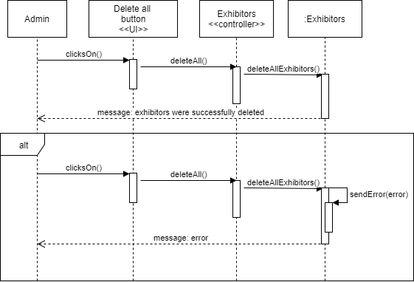

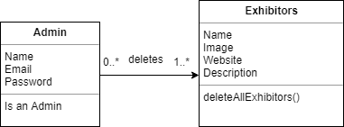

**User story #755**

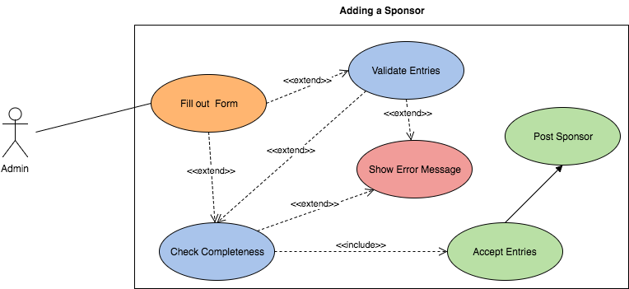

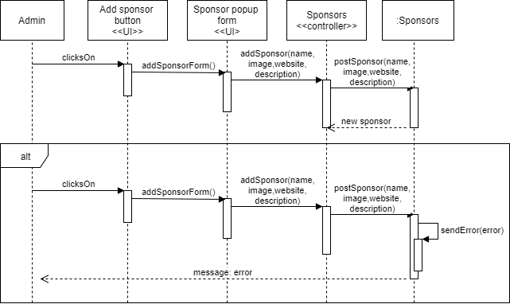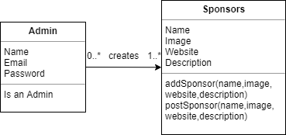

**User story #751**

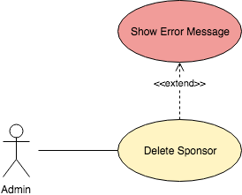

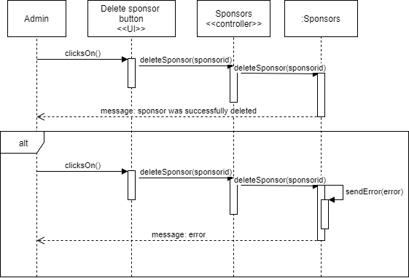

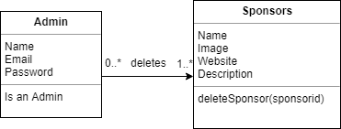

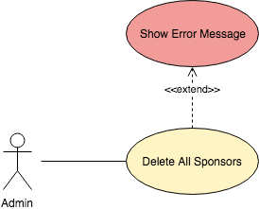

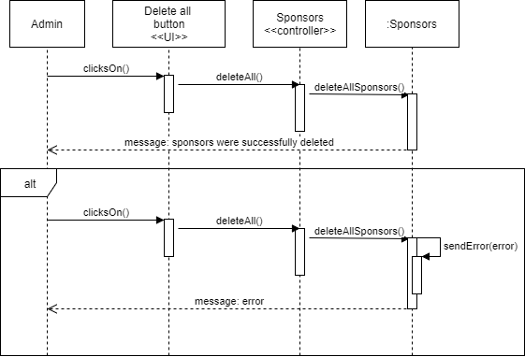

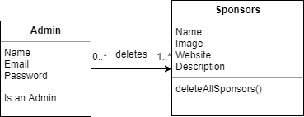

**User Story #759**

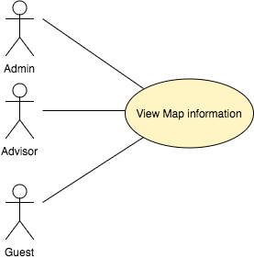

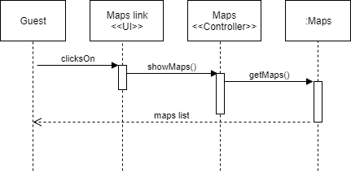

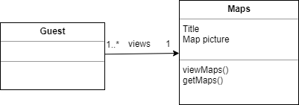

**User story #734**

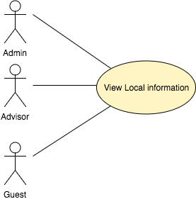

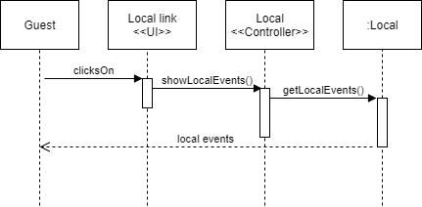

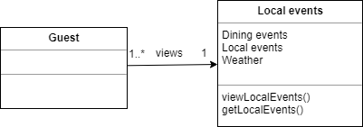

**User Story #735**

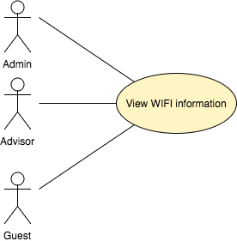

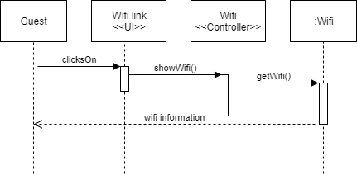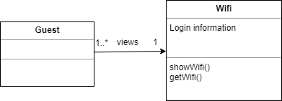

**User story #760**

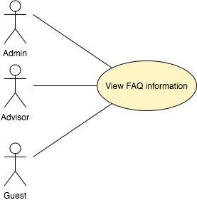

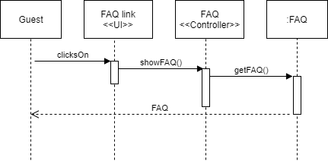

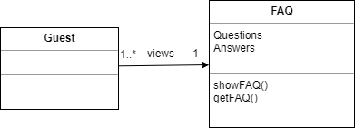

## Appendix B - User Interface Design

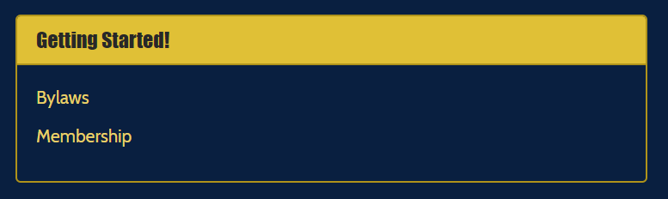

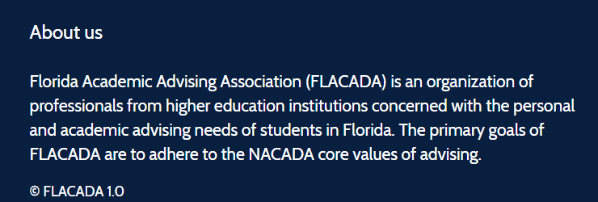

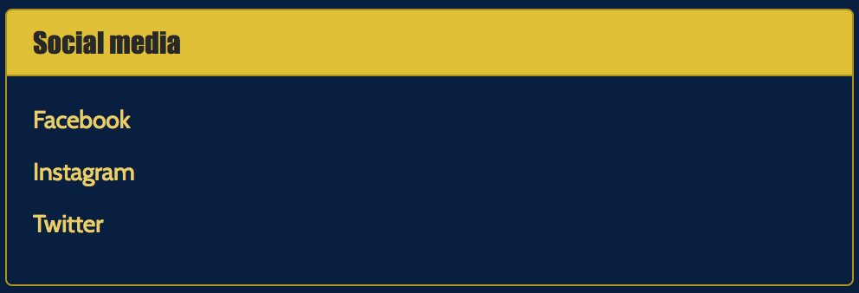



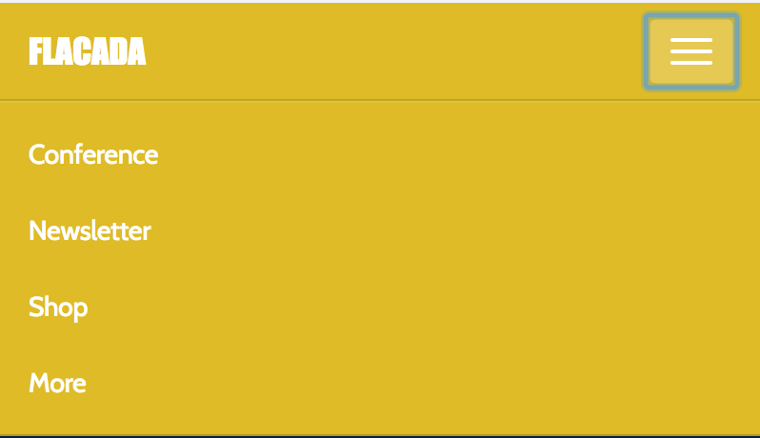

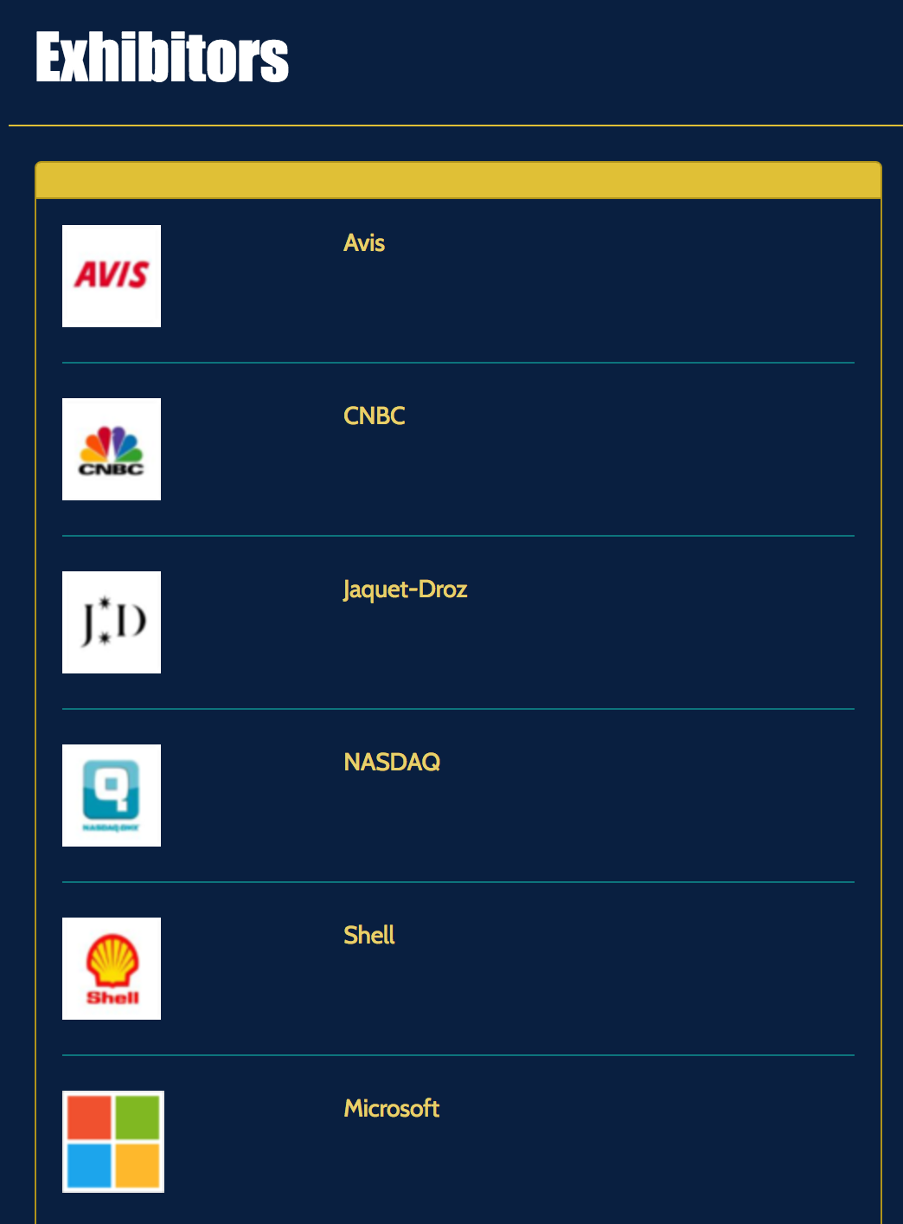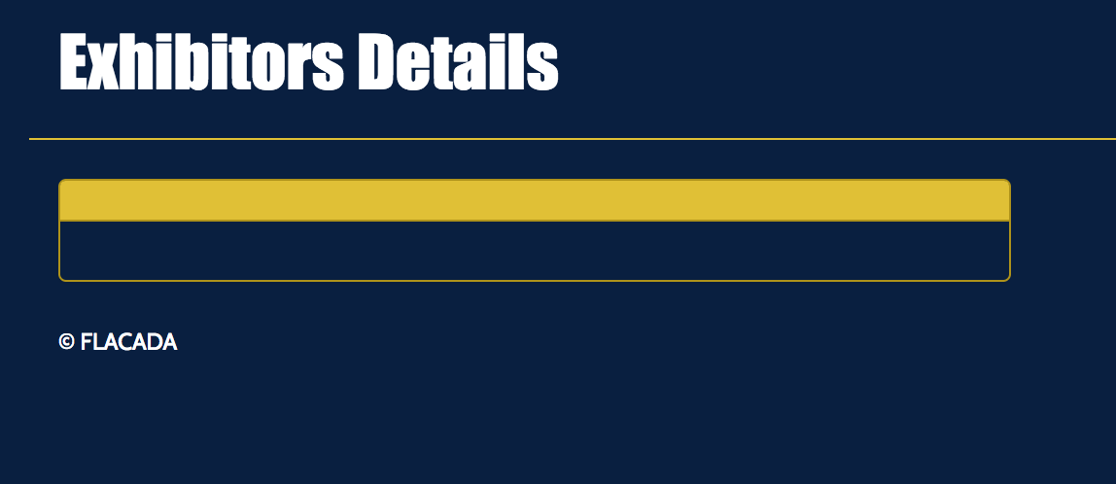

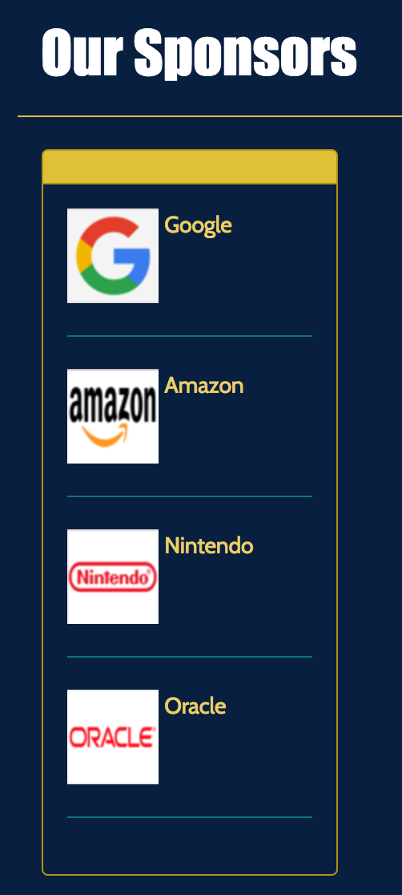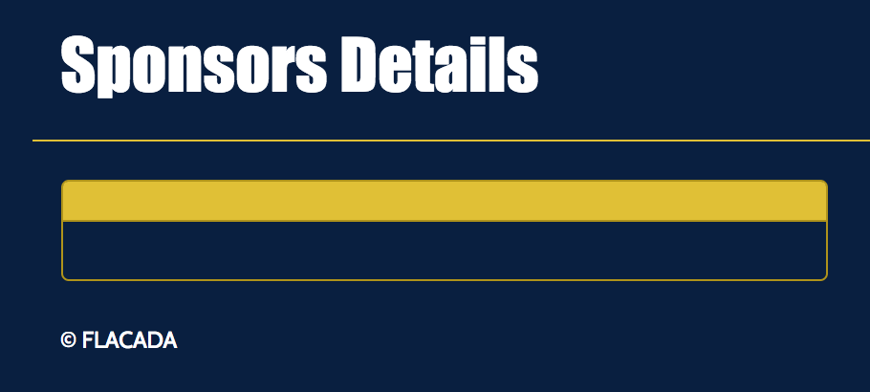

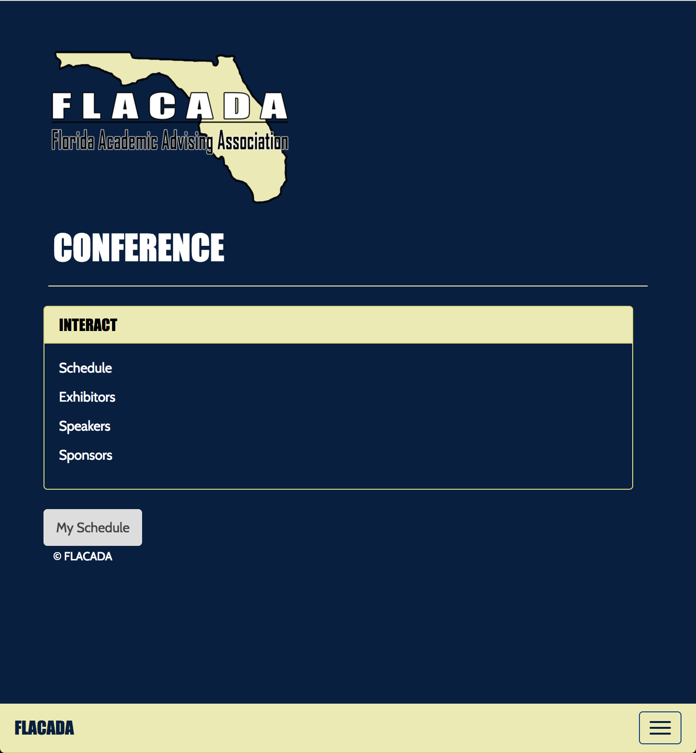 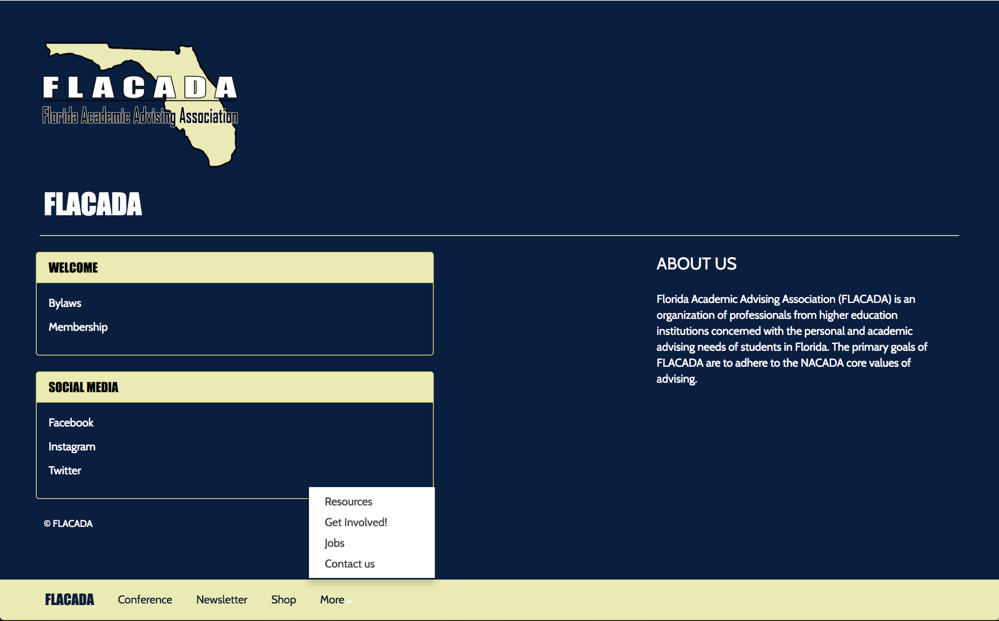 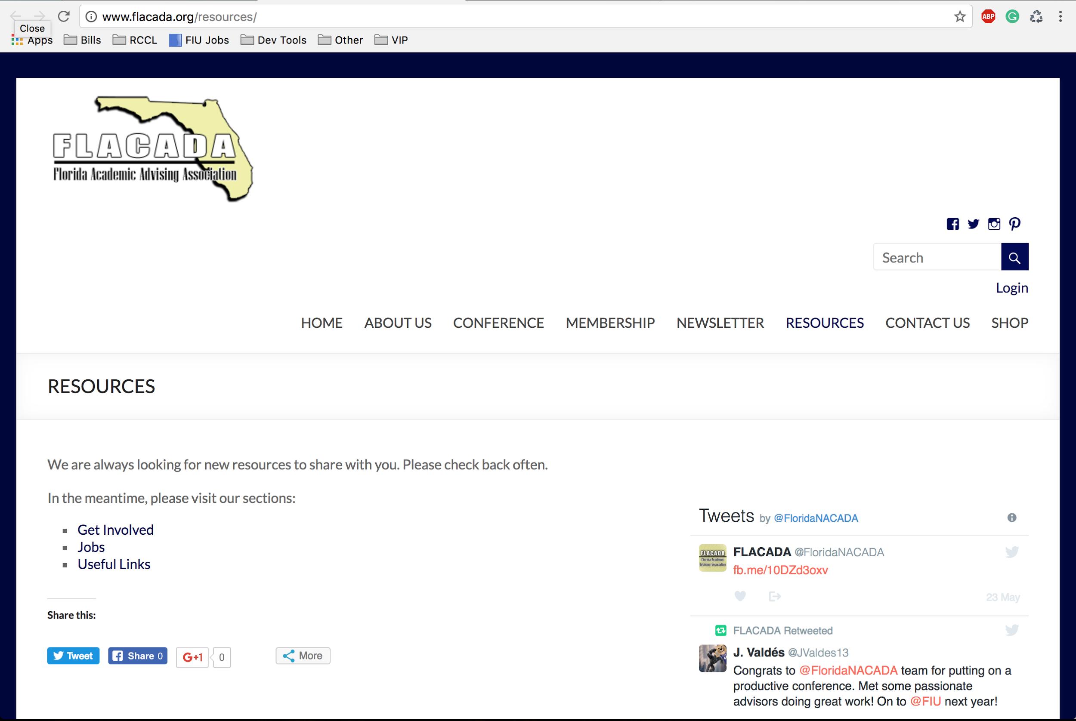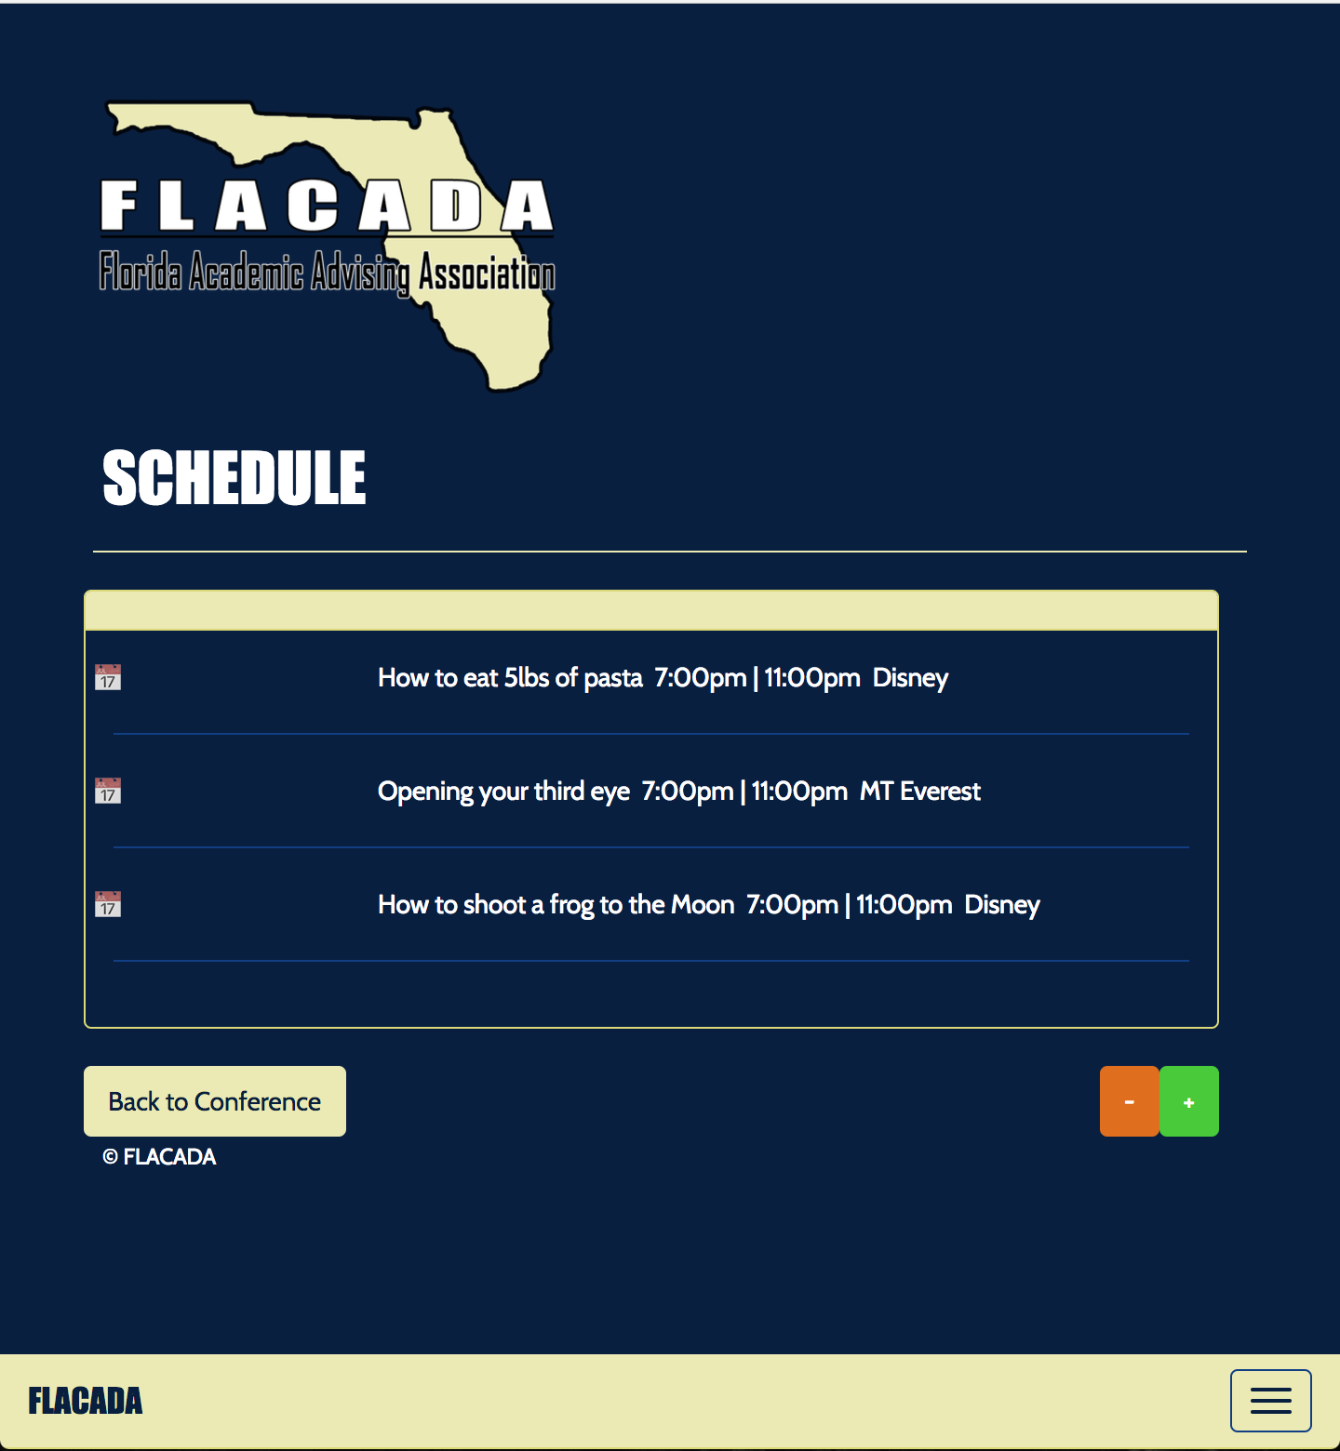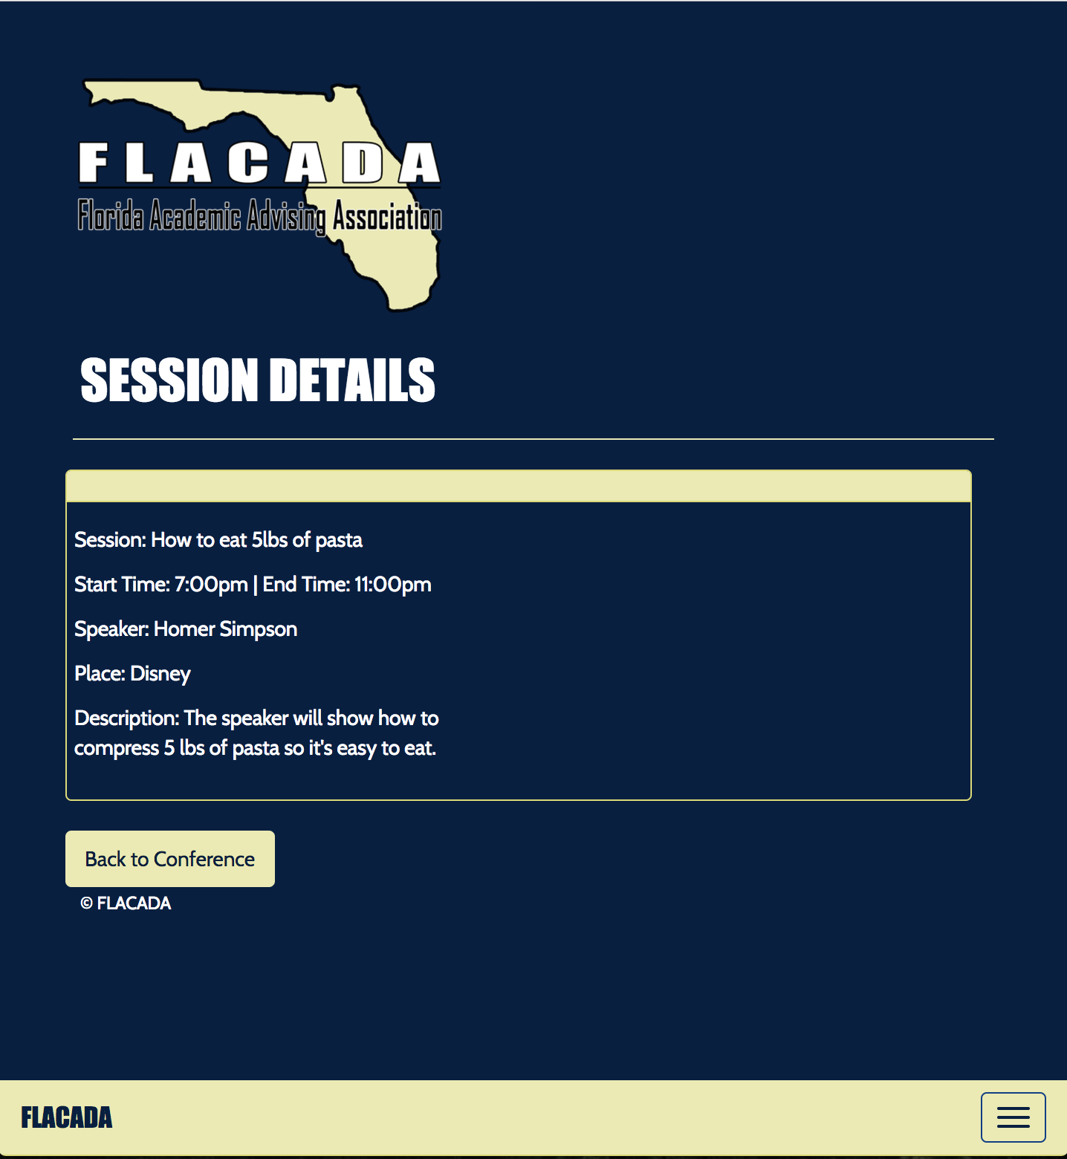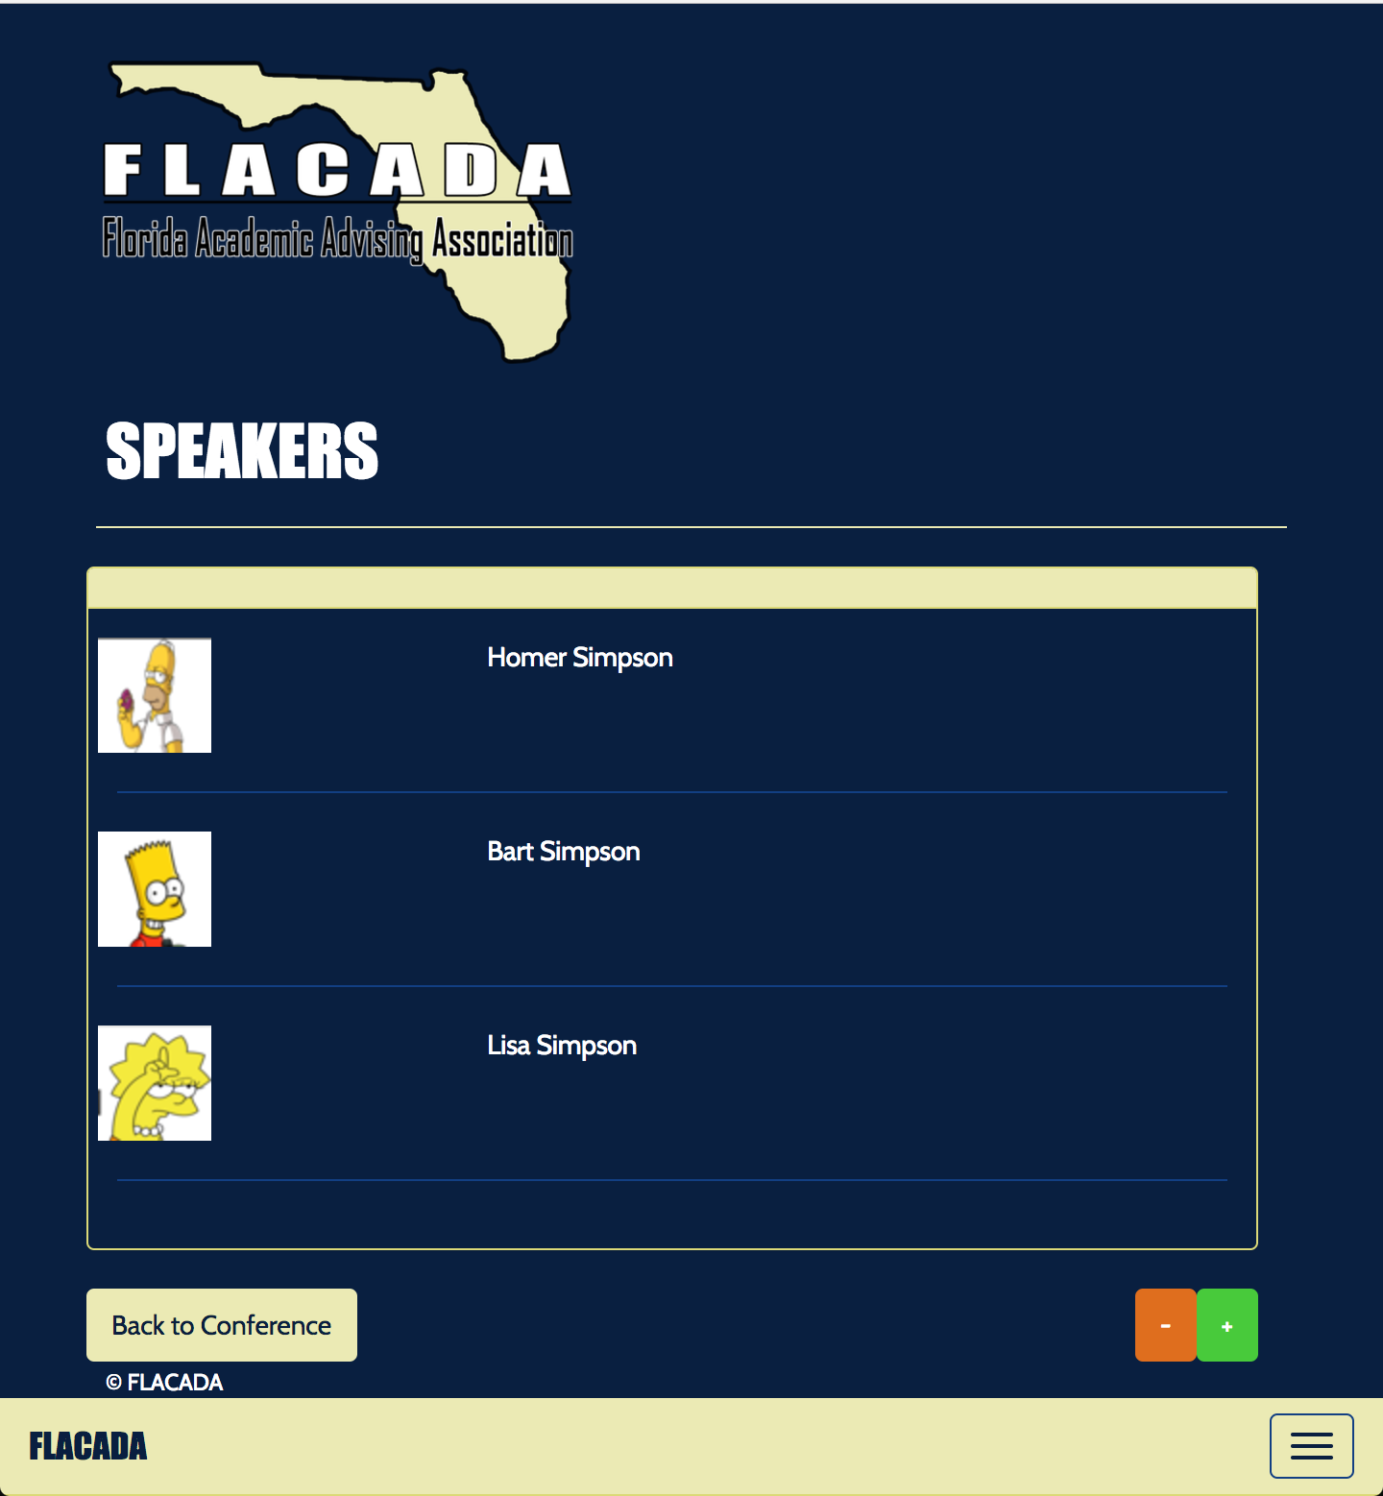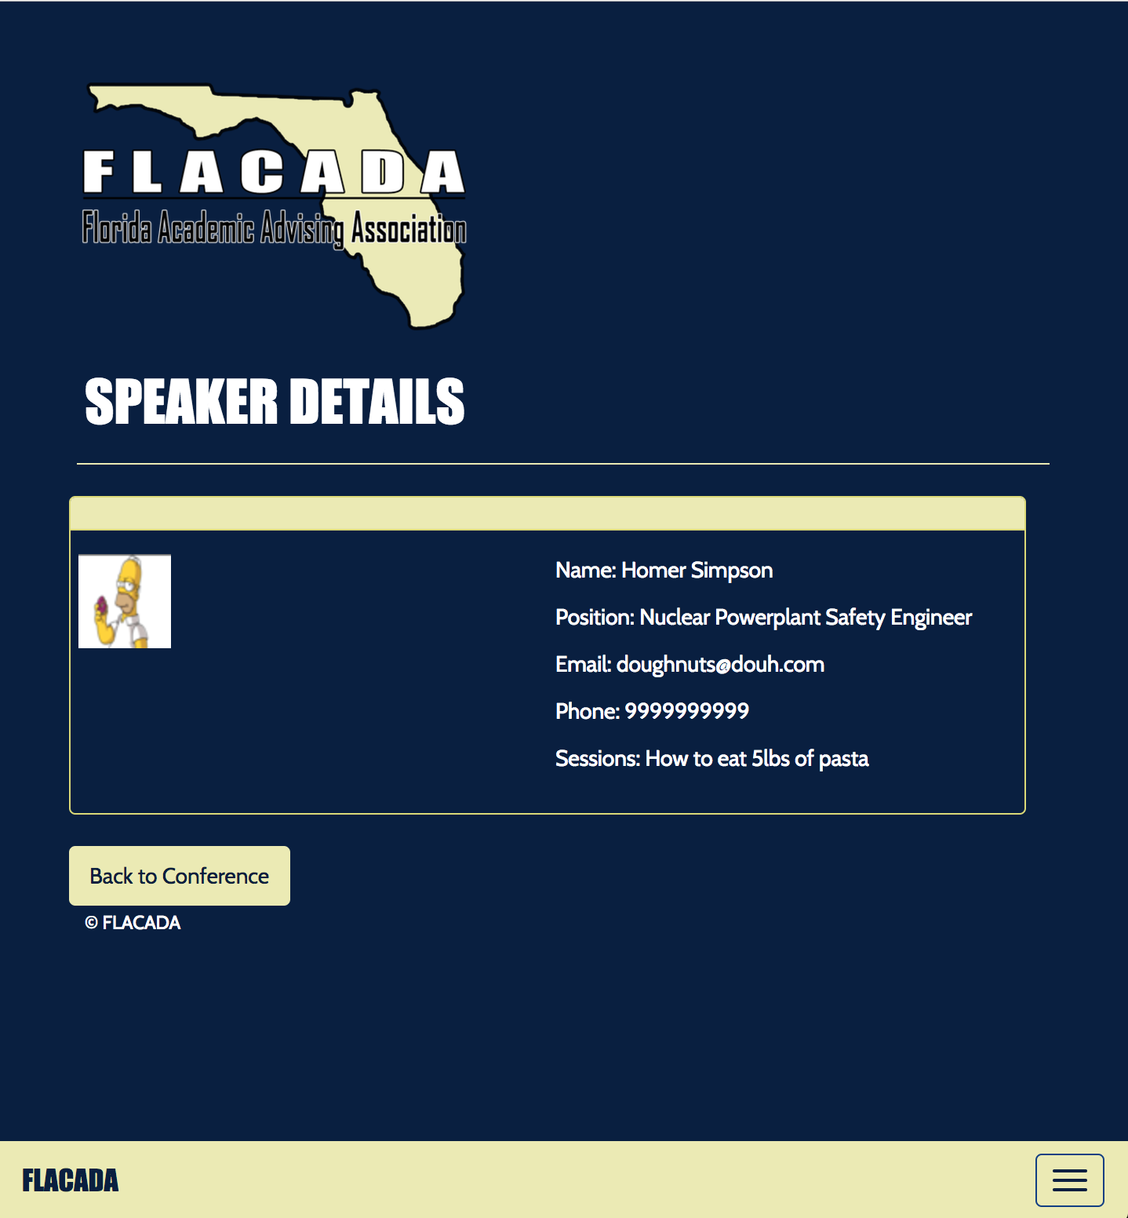

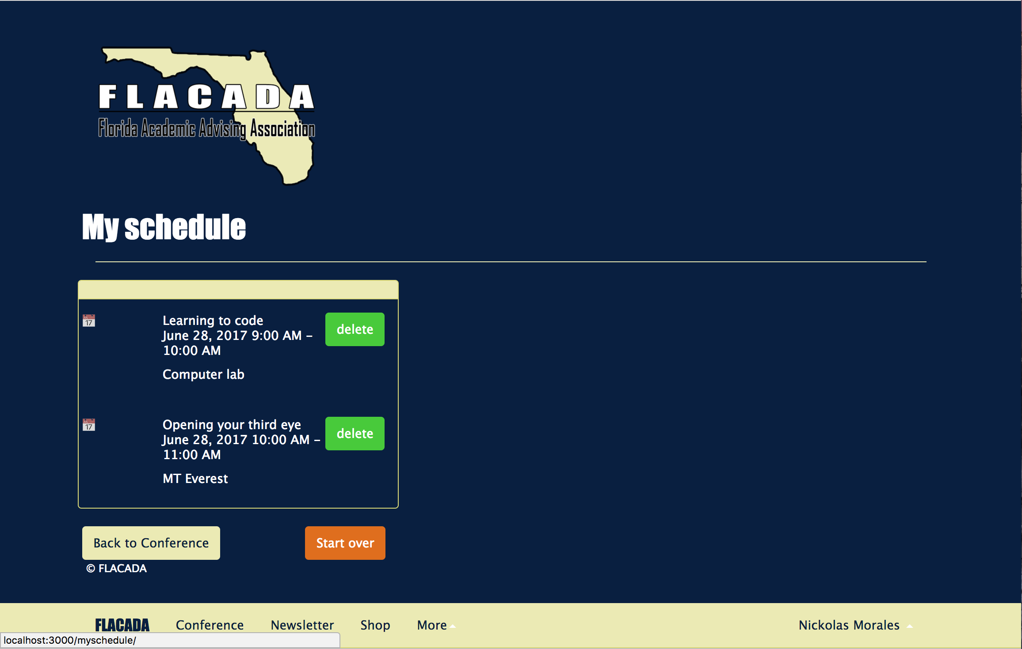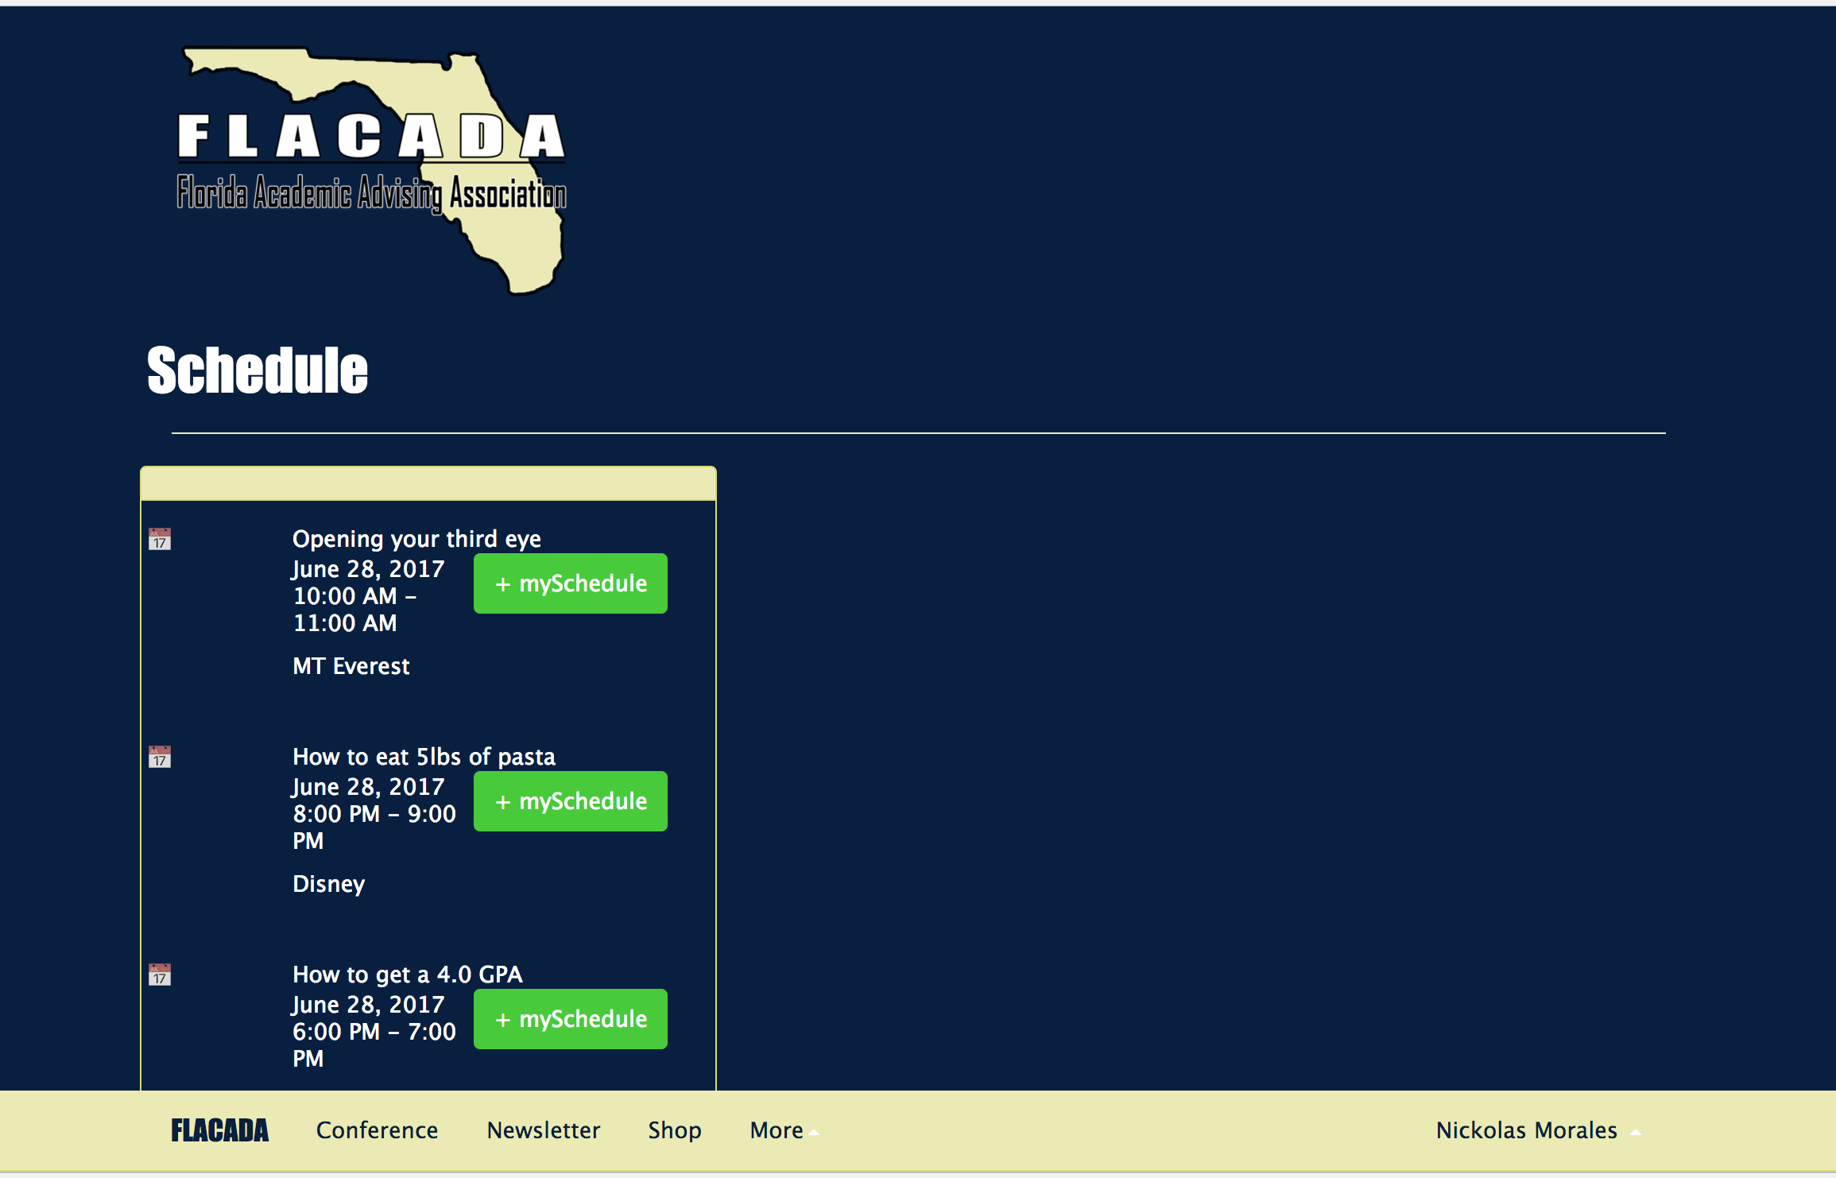

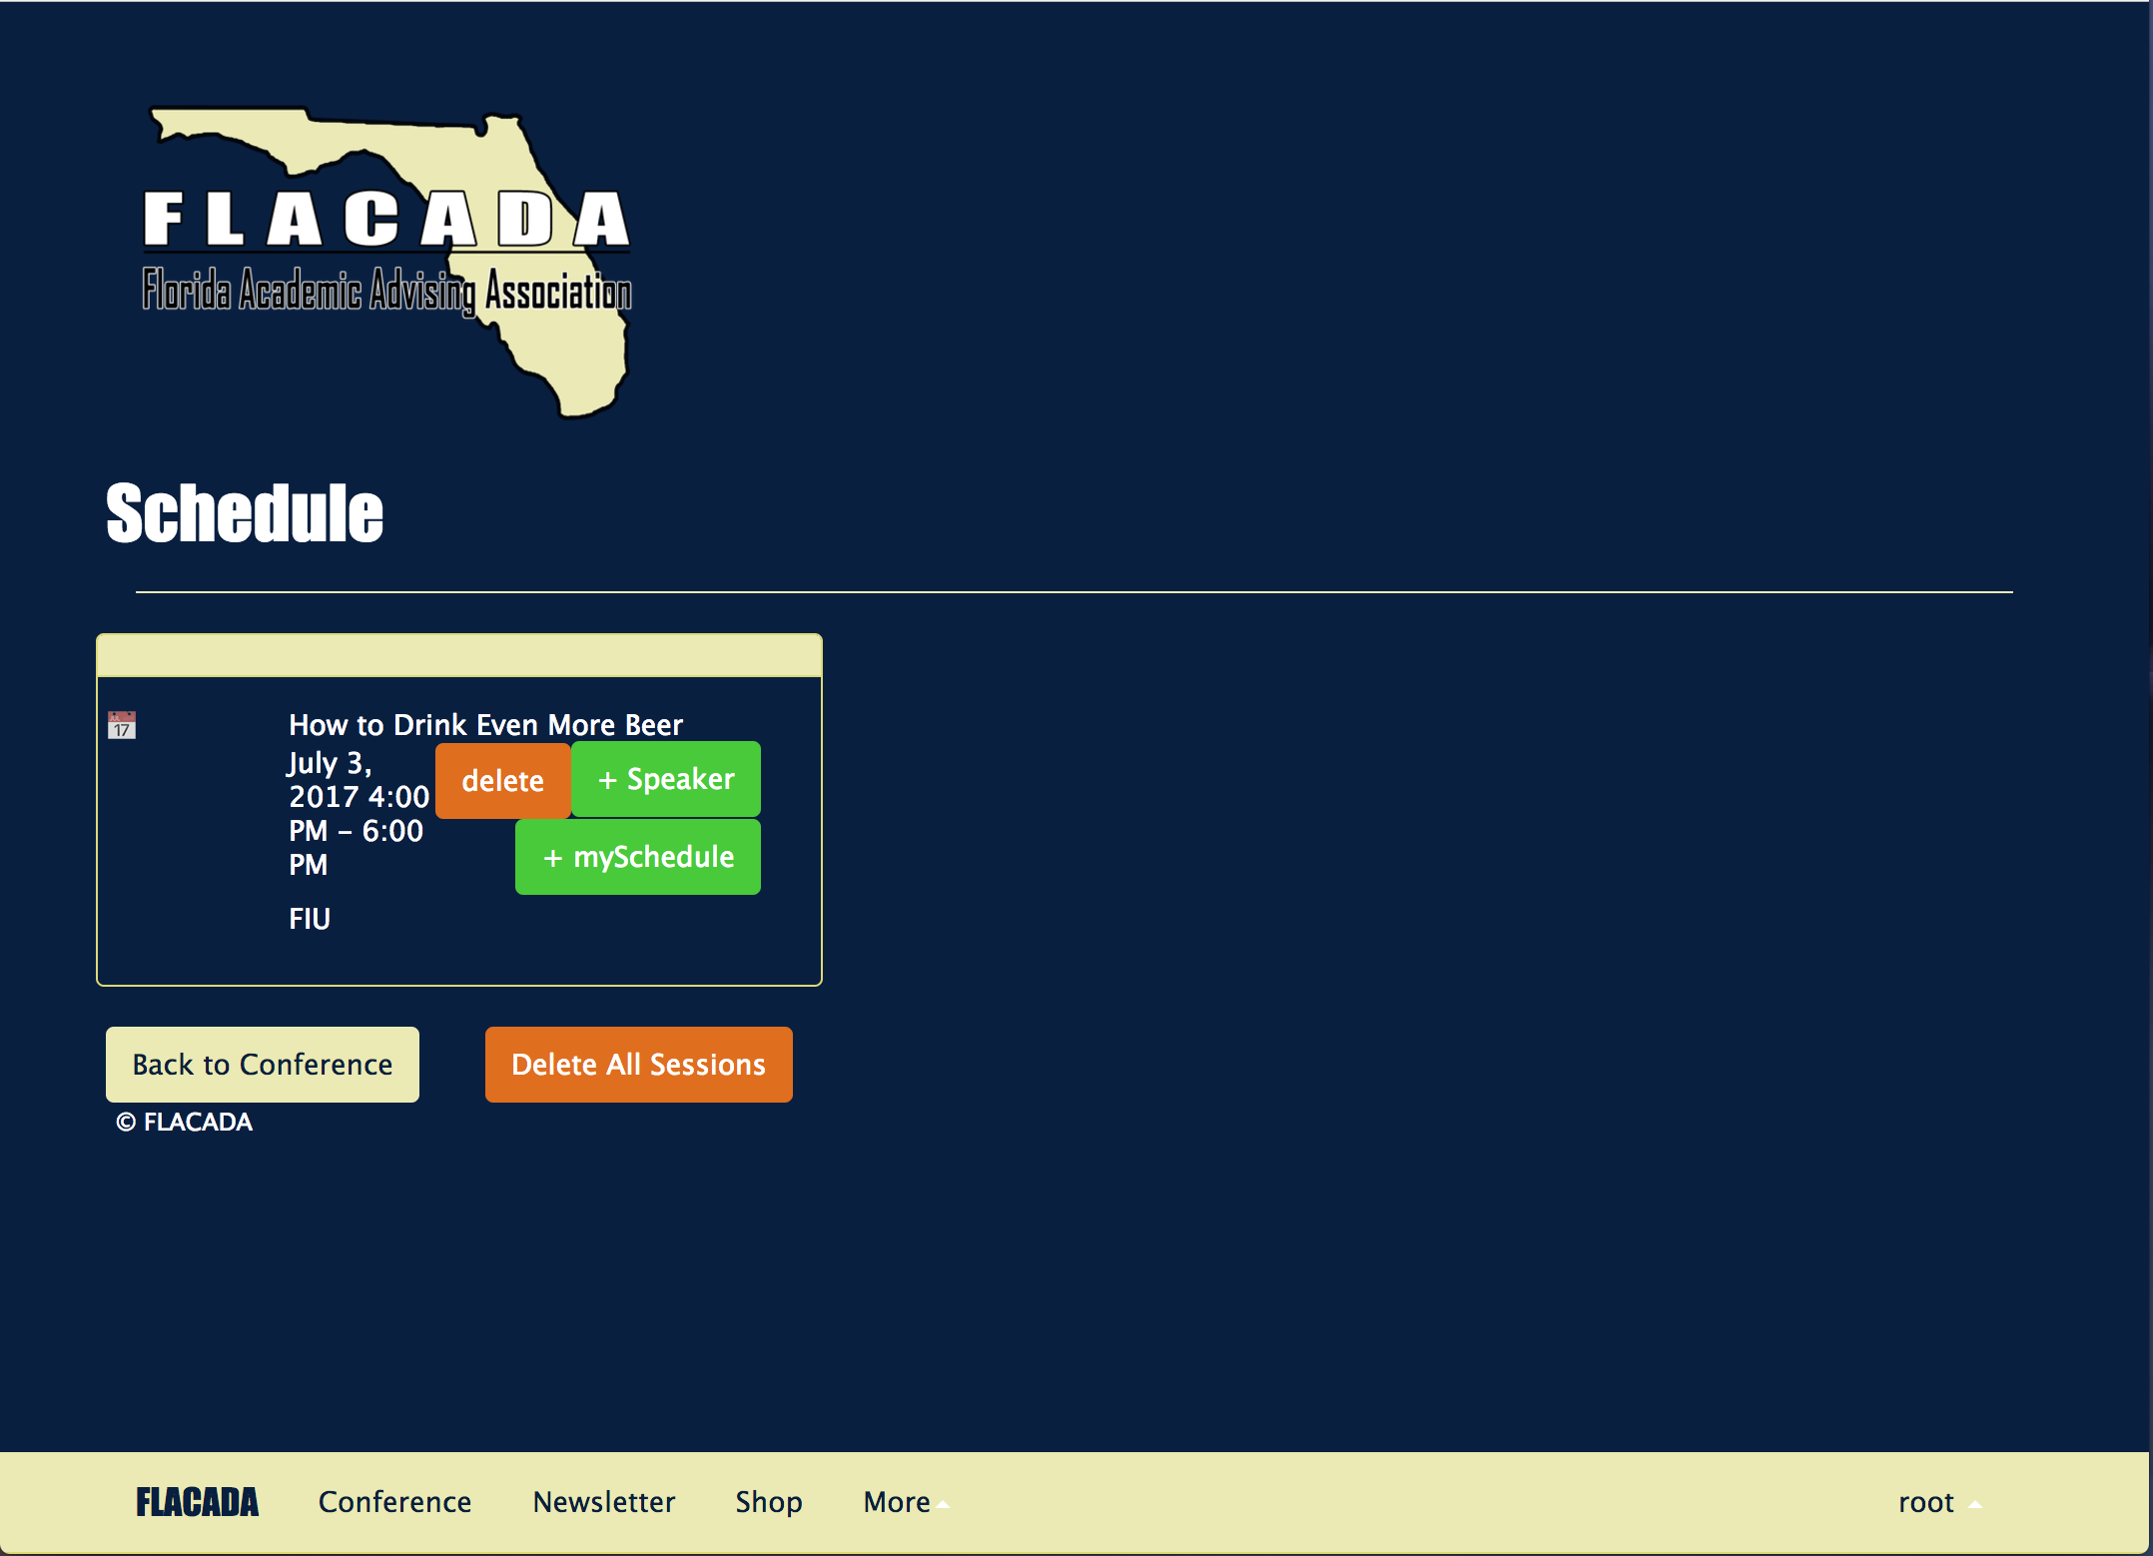

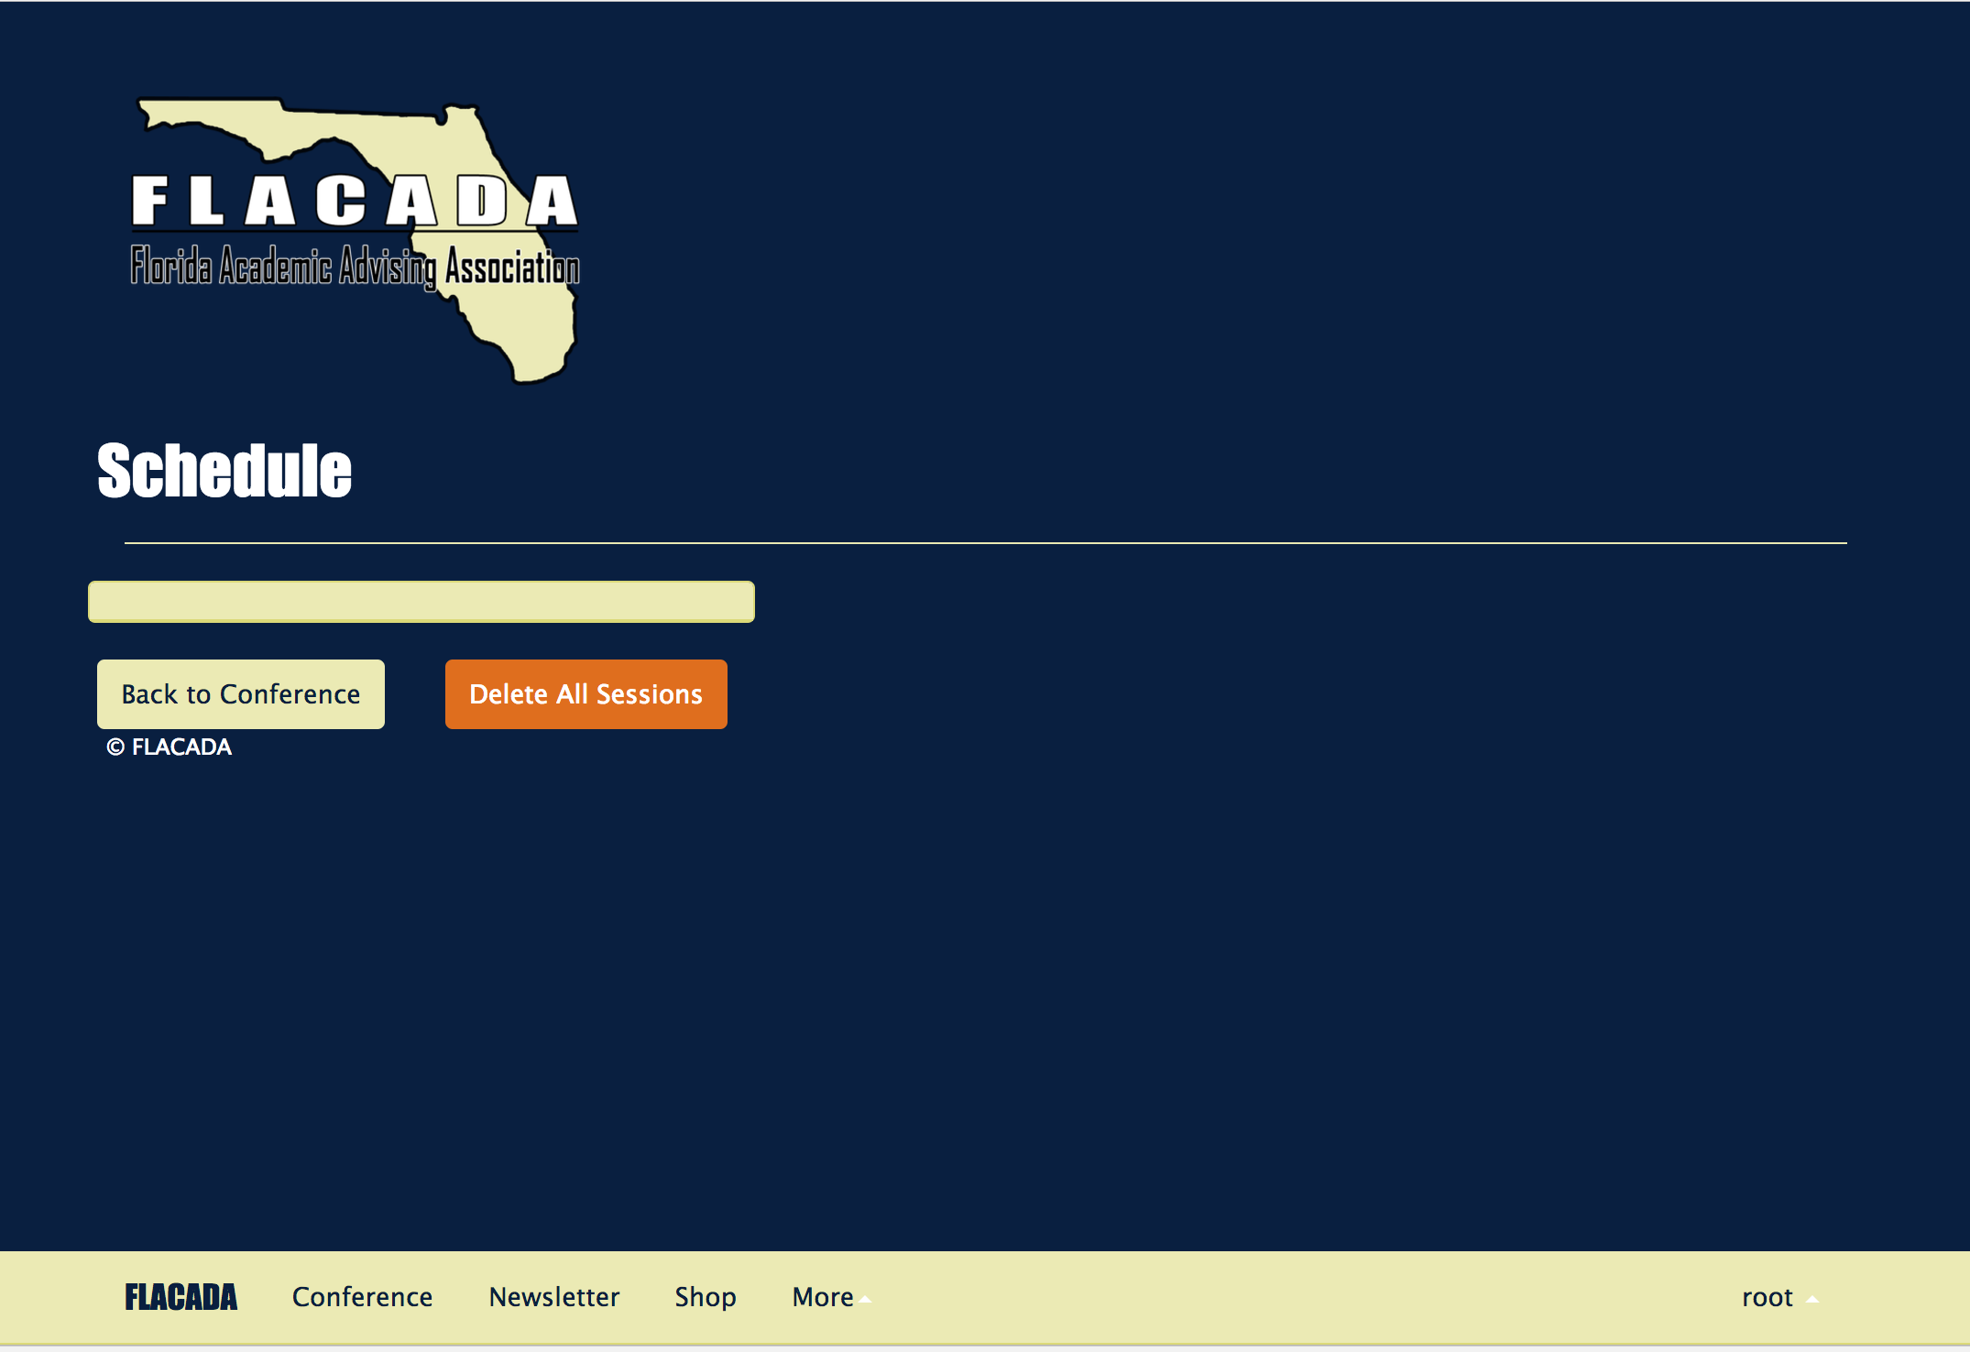

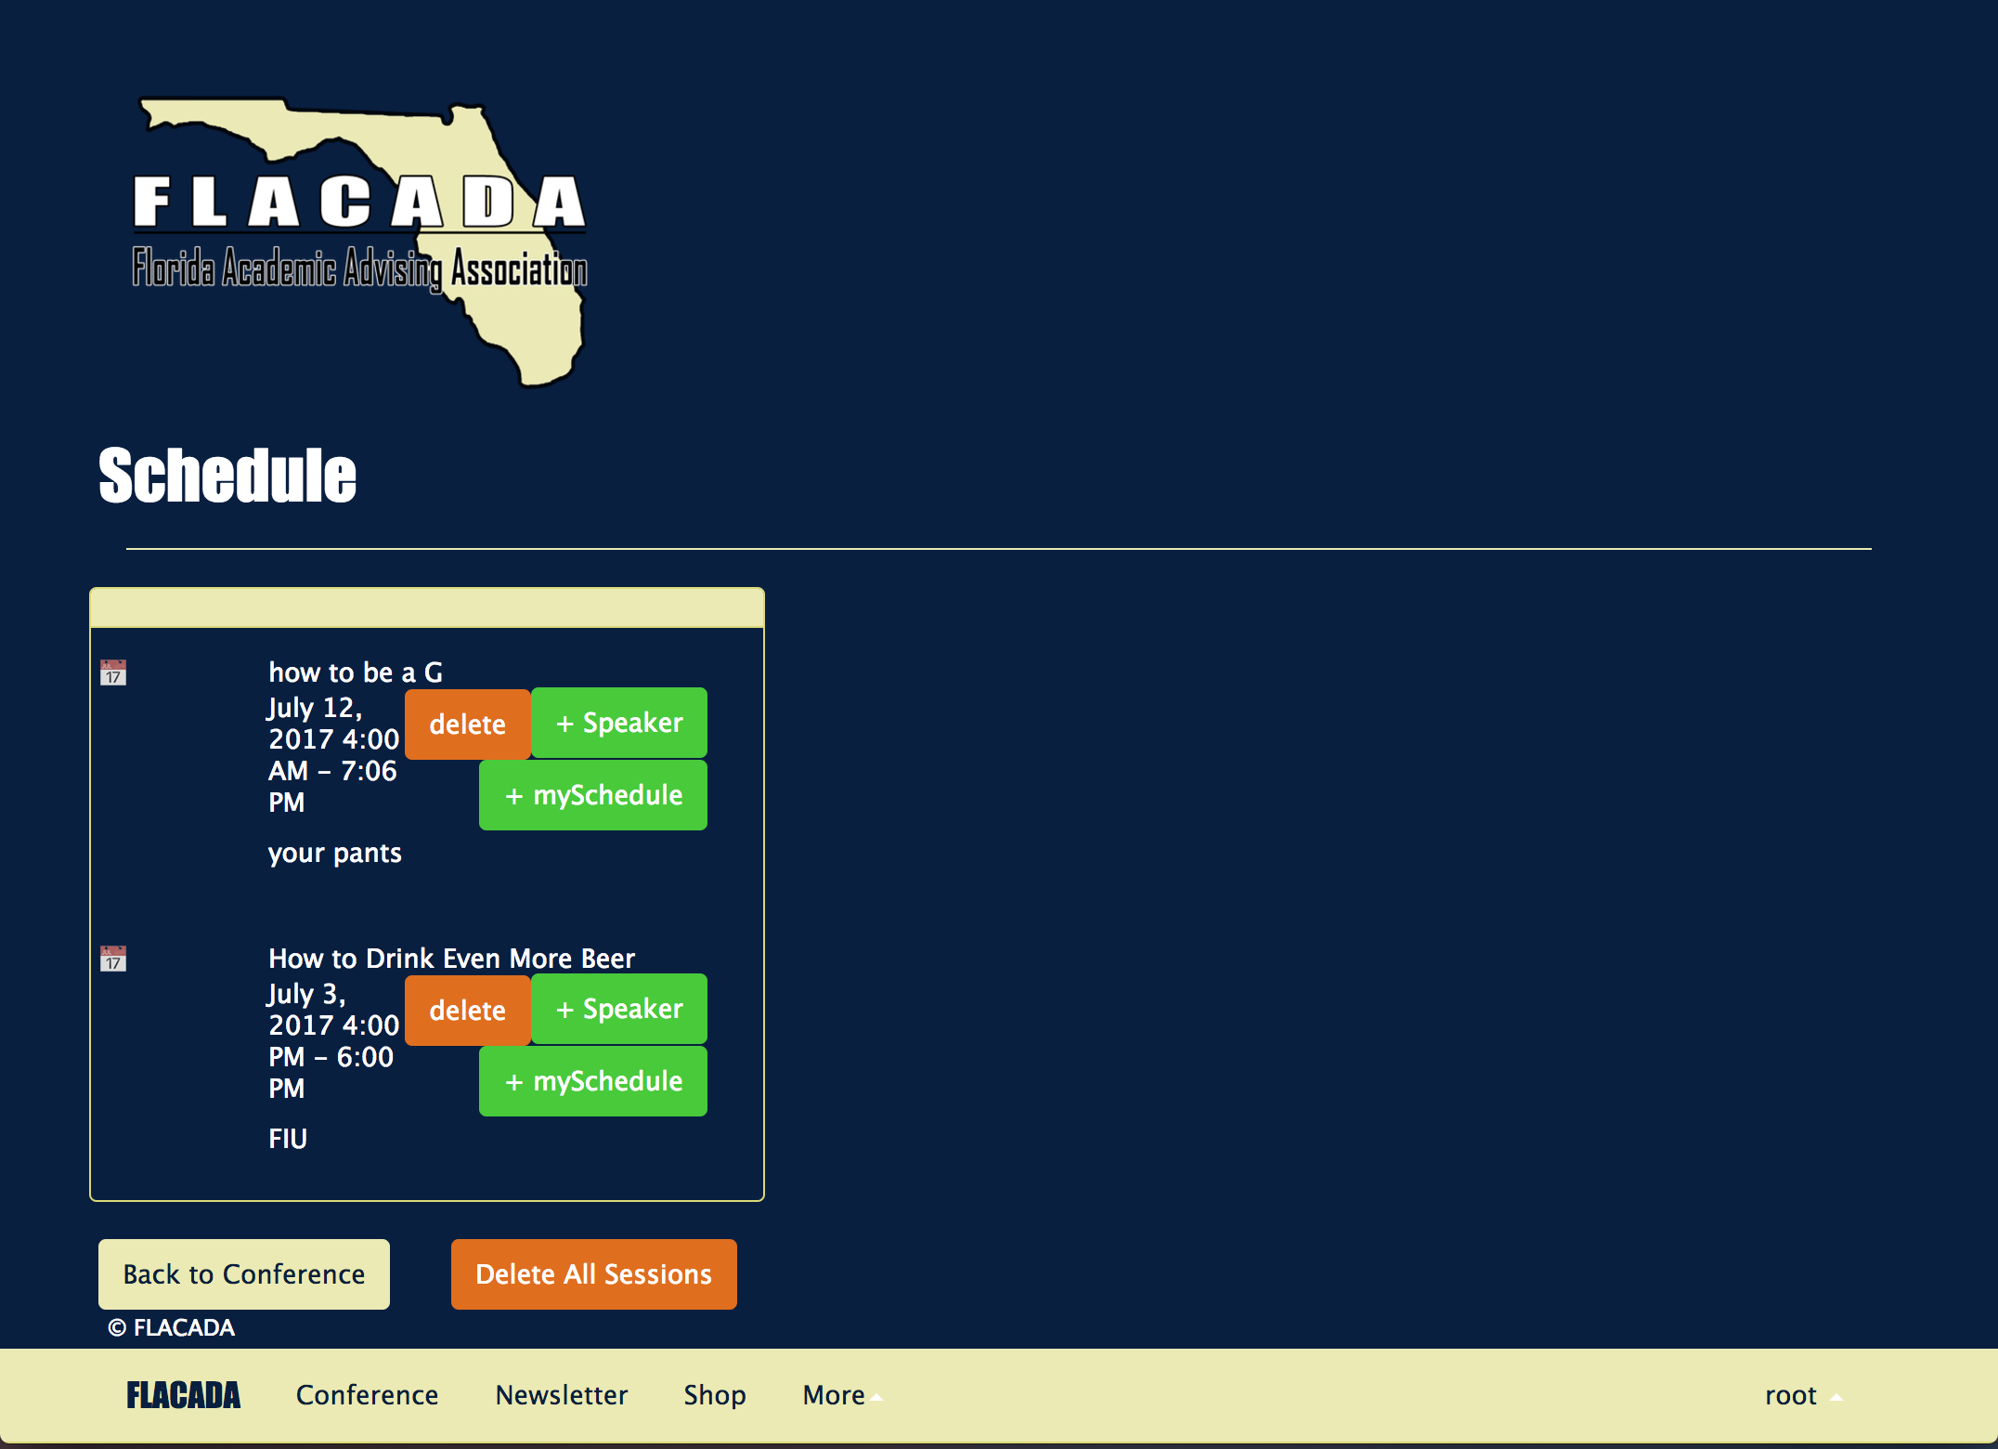



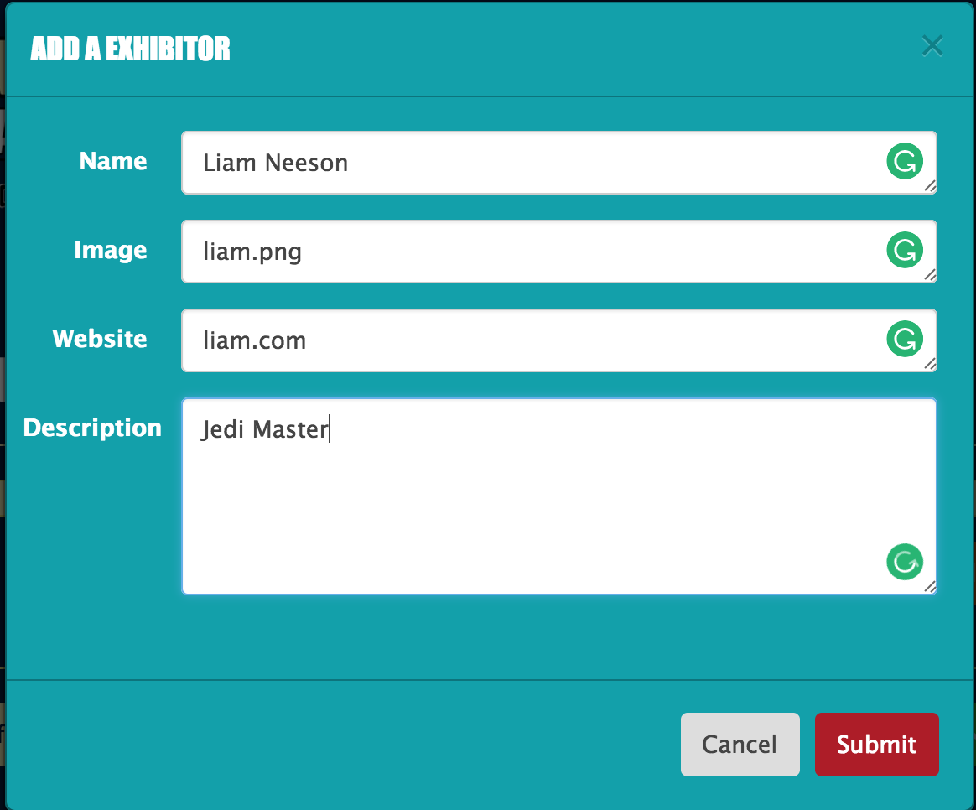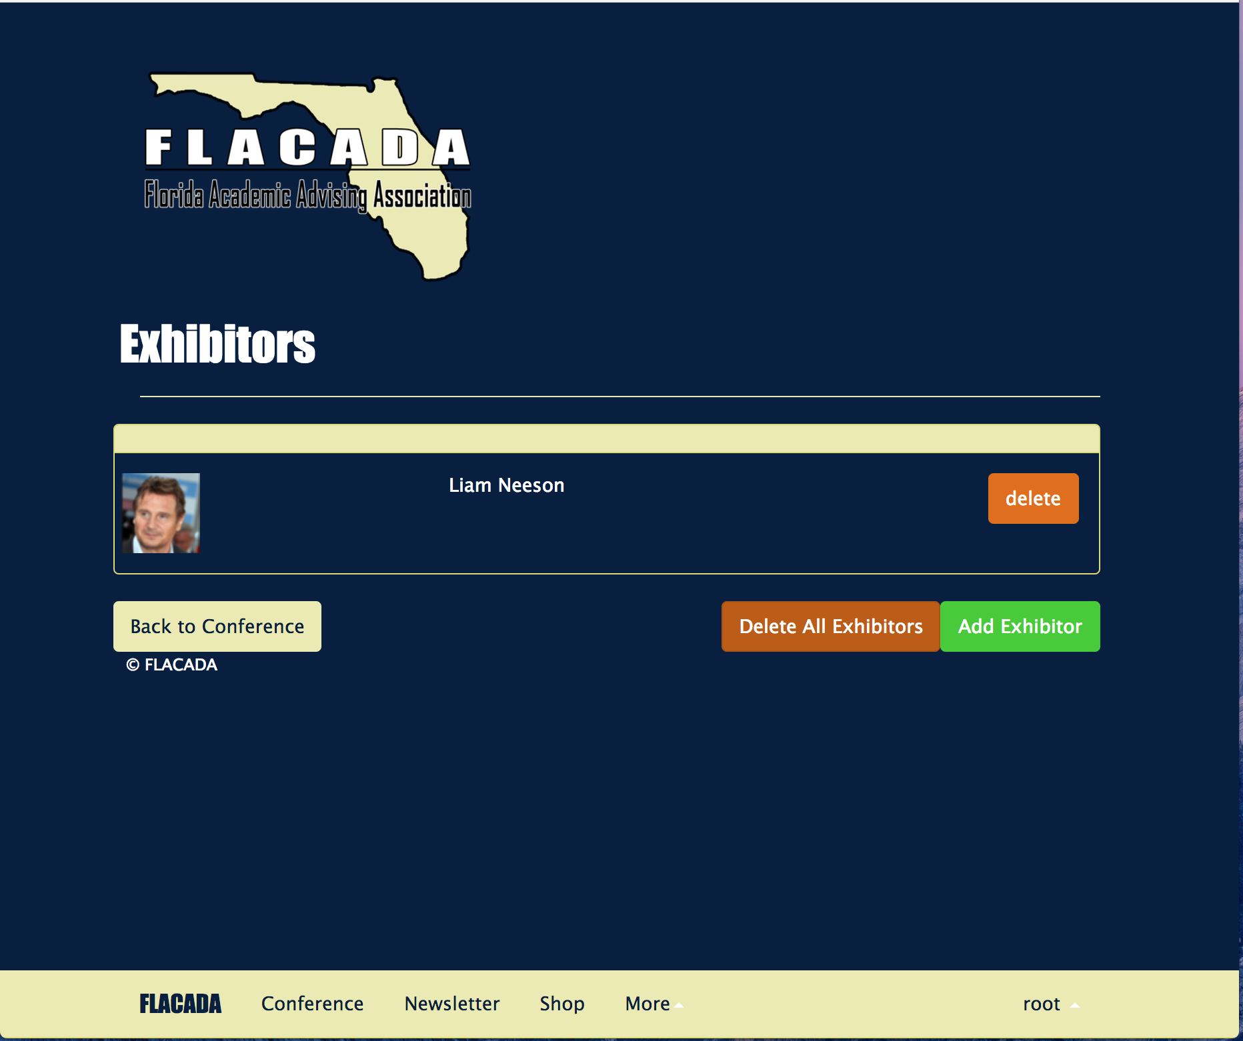

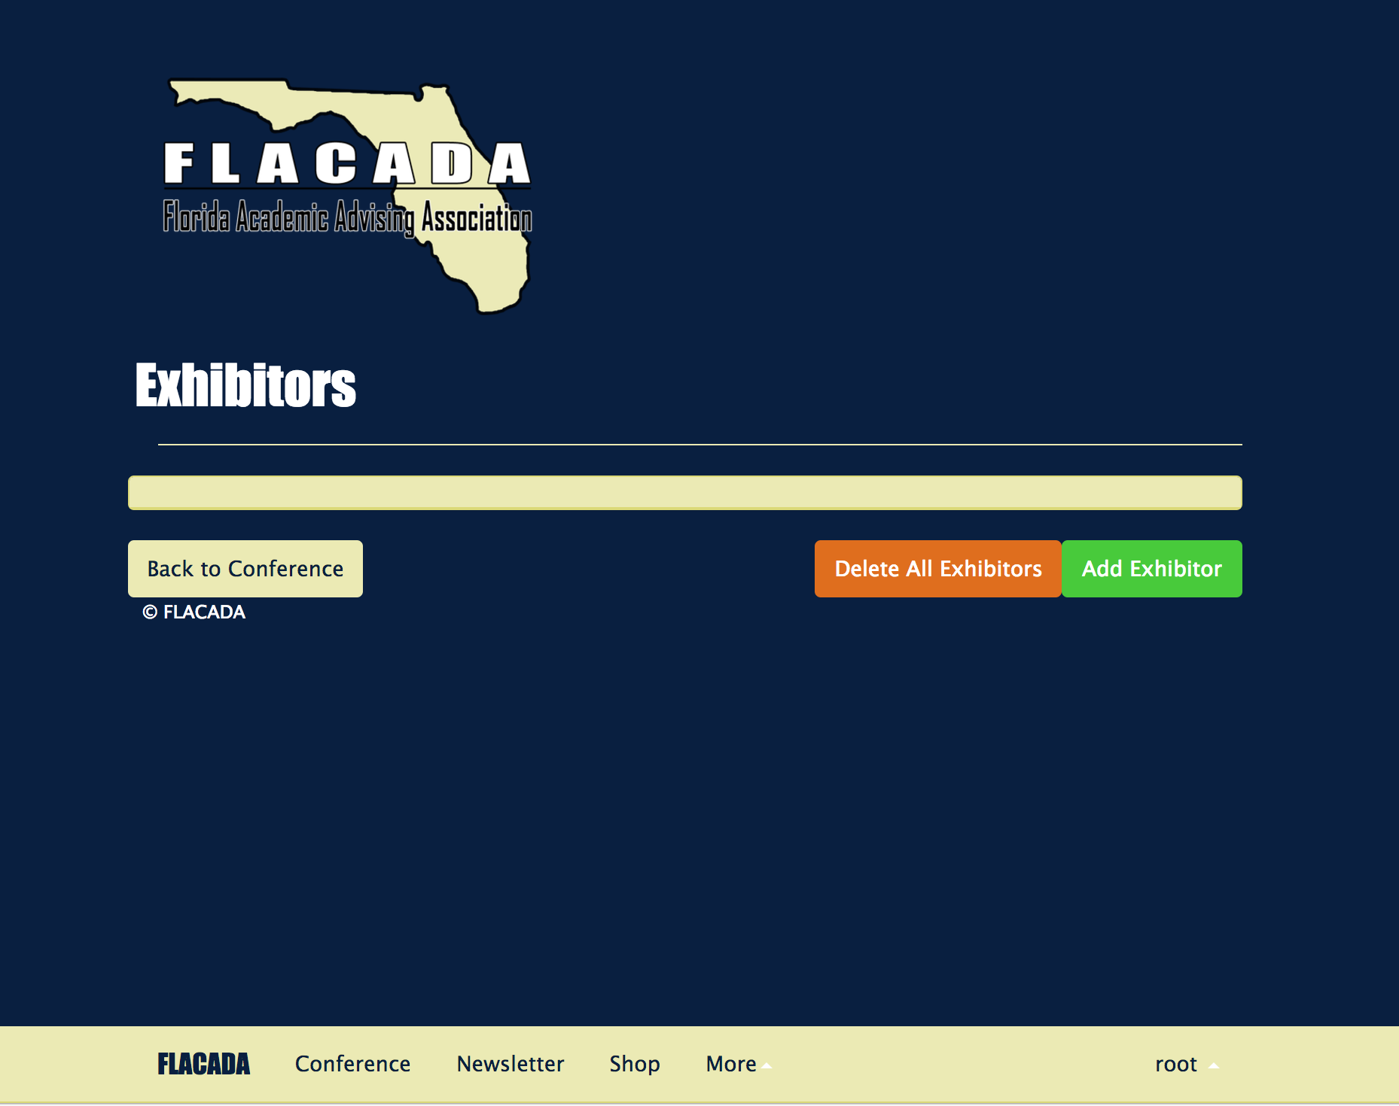

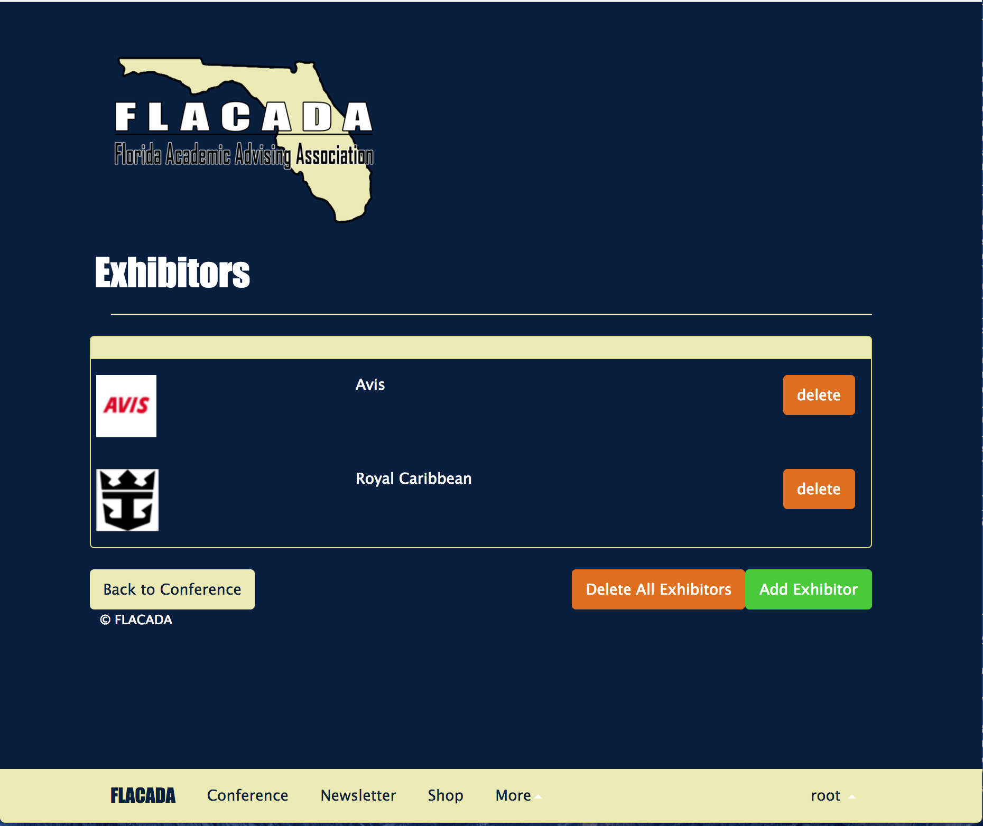



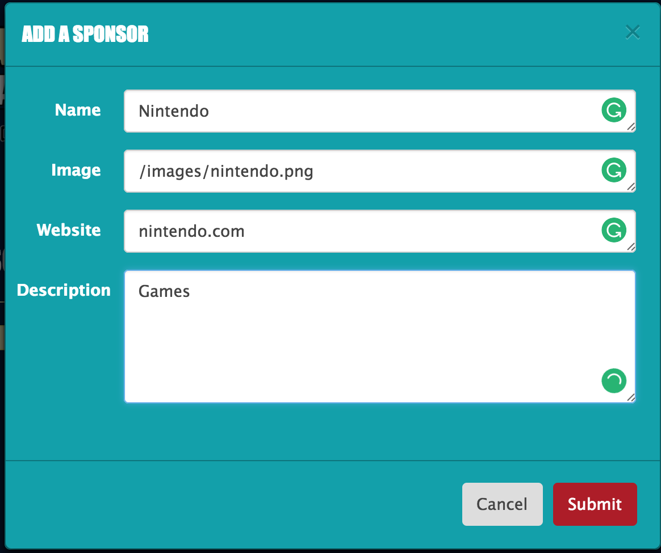

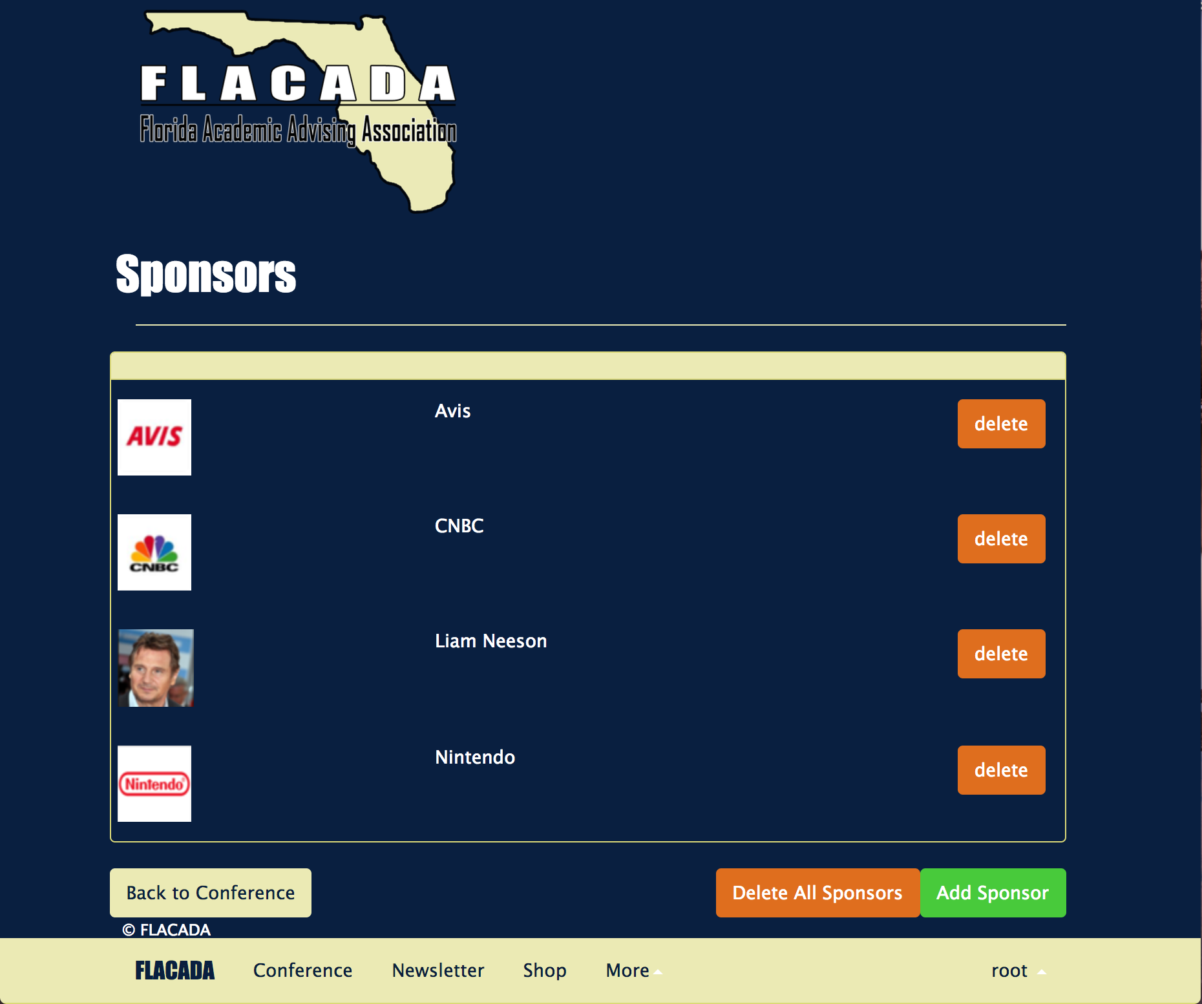



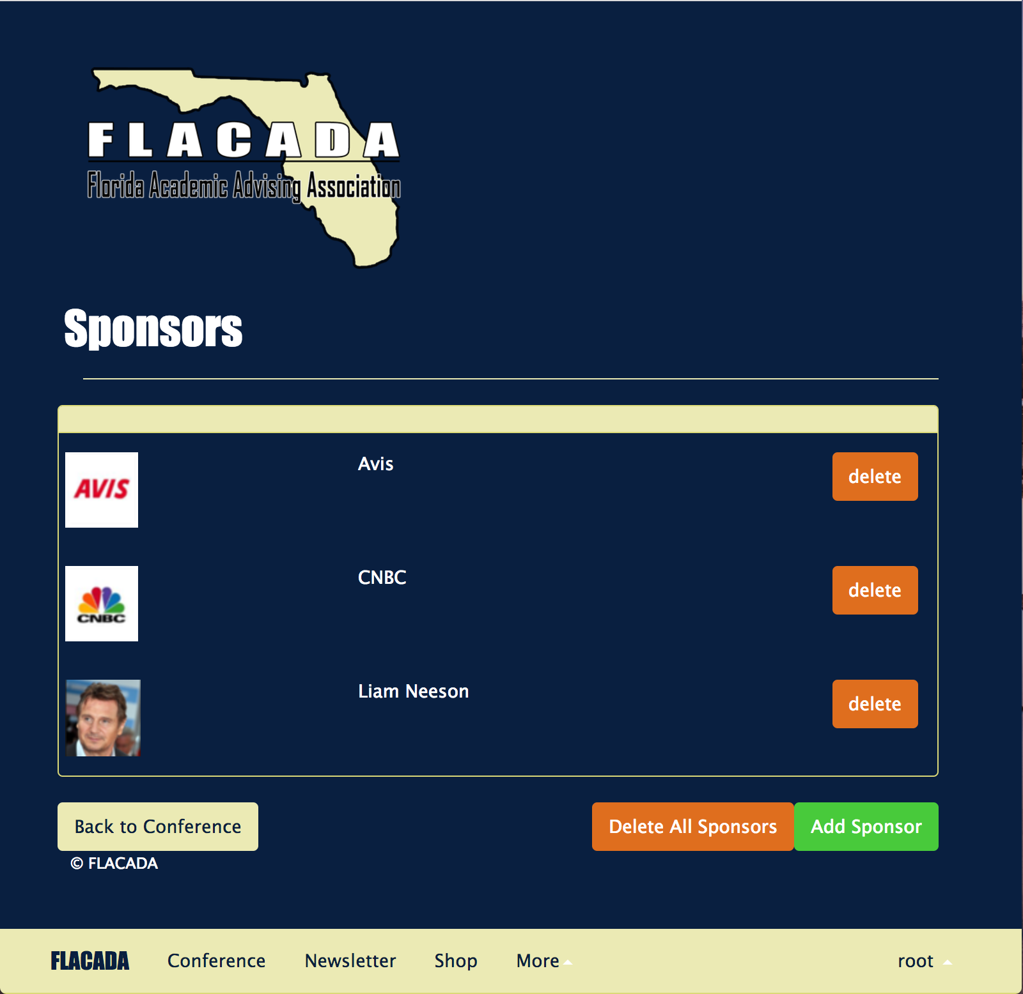



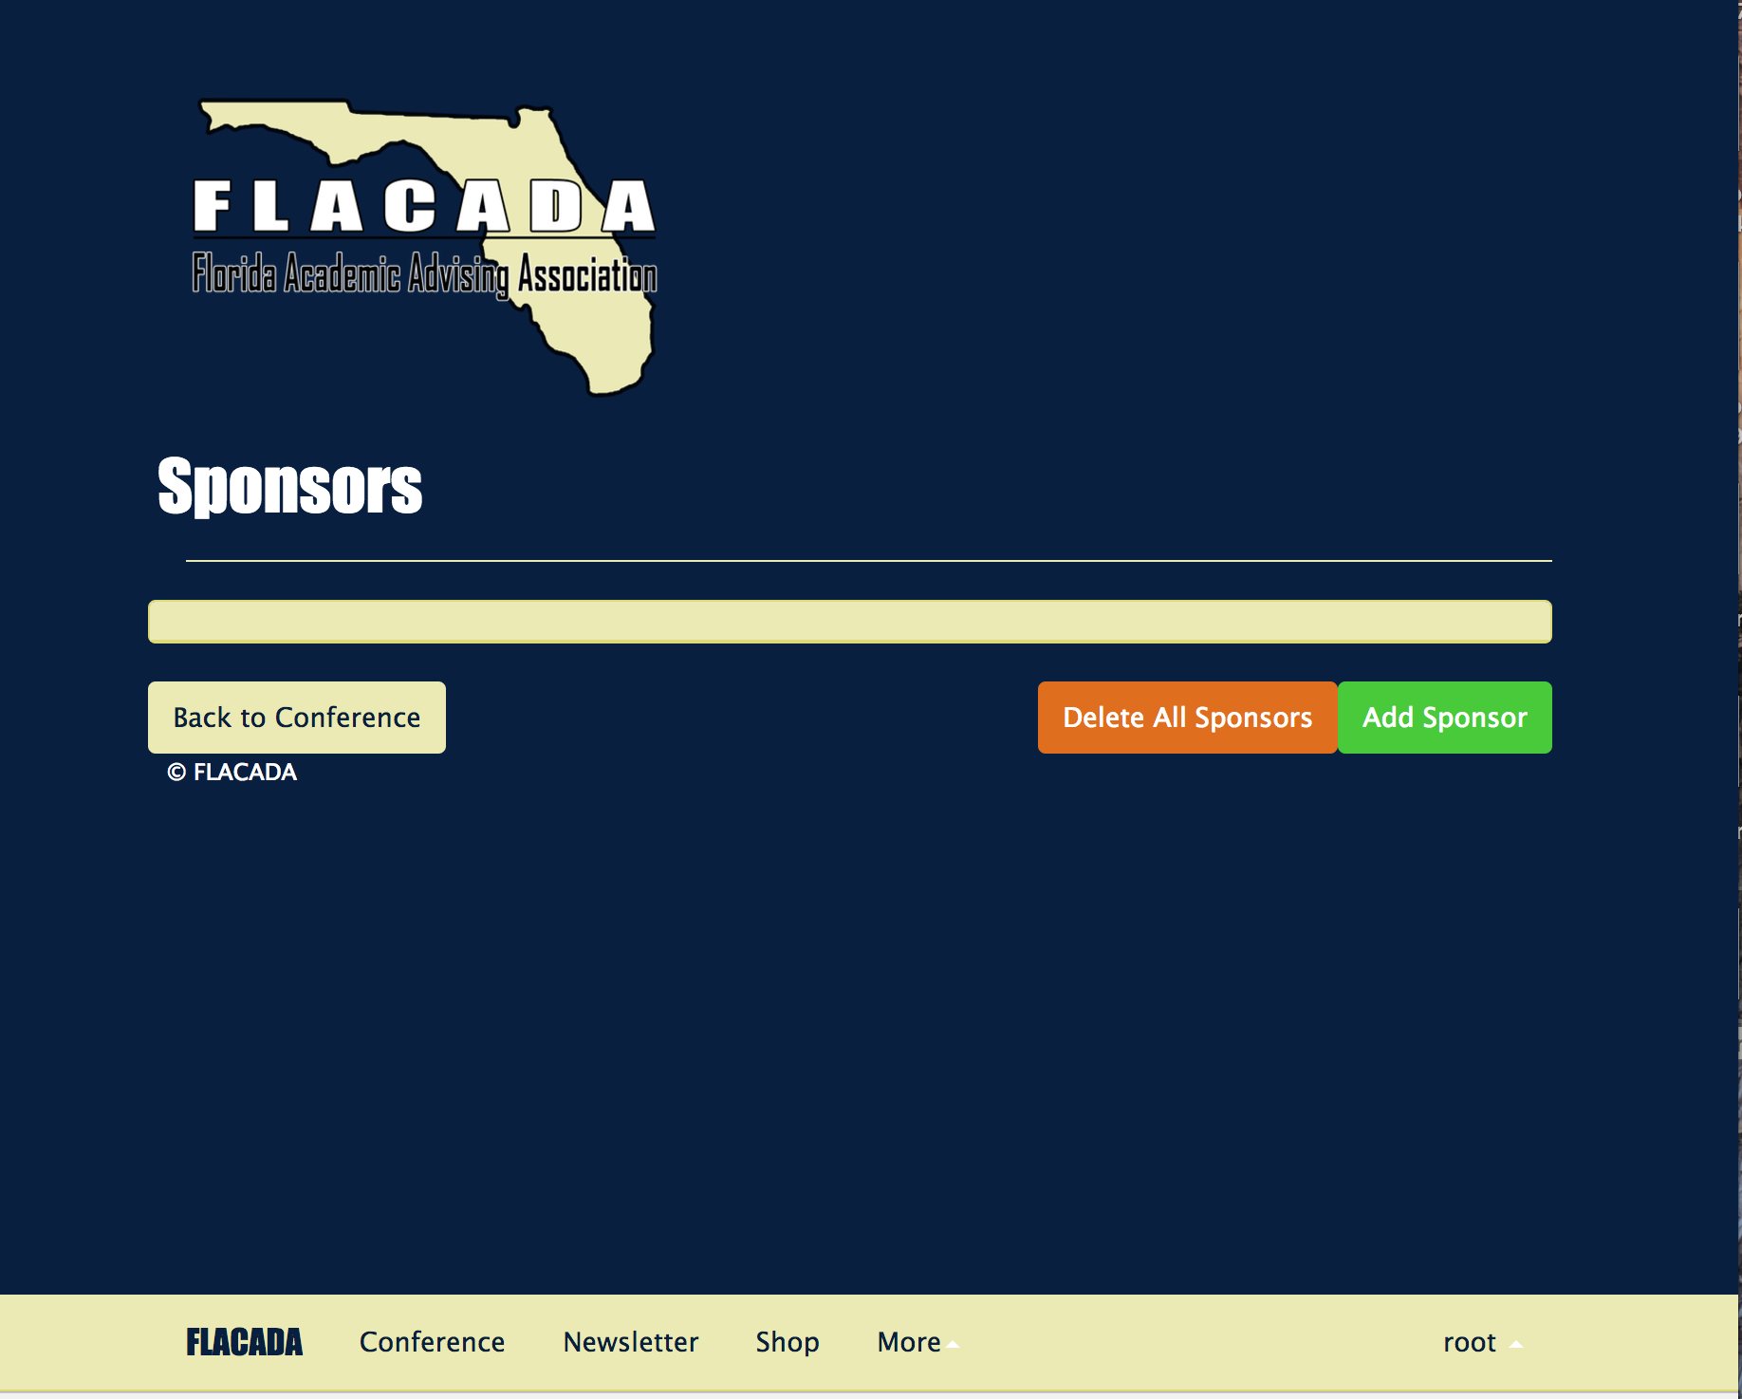

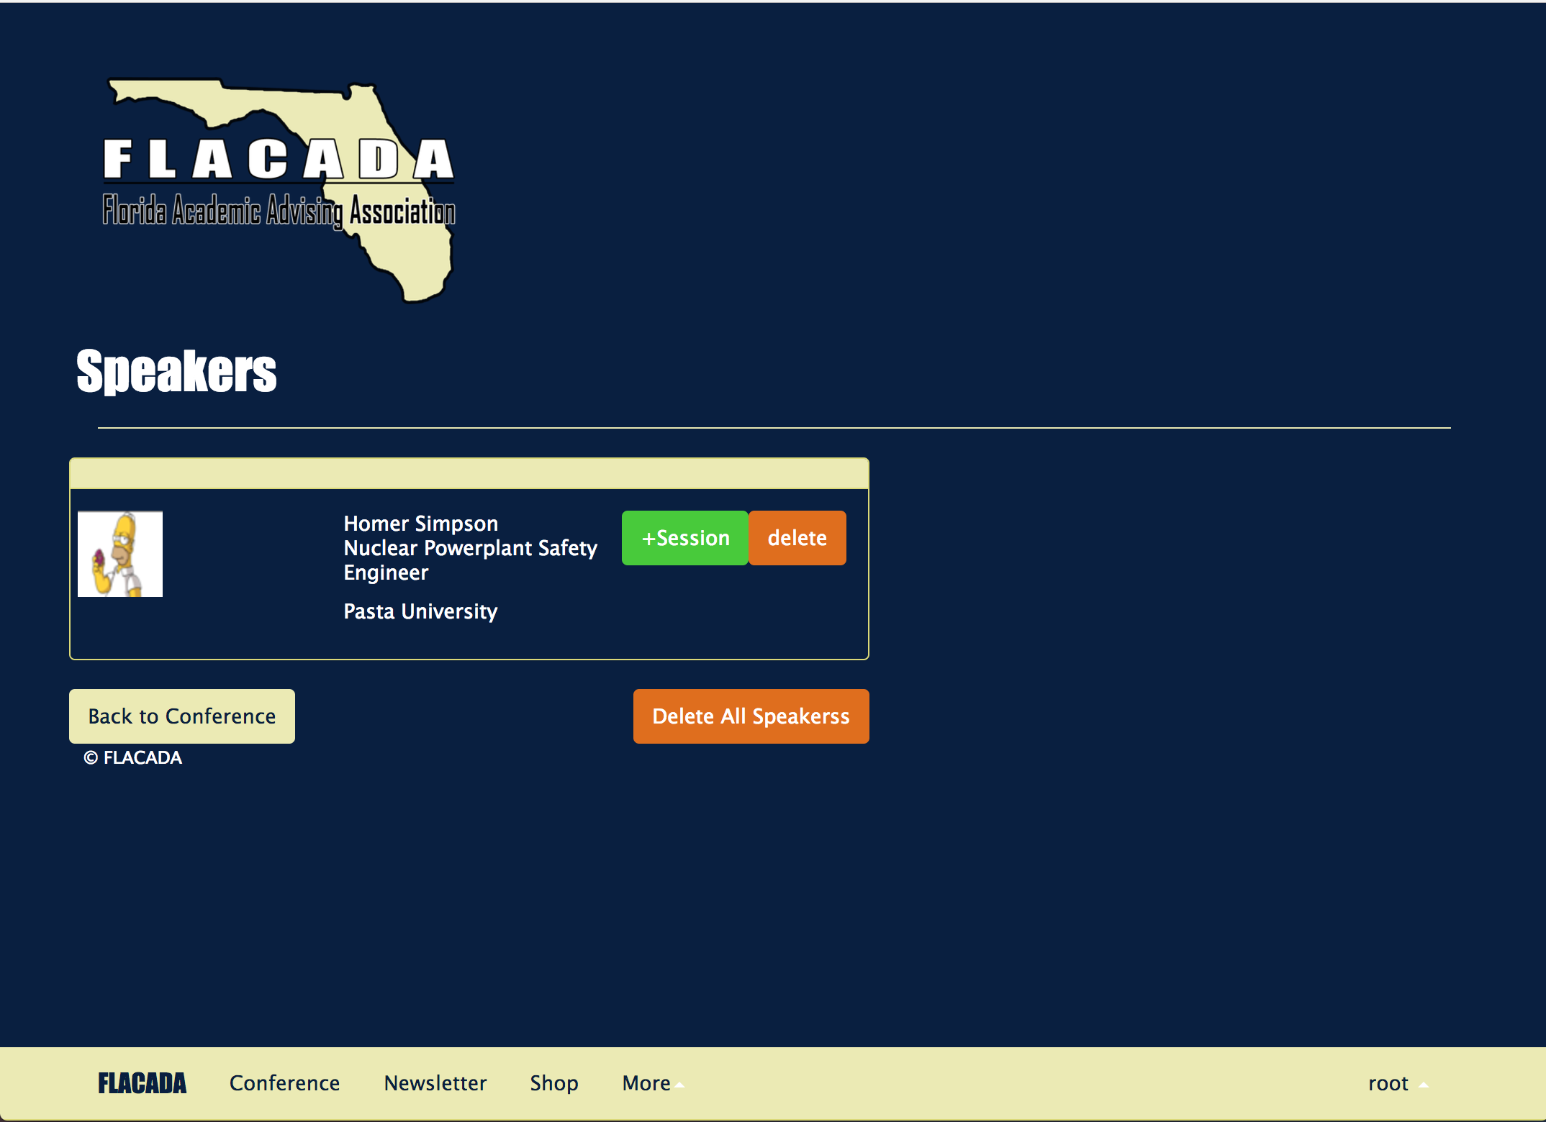

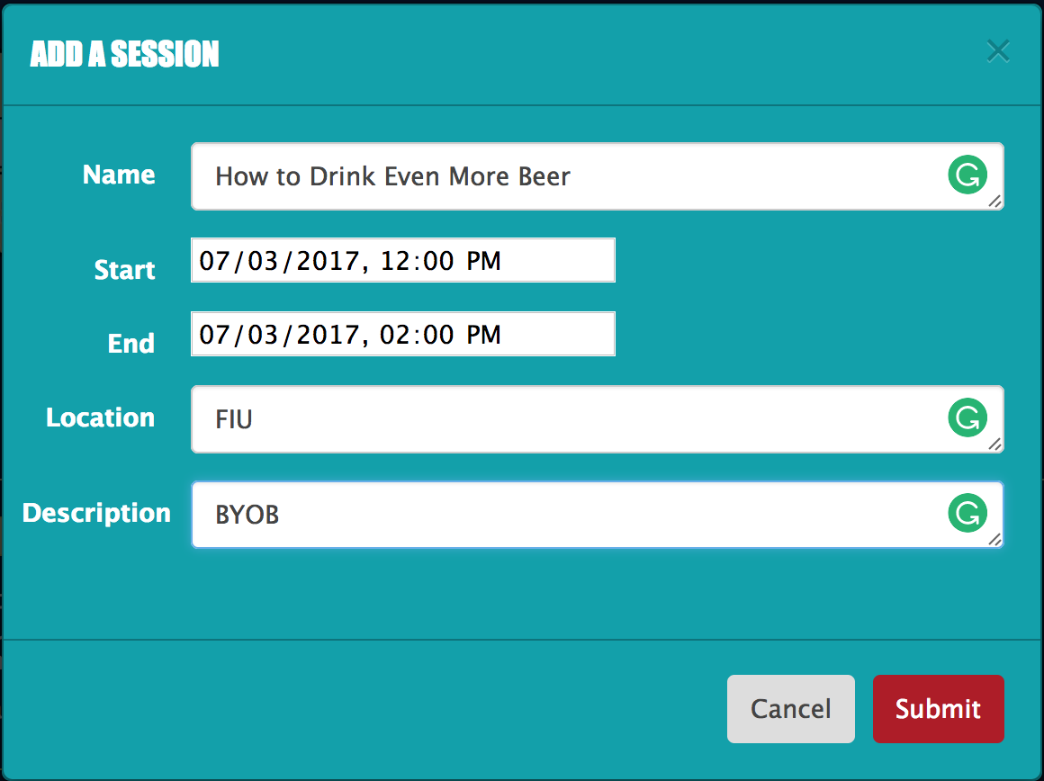











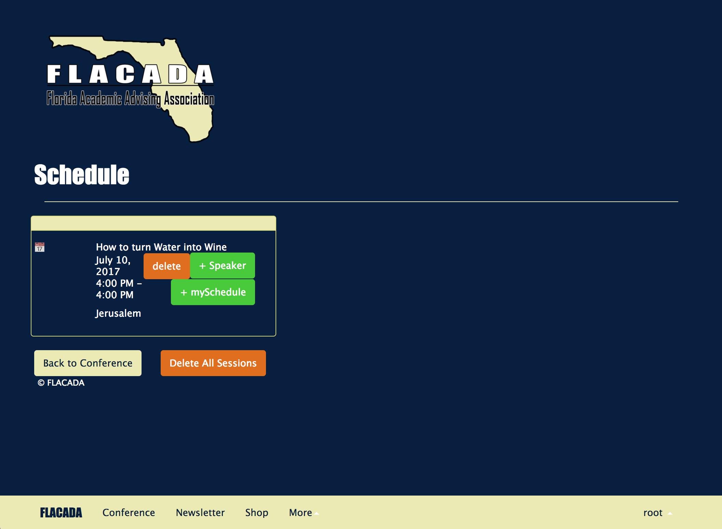

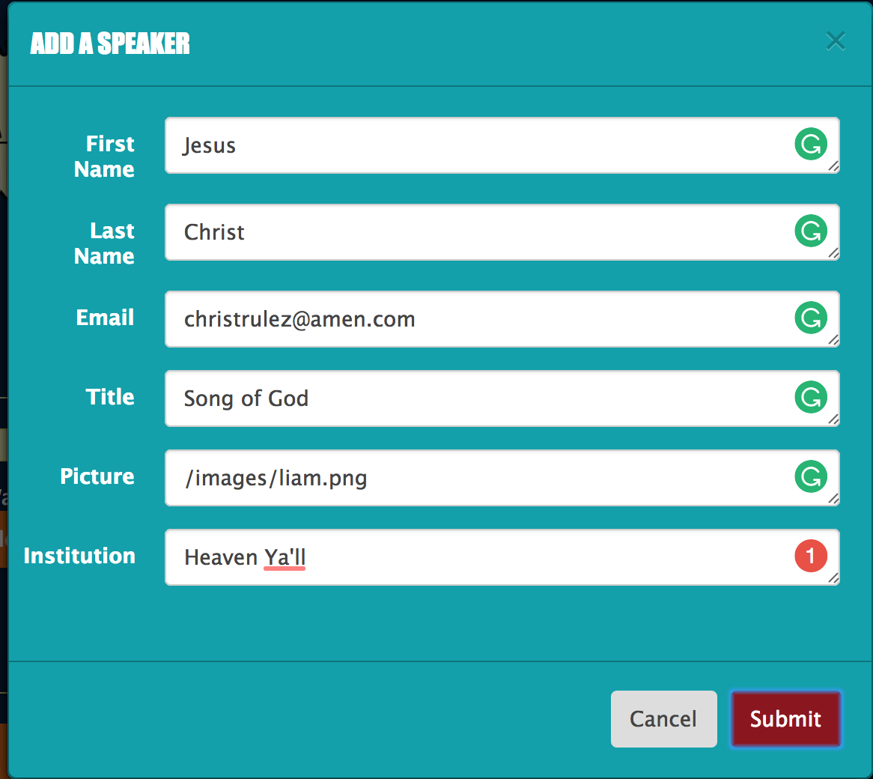

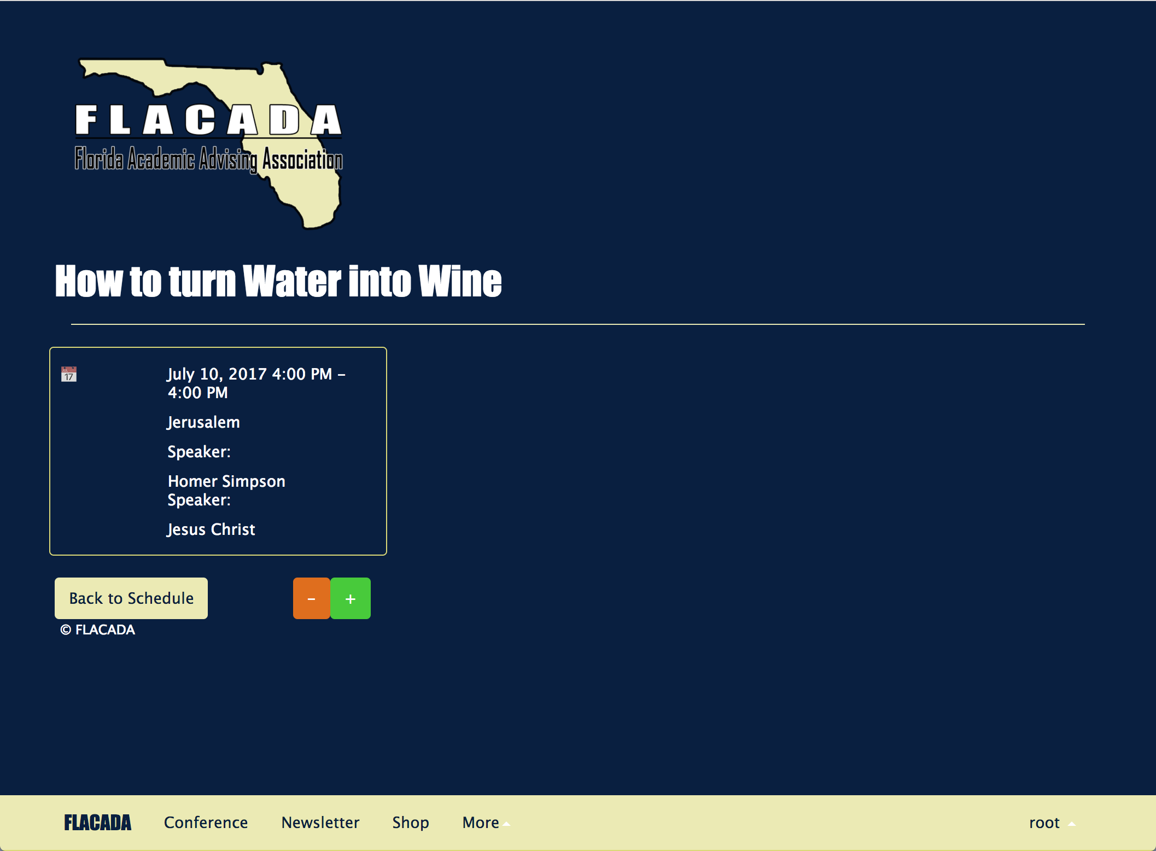

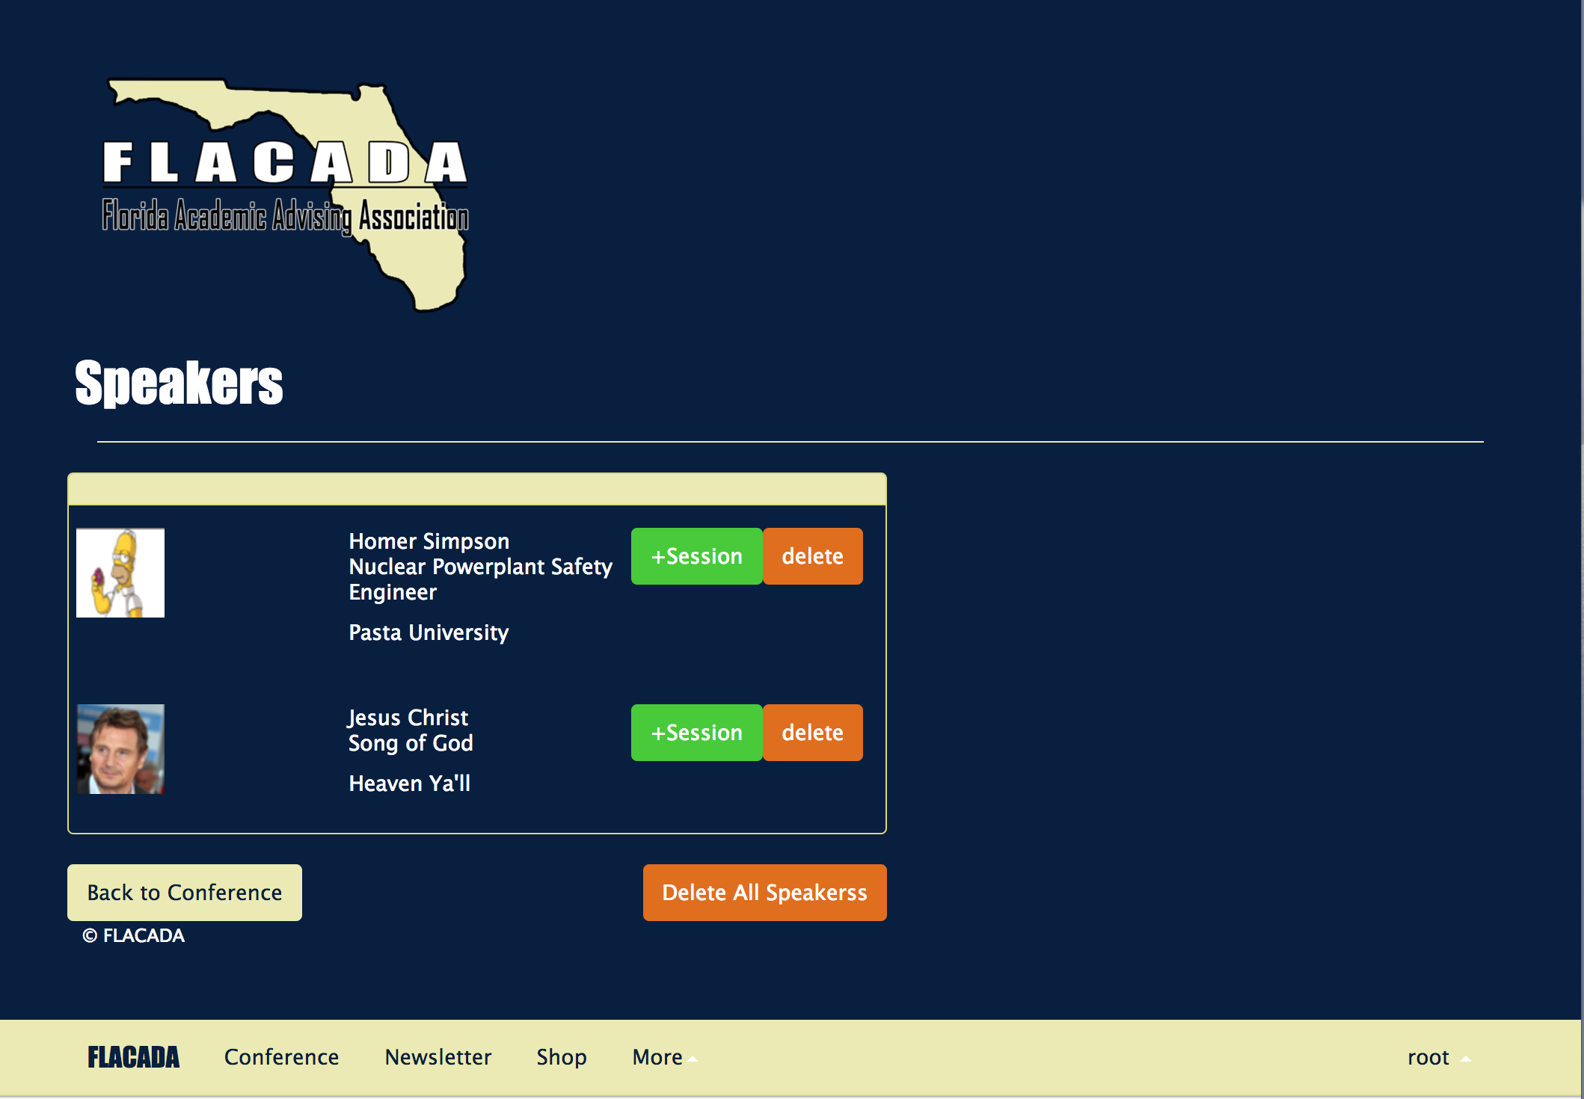

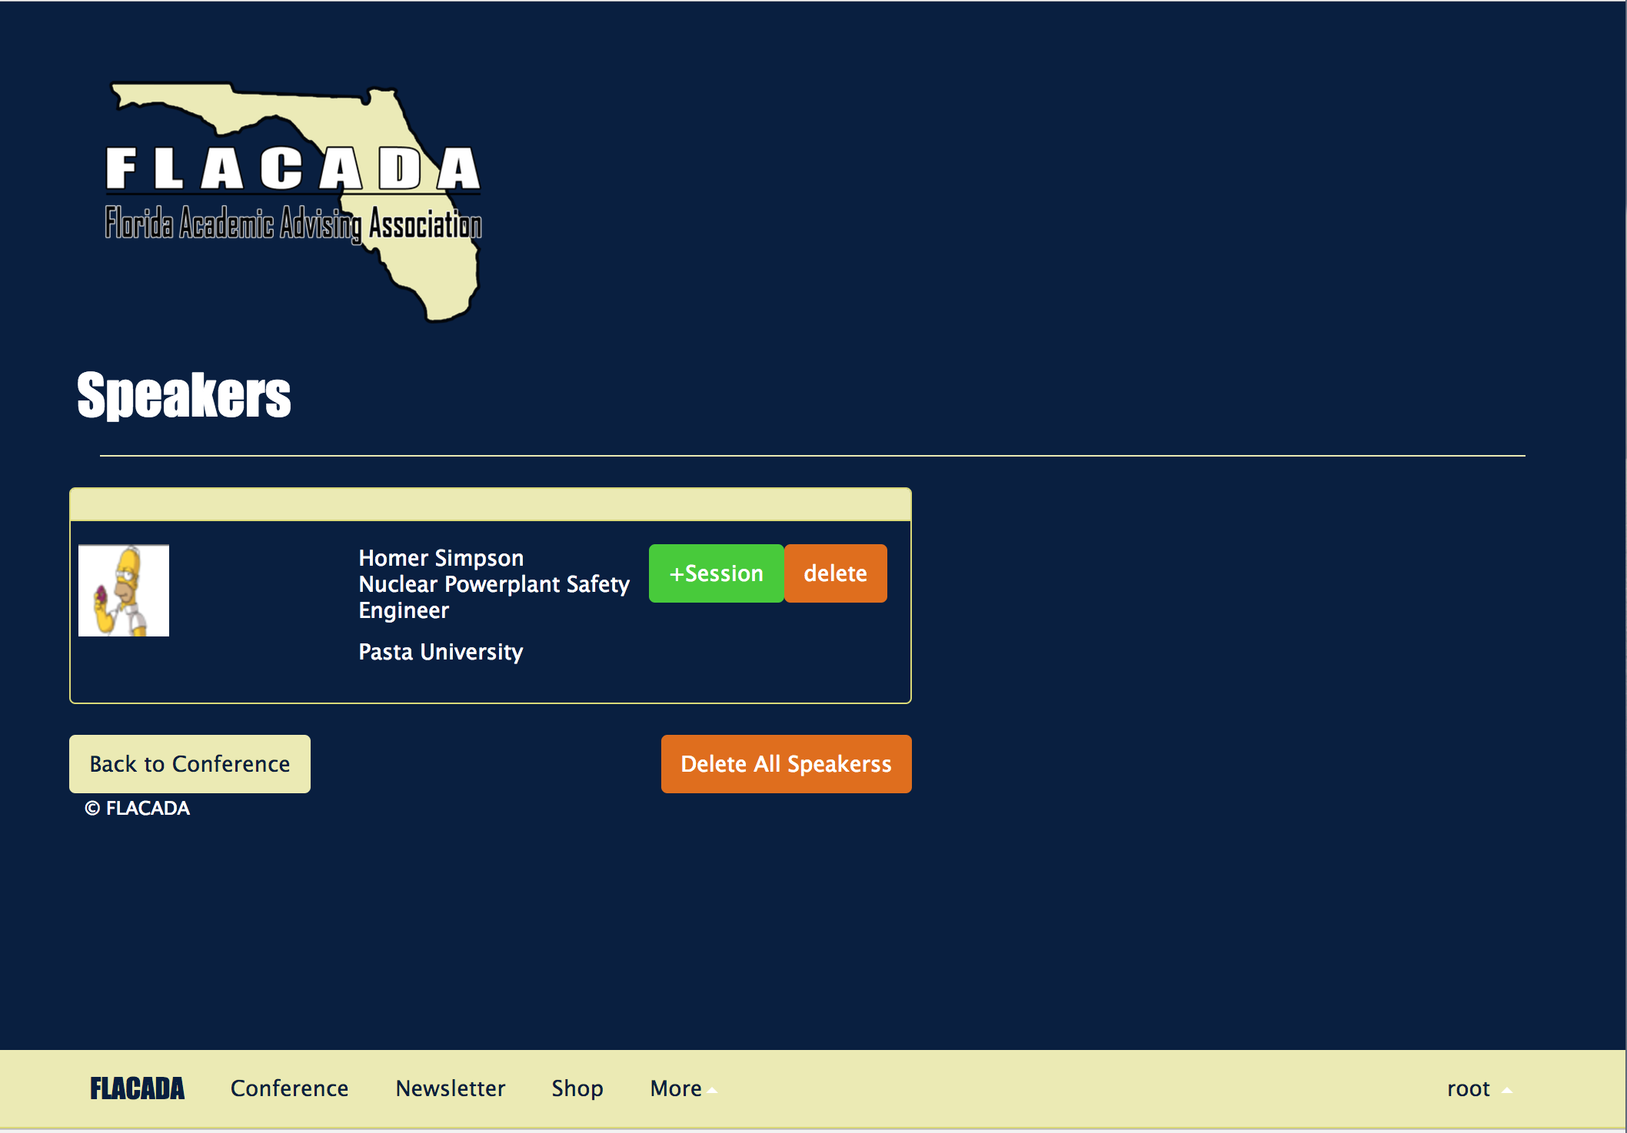



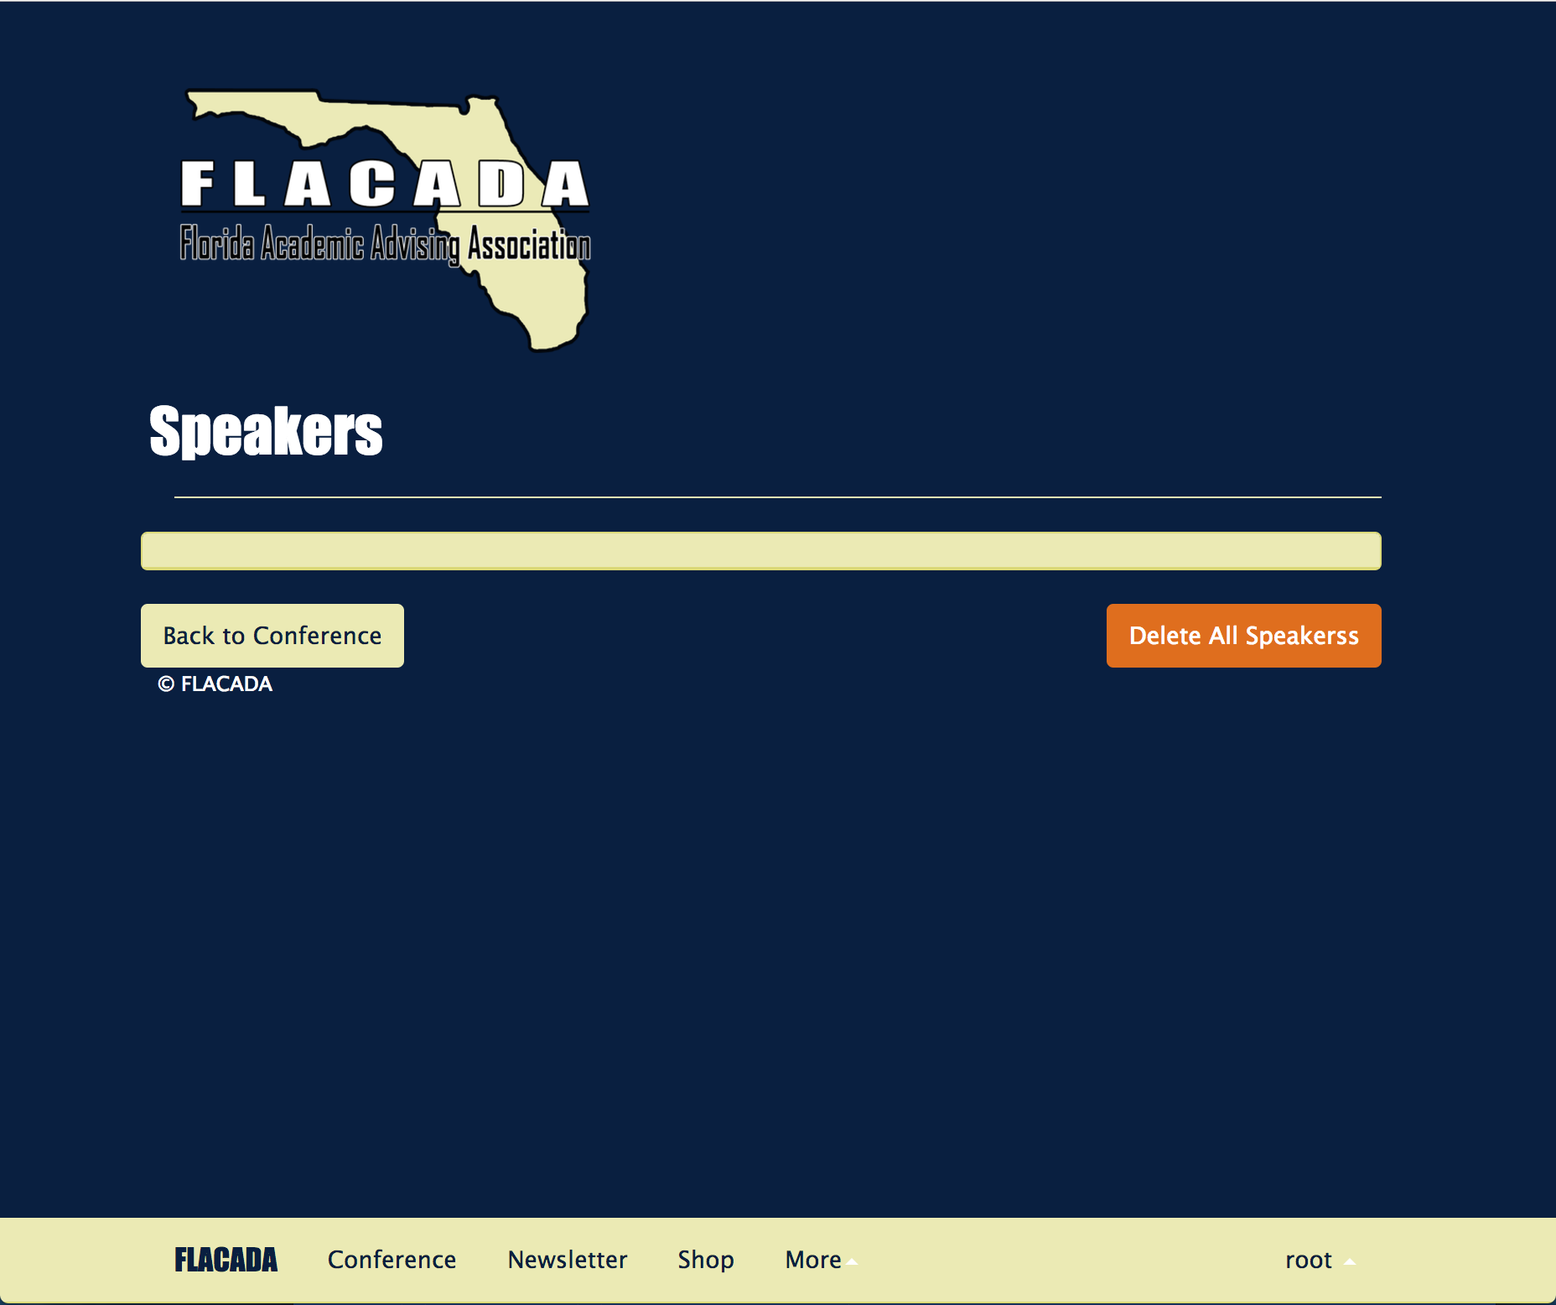

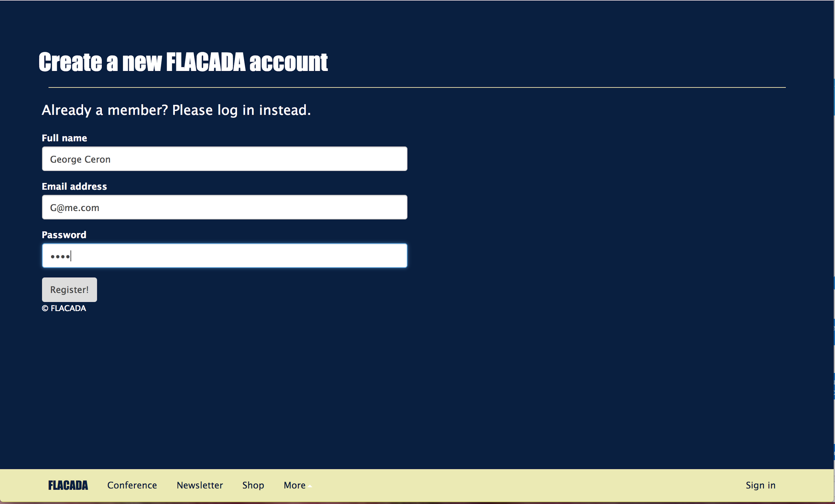

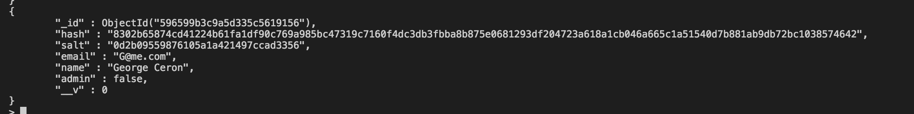

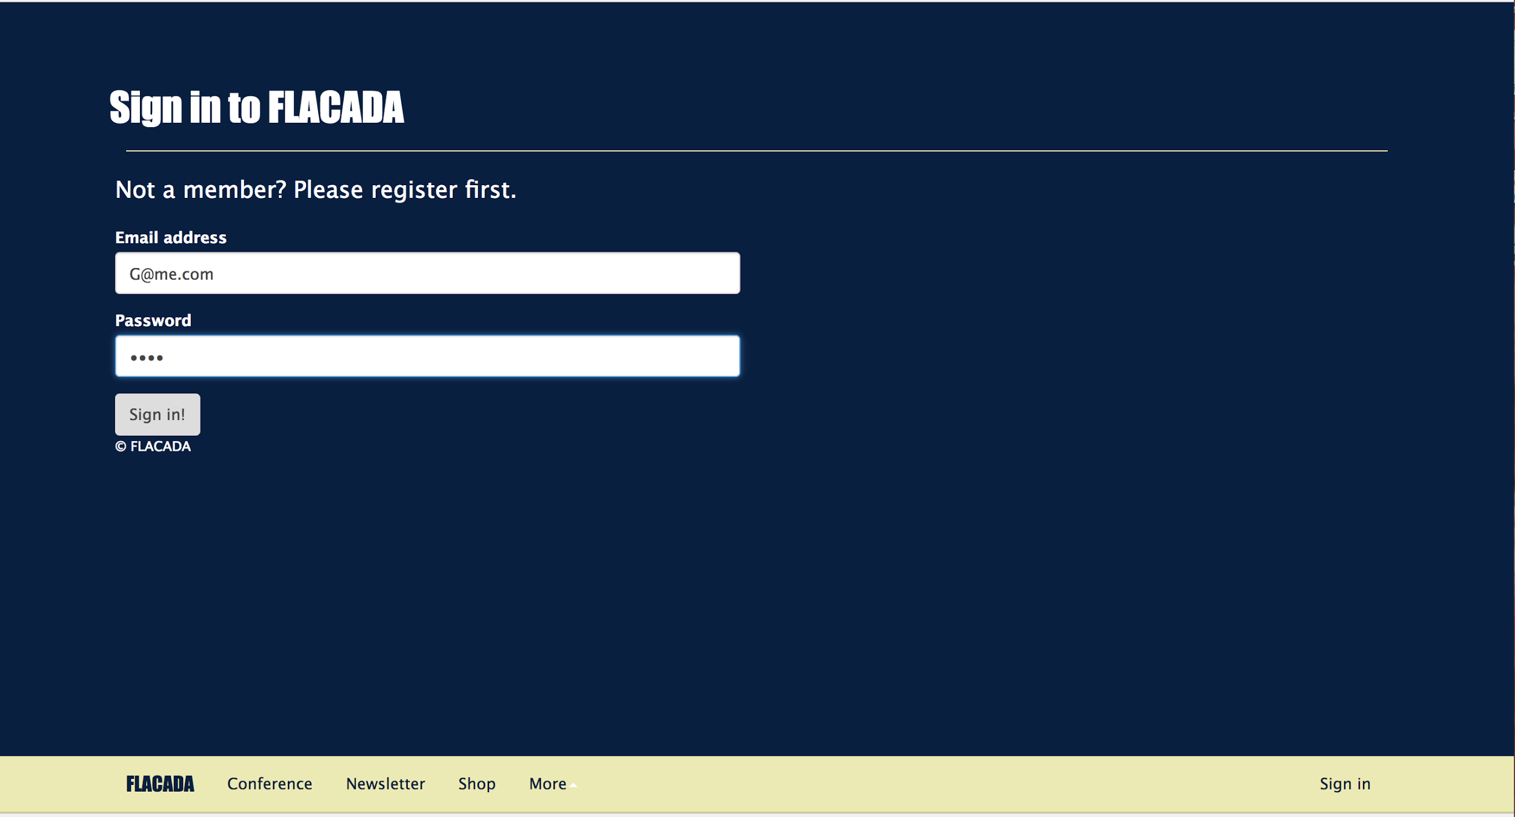





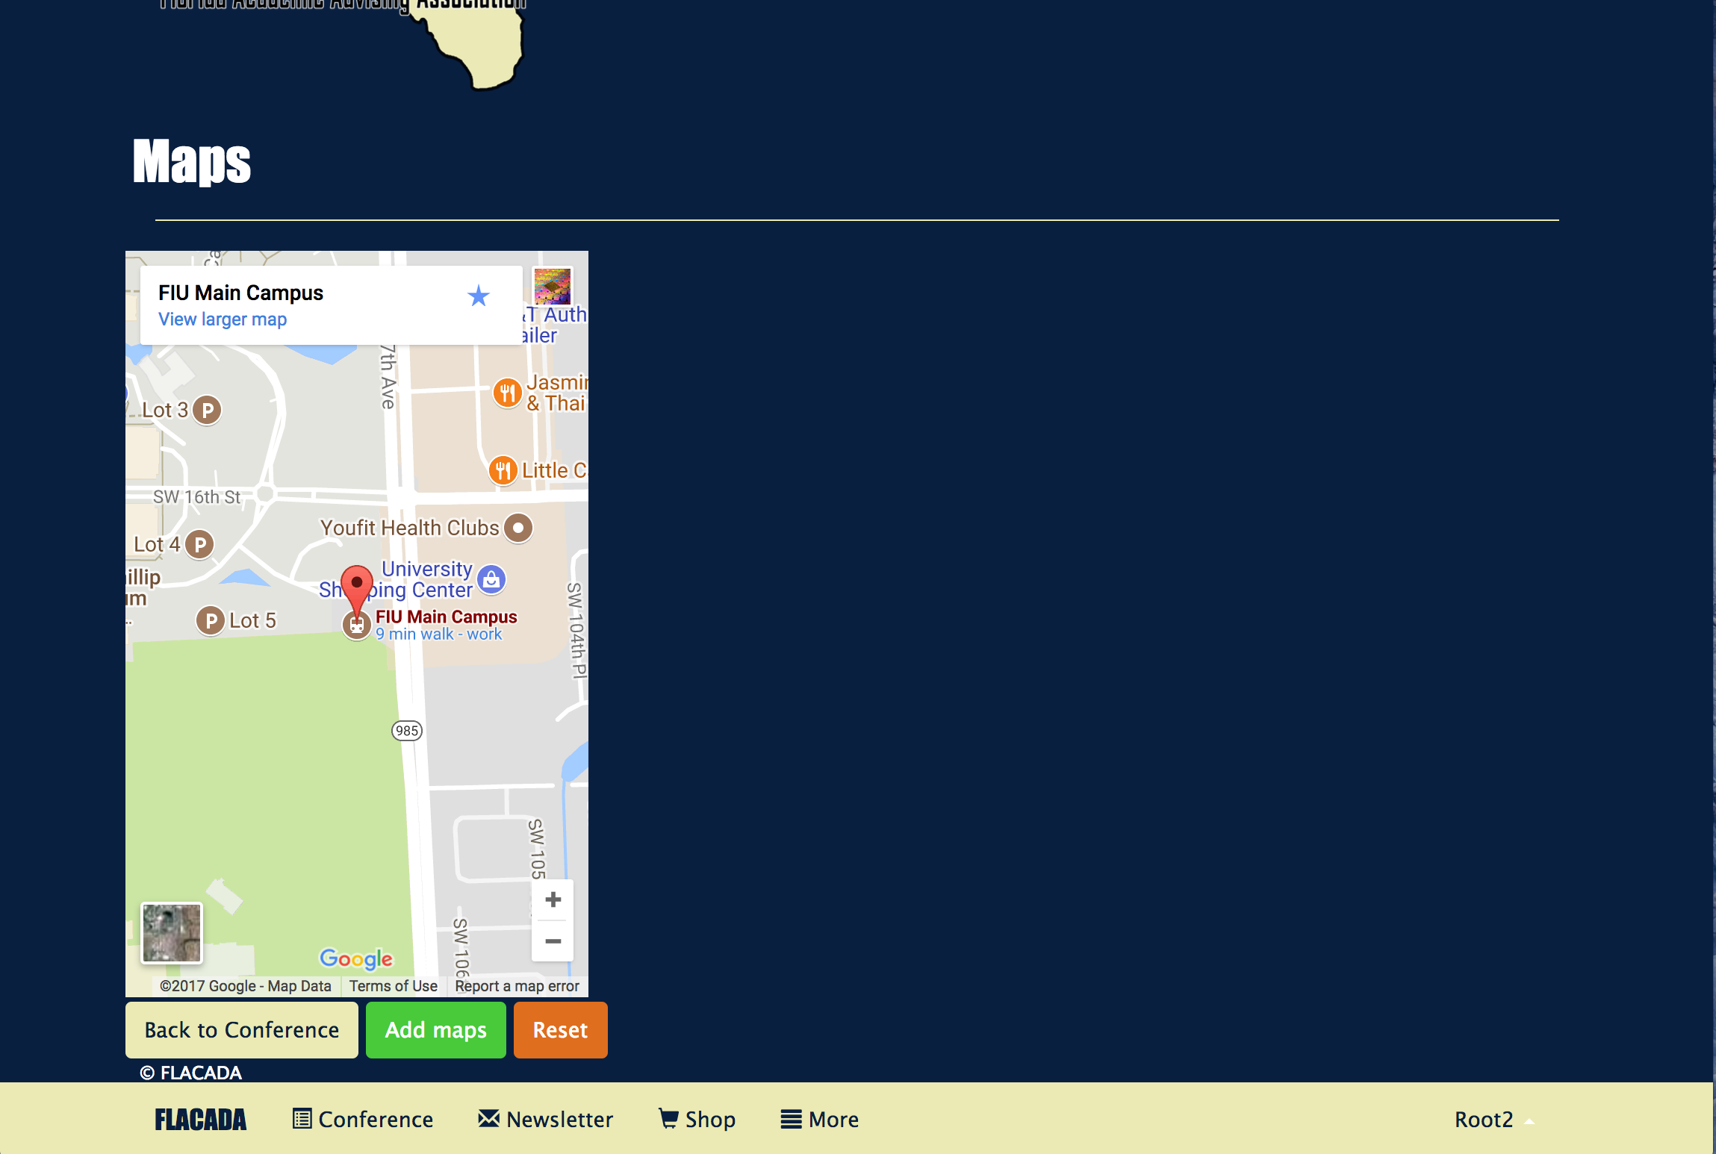

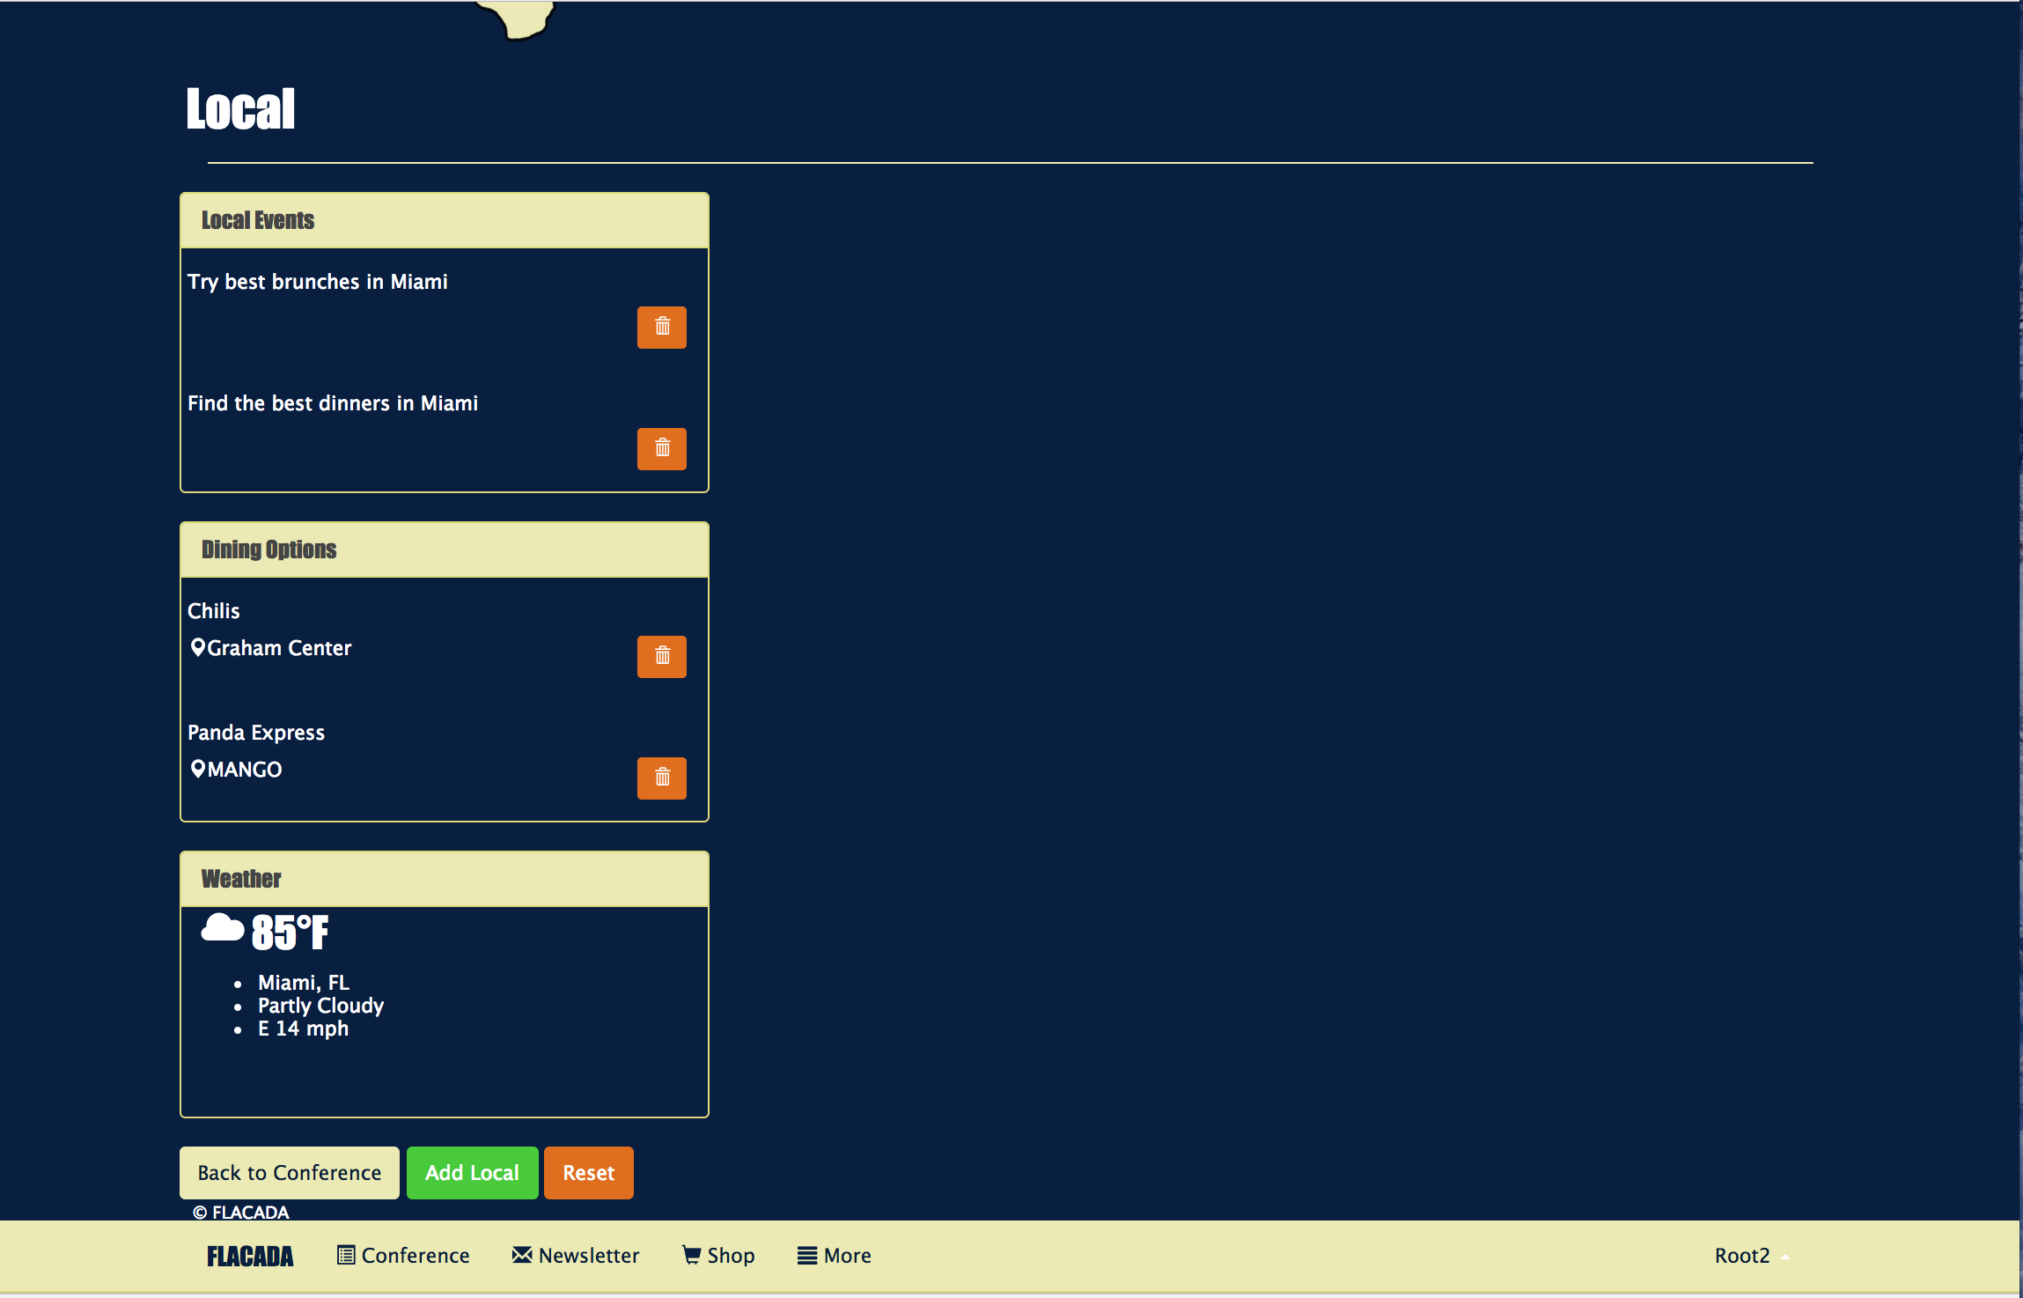

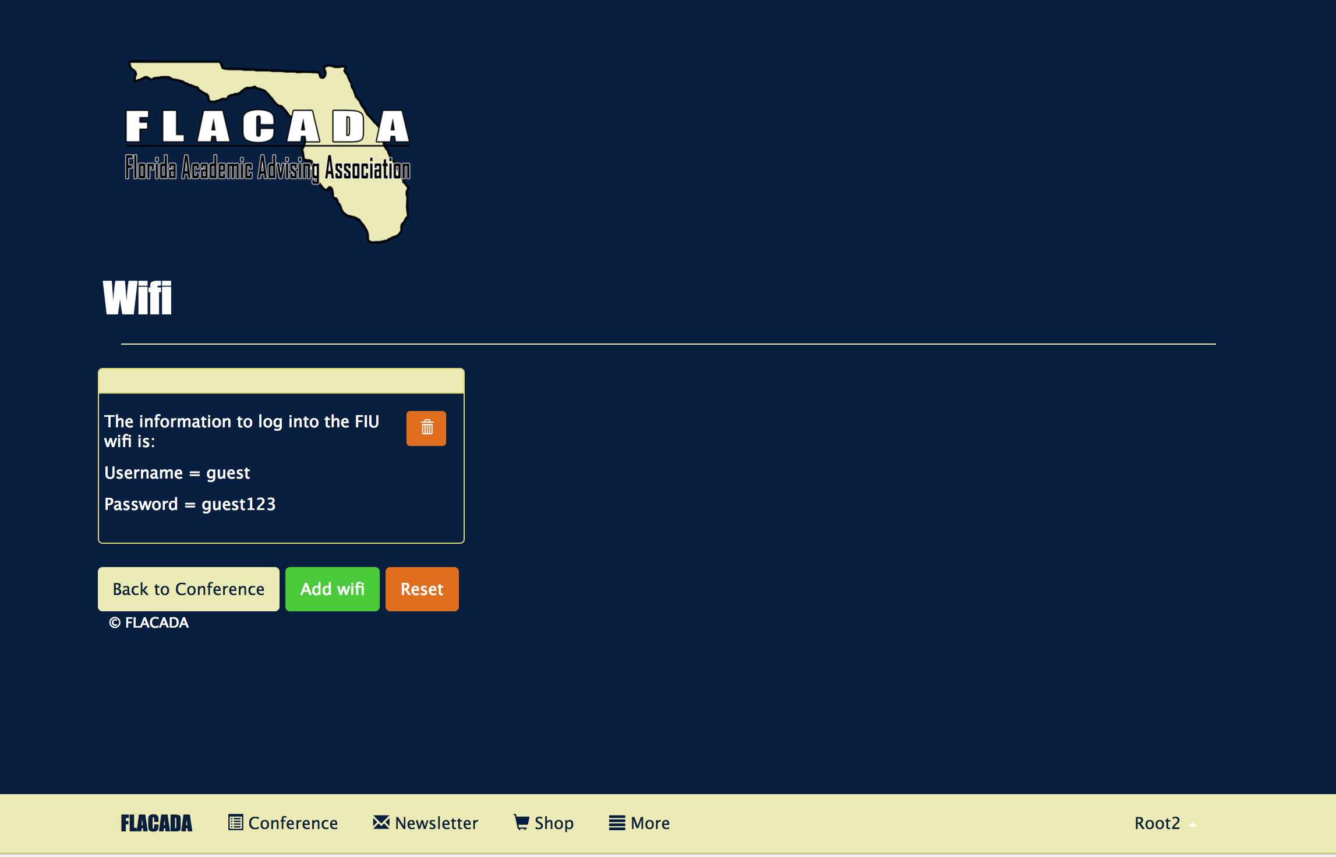

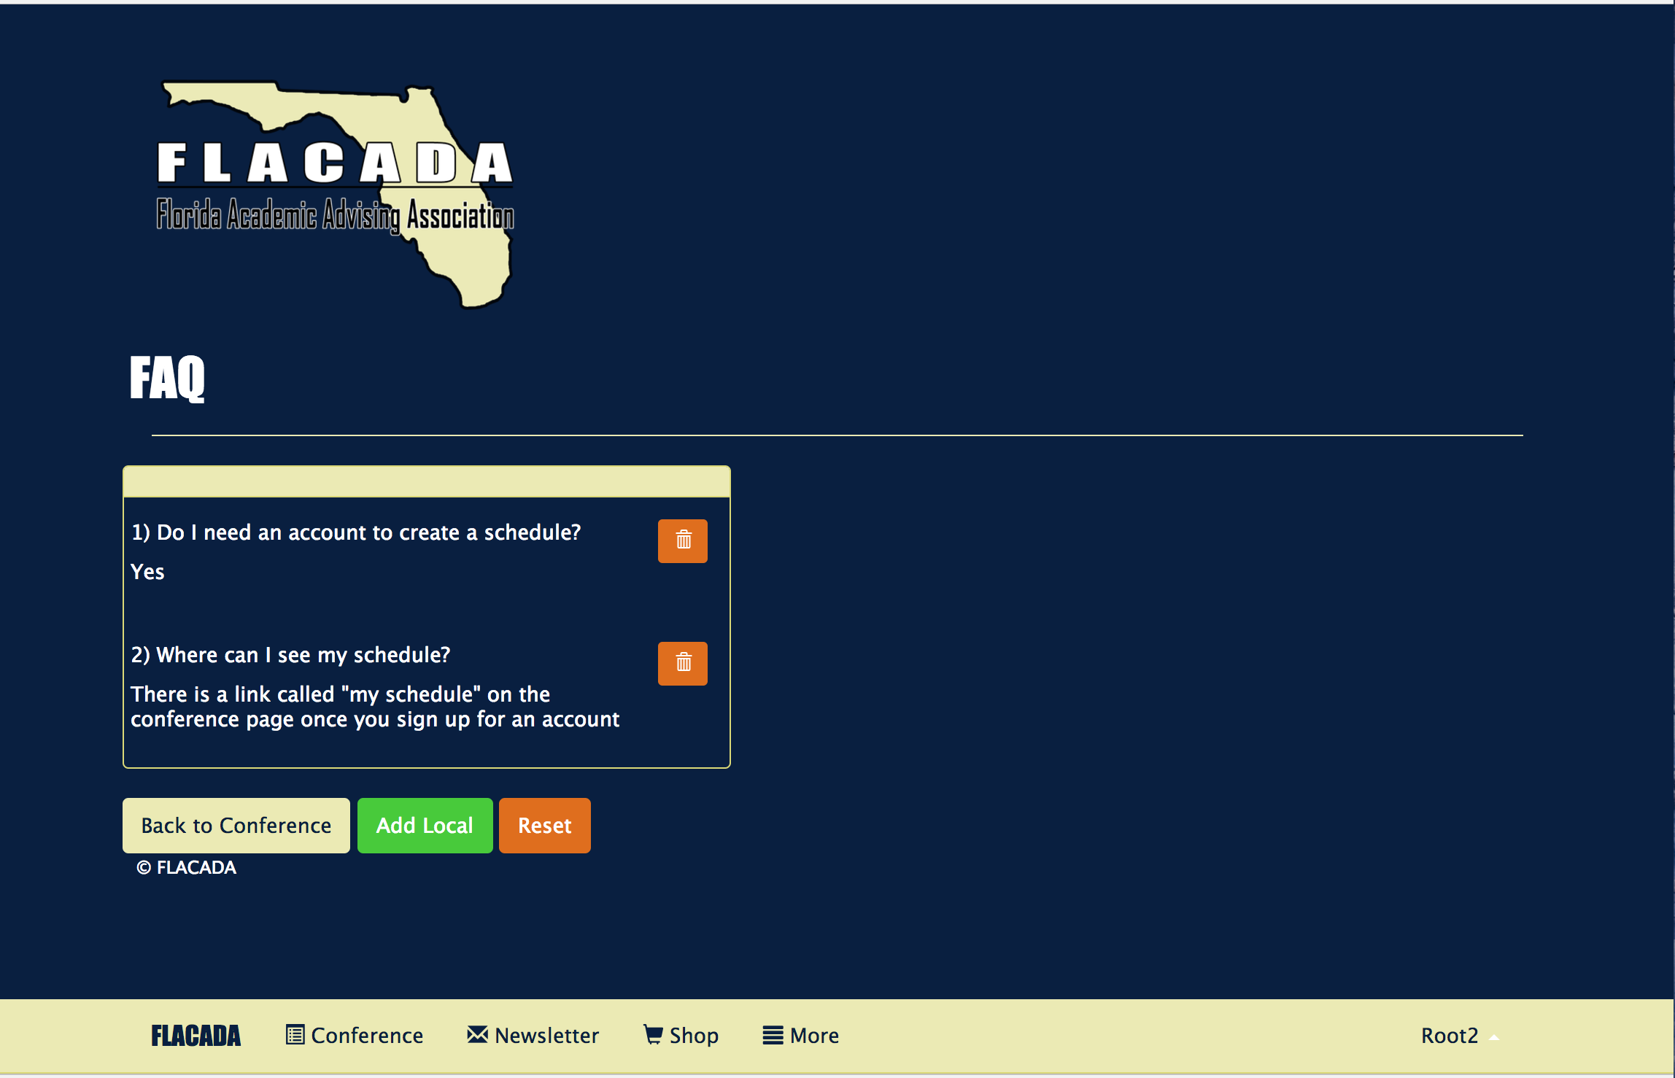

## Appendix C - Sprint Review Reports

**Sprint Review Meeting Minutes 5/26/2017**

Attendees: Nickolas Morales, Mabel Amaya, Helen Gonzalez

Start time: 8:00pm

End time: 9:00pm

After a show and tell presentation, the implementation of the following user stories were accepted by the product owners: All.

* User story: #685 - Homepage

The following ones were rejected and moved back to the product backlog to be assigned to a future sprint at a future Spring Planning meeting.

* N/A

**Sprint Review Meeting Minutes 6/13/17**

Attendees: Nickolas Morales, Mabel Amaya, Helen Gonzalez

Start time: 7:00pm

End time: 8:00pm

After a show and tell presentation, the implementation of the following user stories were accepted by the product owners:

* User story: #689 - Exhibitors and Sponsors

The following ones were rejected and moved back to the product backlog to be assigned to a future sprint at a future Spring Planning meeting.

* N/A

**Sprint Review Meeting Minutes 6/23/17**

Attendees: Nickolas Morales, Mabel Amaya, Helen Gonzalez

Start time: 7:00pm

End time: 8:00pm

After a show and tell presentation, the implementation of the following user stories were accepted by the product owners:

* User story: #692 - More tab - resources
* User story: #713 - More tab - contact us
* User story: #714 - More tab - get involved!
* User story: #715 - More tab - jobs
* User story: #704 - Sessions
* User story: #712 - Speakers

The following ones were rejected and moved back to the product backlog to be assigned to a future sprint at a future Spring Planning meeting.

* N/A

**Sprint Review Meeting Minutes 7/8/17**

Attendees: Nickolas Morales, Mabel Amaya, Helen Gonzalez

Start time: 7:00pm

End time: 8:00pm

After a show and tell presentation, the implementation of the following user stories were accepted by the product owners:

* User story: #693 - Implement my schedule page
* User story: #724 - Implement create sessions
* User story: #725 - Implement register
* User story: #729 - Implement delete sessions
* User story: #750 - Implement delete speakers
* User story: #757 - Implement login
* User story: #758 - Implement logout
* User story: #753 - Create button to add sessions to my schedule
* User story: #754 - Create button to delete sessions from my schedule
* User story: #756 - Implement create speakers

The following ones were rejected and moved back to the product backlog to be assigned to a future sprint at a future Spring Planning meeting.

* N/A

## Appendix D - User Manuals, Installation/Maintenance Document, Shortcomings/Wishlist Document and other documents

**Installation/maintenance**

**After you’ve downloaded mongodb and node.js:**

When our zip folder for the app is downloaded, while on the root folder type the following command on the terminal:

**npm install**

This is going to install all the node modules the app needs to run.

The next step is to create a mongodb folder anywhere on your computer and inside the folder create another folder named data

From the command prompt, go to the location of the mongodb folder and type:

**mongod --dbpath data**

This will start a local database that the app can connect to

After starting the mongo server, our next step is to connect to a local server. On the root of the application folder type:

**nodemon**

After this, the app will be shown at:

**http://localhost:3000/**

Our application is also live on heroku. In order to get a local repository of the application, you’re going to need a heroku account. After signing up for an account, on the root folder of the app log into heroku by typing:

**heroku login**

You will be asked provide your credentials.

Once you login, you can create the local repository by typing:

**heroku git:remote -a sheltered-mesa-44284**

(sheltered-mesa-44284 is the name of our heroku application)

To push changes to the app:

**git add .**

**git commit -m “Commit message here”**

**git push heroku master**

Since we’re not pushing from the master branch, we have to type this instead:

**git push heroku develop:master**

**heroku addons:add mongolab**

We are using a heroku addon called mongolab to store our information, to see the database type:

**heroku addons:open mongolab**

To get the database URI:

**heroku config:get MONGOLAB_URI**

This will output the full connection string. This is the structure of the connection string:

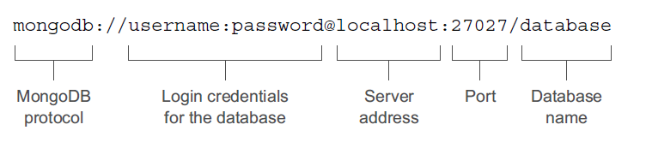

To push data into the application, first a temporary folder has to be created:

**mkdir -p ~/tmp/mongodump**

Then:

**mongodump -h localhost:27017 -d flacada -o ~/tmp/mongodump**

Where:

-h: The host server (and port)

-d: The database name

-o: The output destination folder

Finally, using the information we got for the database URI

mongorestore -h (to fill in) -d (to fill in) -u (to fill in) -p (to fill in) ~/tmp/mongodump/flacada

Where:

-h: Live host and port

-d: Live database name

-u: Username for the live database

-p: Password for the live database

To connect the MongoDB shell to an external database you use the same mongo command, but add information about the database you want to connect to. You need to include the hostname, port, and database names, and you can supply a username and password if required. This is put together in the following construct:

**mongo hostname:port/database_name -u username -p password**

To ensure that the Heroku environment variable is set correctly for production type the following terminal command:

**heroku config:set NODE_ENV=production**

You can specify different environment variables when starting the Node application by prepending the assignment to the launch command. For example:

**NODE_ENV=production nodemon**

**Shortcomings/Wishlist**

We did not have enough time to implement the following user stories:

**User story #705 - Implement notifications**

As a user, I would like to get notifications about the sessions on my schedule so that I can be reminded about their start time

**User story #742 - Get social**

As a user, I would like to have a live feed of a specified social media hashtag

**User story #812 - Implement create maps**

As an admin, I would like to create maps so that I can add new maps to the maps page

**User story #813 - Implement create FAQ**

As an admin, I would like to create FAQ so that I can add new FAQ to FAQ maps page

**User story #816 - Implement create local**

As an admin, I would like to create local events so that I can add new local events to the local page

**User story #817 - Implement create wifi**

As an admin, I would like to create wifi information so that I can add new wifi information to the wifi page

**User story #814 - Implement delete maps**

As an admin, I would like to delete maps so that I can control the content in the maps page

**User story #815 - Implement delete FAQ**

As an admin, I would like to delete FAQ so that I can control the content in the FAQ page

**User story #818 - Implement delete local**

As an admin, I would like to delete local events so that I can control the content in the local page

**User story #819 - Implement delete wifi**

As an admin, I would like to delete wifi information so that I can control the content in the wifi page

We would also like to improve the security and UI design of the application.

# 

# 

# 

# 

# 

# 

# References

* <https://docs.angularjs.org/misc/started>
* <https://nodejs.org/en/docs/>
* <https://docs.mongodb.com/getting-started/shell/>
* <https://devcenter.heroku.com/articles/getting-started-with-nodejs#introduction>
* http://mongoosejs.com/docs/guide.html